Annual Progress Report (APR)



2019 Air Quality Annual Progress Report (APR) for Falkirk Council

In fulfilment of Part IV of the Environment Act 1995
Local Air Quality Management June 2019

Local Authority Officer | John Millar
Department | Environmental Health
Address | Abbotsford House, Davids Loan, Falkirk, FK2 7YZ
Telephone | 01324 504873
E-mail | JohnA.Millar@falkirk.gov.uk
Report Reference number | Annual Progress Report 2019
Date | July 2019

Executive Summary: Air Quality in Our Area

Air Quality in Falkirk Council
In 2018, the air quality within the Falkirk Council area continued to be good from 2017.
Falkirk Council air quality monitoring results for all pollutants measured have shown a slight increase in National Air Quality Strategy (NAQS) objective exceedances from results recorded in 2017 for certain pollutants. There were no national NAQS objective exceedances in 2017 however, there were three in 2018.
Specifically these were:
One exceedance of the nitrogen dioxide (NO₂) NAQS (annual mean) objective limit (40µg/m³) at a (non-automatic) diffusion tube location: NA27 Falkirk West Bridge St (44µg/m³).
Two exceedances of the estimated (see Appendix C for details) particulate matter (PM_{2.5}) NAQS (annual mean) objective limit (10µg/m³) recorded at fixed automatic locations: A5 Falkirk Hope Street (11µg/m³) and A15 Main Street, Bainsford (12µg/m³).
Falkirk West Bridge St is located within the Falkirk Town Centre Air Quality Management Area (AQMA) which was declared in 2011 in recognition of the potential to exceed NAQS objectives for NO₂ and Particulate Matter (PM₁₀). The Falkirk Town Centre Air Quality Management Action Plan (AQAP) was approved in June 2015 and focuses on long-term key point actions to reduce air pollution in the area rather than short-term fixes. Key measures outlined in the plan are:
- Reducing emissions from individual vehicles;
- Promoting the EcoStars Fleet Recognition Scheme;
- Promoting alternative and sustainable modes of transport;
- To educate and inform the public on air quality issues.
In 2018, Falkirk Council made significant progress in implementing these measures. For example, there are now forty electric vehicle (EV) charging bays throughout the Falkirk Council area with more planned in the upcoming year, an action which is helping to promote alternative modes of travel and help to achieve measures

included in Falkirk Council’s Sustainable Development and Climate Change Strategy 2012 - 2017.
Plans for future upgrades of the EV charge network include:
- In 2018 / 19, Falkirk Council are installing an additional sixteen (7, 22, and 50kW) EV chargers which will be registered on the Charge Place Scotland website;
- The Low Carbon Vehicle Hub at Falkirk Stadium is due to open in October 2019, which will provide five 50kW chargers, eight 22kW chargers and include a photovoltaic (PV) charging canopy;
- Falkirk Council are planning to install a new 50kW charger at Larbert train station as part of improvement works to the station’s car park;
The Falkirk Council vehicle fleet currently includes twenty seven electric cars and seven electric vans. This is a significant increase from 2017 in EV within the Council’s ownership. There are plans to increase this EV fleet further in the future.
The Council are also promoting a variety of active and sustainable travel measures and schemes in 2018 / 19 to help reduce traffic emissions. Full details of the progress Falkirk Council is making towards the measures outlined in the Air Quality Action Plans can be seen in Section 2.2 of this report.
In 2018, all seven automatic NO₂ analysers within Falkirk Council’s air quality monitoring network met both NO₂ NAQS objectives. The remaining sixty NO₂ (non- automatic) diffusion tubes in Falkirk Council’s network met the NAQS objective.
Falkirk Council measured PM₁₀ concentrations at eight locations during 2018. The NAQS objectives for PM₁₀ were met at all eight locations. The PM₁₀ analyser located at Falkirk Grahams Road was transferred to nearby Hope Street on the 10th October 2018.
The site with the highest annual mean PM₁₀ concentration (but within the NAQS PM₁₀ objective) was A4 Haggs (Roadside, 14µg/m³). Over a five year period (from 2014 until 2018), all eight sites have recorded PM₁₀ (annual mean) long-term reductions.
The A14 Banknock 3 monitoring site recorded the greatest number of PM₁₀ daily exceedances (2) which is a slight increase from none recorded in 2017, however, this is within the NAQS limit (>50µg/m³).

Over a five year period (from 2014 to 2018), all eight montioring sites have recorded PM₁₀ (annual mean) concentration reductions. Of these eight sites, three have recorded PM₁₀ (24-hr mean) reductions: A4 Falkirk Haggs (Roadside), A7 Falkirk West Bridge St (Roadside) and A13 Banknock 2 (Roadside). One site recorded an increased PM₁₀ (24-hr mean) result: A14 Banknock 3 (Urban Background). Four sites have recorded the same PM₁₀ (24-hr mean) concentrations: A8 Grangemouth AURN (Urban Background / Industrial), A10 Grangemouth Municipal Chambers (Urban Background / Industrial), A12 Falkirk Grahams Rd (Roadside) and A15 Main St, Bainsford (Roadside).
PM_{2.5} is measured at three locations within the Falkirk Council area, these are: A7 Falkirk West Bridge St (Roadside), A8-Grangemouth AURN (Urban Background / Industrial) and A13-Banknock 2 (Roadside). During 2018 there were no exceedances of the PM_{2.5} Scottish NAQS objective (10µg/m³) at any of the three monitoring sites.
Two sites (A7 Falkirk West Bridge St and A13 Banknock 2) recorded the same annual mean PM_{2.5} concentration (6µg/m³). A8 Grangemouth AURN site recorded a concentration of 7µg/m³. The PM_{2.5} concentrations at the Grangemouth AURN site have gradually reduced from 9.2µg/m³ in 2015 to 6µg/m³ in 2016 and 2017. 2018 saw a marginal increase to 7µg/m³ however, this concentration remains reasonably low and within the NAQS objective limit. This reduction may be may be attributed to the commisioning of the tail gas treatment (TGT) unit at the INEOS Grangemouth complex in 2013. Since the commissioning of the TGT unit, SO₂ concentrations have reduced within the Grangemouth AQMA. As sulphate species are known to contribute towards the formation of secondary PM_{2.5}, a reduction in SO₂ could also impact local PM_{2.5} concentrations.
The PM_{2.5} estimations indicate that two sites: A5 Falkirk Hope Street (11µg/m³) and A15 Main Street, Bainsford (12µg/m³) exceeded the NAQS objective limit of 10µg/m³. The PM_{2.5} concentrations are estimated using a local correction factor as per LAQM.TG (16)^{Ref} ¹ based on continuous PM₁₀ data. See Appendix C for further details.
In 2018, Falkirk Council monitored sulphur dioxide (SO₂) at six locations. Four of the sites are located within the Grangemouth (15-minute) AQMA and two of the sites are located outwith the AQMA. There were no exceedances of the SO₂ objectives (15-

minute, hourly or daily) recorded at any of the Falkirk Council monitoring locations during 2018.
The site that recorded the only exceedance of the 15-minute NAQS objective during 2018 was A9 Grangemouth Moray (1). No other SO₂ exceedances were recorded at any of the other sites during 2018.
This is the fifth consecutive year that no breaches of the SO₂ objectives (15-minute, hourly or daily) have been recorded at any site in the Grangemouth AQMA. It is important to stress that although there was an exceedance of the 15-minute NAQS objective concentration, the number of exceedances were below the maximum permitted by the respective NAQS objective.
The Grangemouth Emission Study 2018 / 19 which is being completed by Sweco is currently being prepared and expected to be published in late summer 2019. The study report will include a review and assessment of the Grangemouth AQMA.
The benzene and 1, 3-butadiene diffusion tube monitoring conducted in 2018 met the NAQS (annual running mean) objectives for each pollutant respectively.

Actions to Improve Air Quality
Falkirk Council made significant improvements to its air quality monitoring network during 2018. These improvements included upgrading the Grangemouth AURN PM₁₀ and PM_{2.5} analysers from R&P 1400 TEOM analysers to Met One 1020 Beta Attenuation Monitors (BAM). This was shortly followed by an upgrade to the NO_{x} and SO₂ continuous analysers at the Grangemouth AURN site. See Photos 1 and 2 for equipment upgrade details.

Photo 1 – Met One 1020 PM₁₀ and PM_{2.5} BAMs at the Grangemouth AURN Site
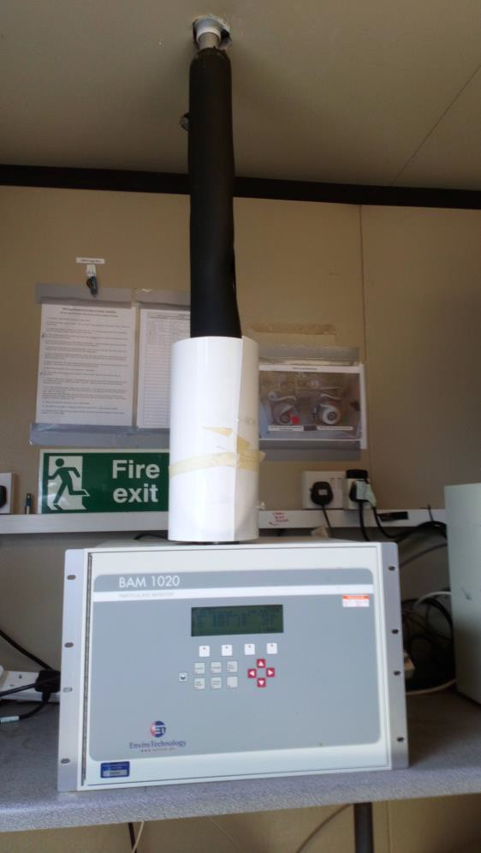
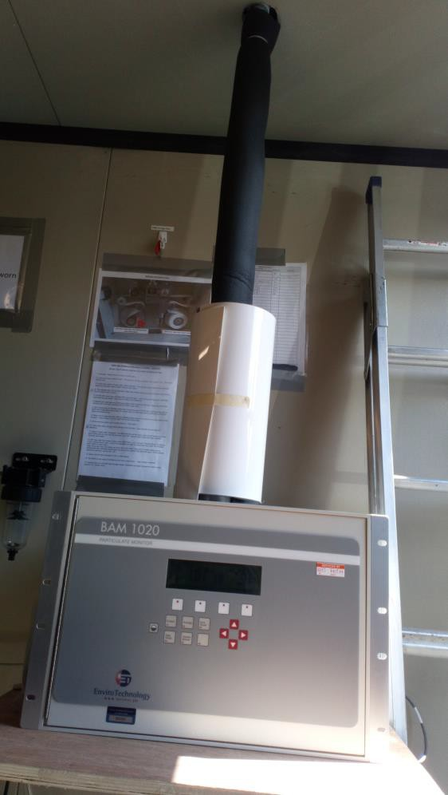
The NO_{x} analyser was upgraded from a MLME Monitor Europe ‘Evo’ Series to an API Teledyne T200 model. The SO₂ analyser was upgraded from a MLME Monitor Europe ‘Evo’ Series to an Ecotech Serinus 50 model. The equipment upgrades completed at the Grangemouth AURN were required as certain manufacturer (Monitor Europe) parts are being discontinued in the coming years and the new analysers will utilise the latest technology which should increase accuracy and data capture rates (through using readily available spare parts).

Photo 2 – API Teledyne T200 (NO_{x}) and Ecotech Serinus 50 (SO₂) Analysers at the Grangemouth AURN Site
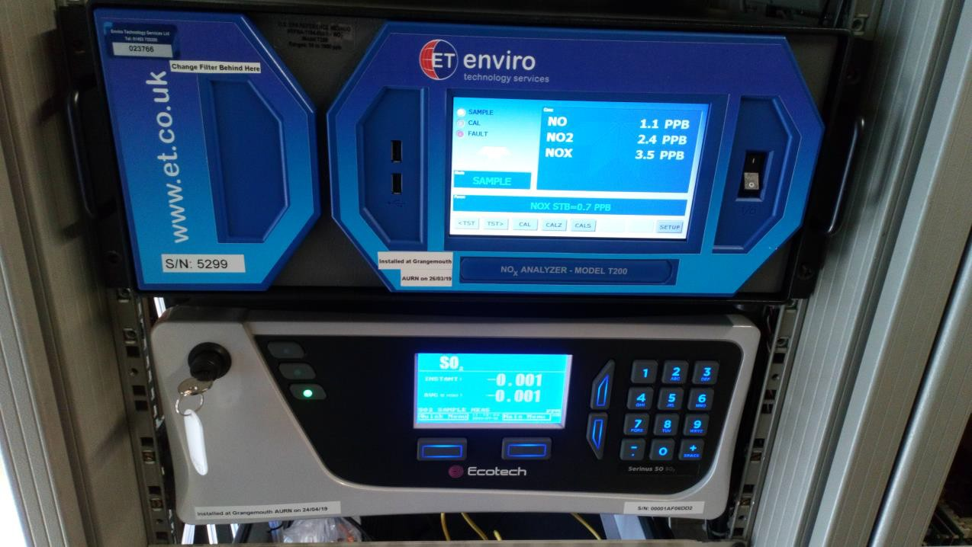
The PM₁₀ (R&P 1400 TEOM) analyser that was located at the Falkirk Grahams Road site was transferred to the nearby Falkirk Hope St site on 10th October 2018. It was decided that the PM₁₀ monitoring location was more prominent (for monitoring road traffic emissions) if housed within the nearby Falkirk Hope Street site. The Falkirk Grahams Road roadside site was subsequently decommissioned and removed from street level on 11th March 2019, this network change should increase efficiency through reduced energy use.
Multiple Falkirk Council monitoring sites had the sample inlet roof cages replaced with new units. Improved weather protection and aesthetics were achieved after cage installations at the following sites: A5 Falkirk Hope St, A7 Falkirk West Bridge St, A8 Grangemouth AURN, A10 Grangemouth Municipal Chambers, A11 Grangemouth Zetland Park and A13 Banknock 2.
It is anticipated that there will be an upgrade to the PM₁₀ analyser at Grangemouth Municipal Chambers in 2019 to include the functionality to measure PM_{2.5}, details of this upgrade will be provided in the 2020 Annual Progress Report (APR).
In the year 2018 / 19 Falkirk’s ECO Stars fleet scheme has grown significantly from one hundred and fifty six members to two hundred and eight members. Falkirk’s ECO

Stars taxi scheme has a small but engaged membership of seven members. ECO Stars membership consists of operators located within the Falkirk Council local authority area as well as those whose depot is located outwith the Council boundary but operate vehicles within that area; all of these operators have an impact on local air quality. In the past year local membership has grown, with notable fleets such as Scottish Gas Networks and Mackie’s Coaches joining the scheme. In addition Falkirk Council has been working closely with fellow members of the East Central Scotland Vehicle Emissions Partnership (ECSVEP) to work to the objectives set out in the Scottish Government’s Cleaner Air for Scotland (CAFS). Air Quality Action Plan (AQAP) funding has been provided to continue the operation of the Falkirk EcoStars scheme (Fleet Operators and Taxis) during 2018 / 2019.
Falkirk Council also continues to work closely with its partner organisations to manage local air quality issues. The council works closely with SEPA, INEOS and Petroineos to reduce exceedances of the SO₂ objectives within the Grangemouth AQMA.

Local Priorities and Challenges
Education and Awareness of Air Quality Issues
In 2019, Falkirk Council will be developing our engagement with locals through promotion of air quality education resources such as the ‘Learn About Air’ teaching package, the Clean Air Day in Scotland and working closer with the Transport Planning department on promoting alternative / sustainable local transport solutions.

Low Emission Zones
Low Emission Zones (LEZ) are being planned and operated in the four major Scottish cities: Glasgow, Edinburgh, Aberdeen and Dundee over the next few years. There are no current plans for any form of LEZ in the Falkirk Council area. Falkirk Council will be undertaking the ‘Stage 1 Screening Exercise (clause 2.2.25)’ assessment in late 2019 in accordance with the National Low Emissions Framework to inform this process.

How to Get Involved
To obtain further information on air quality within the Falkirk Council area, please visit our air policy webpage at
http://www.falkirk.gov.uk/services/environment/environmental-policy/air-quality/
There are twelve automatic air quality monitoring sites across the Falkirk Council area. The monitoring data from all of the sites can be viewed on the Scottish Air Quality website at:
http://www.scottishairquality.co.uk/latest/summary?view=la
To learn more about the EcoStars Fleet Recognition Scheme and for details of how to join if you are a commercial fleet operator please visit:
https://www.ecostars-uk.com/eco-stars-schemes/

Table of Contents

Executive Summary: Air Quality in Our Area i
Air Quality in Falkirk Council i
Actions to Improve Air Quality v
Local Priorities and Challenges vii
How to Get Involved viii
- Local Air Quality Management 1
- Actions to Improve Air Quality 2
  - Air Quality Management Areas 2
  - Progress and Impact of Measures to address Air Quality in Falkirk Council 3
  - Cleaner Air for Scotland 21
    - Transport – Avoiding travel – T1 21
    - Climate Change – Effective co-ordination of climate change and air quality…22
- Air Quality Monitoring Data and Comparison with Air Quality
Objectives 23
  - Summary of Monitoring Undertaken 23
    - Automatic Monitoring Sites 23
    - Non-Automatic Monitoring Sites 23
  - Individual pollutants 23
    - Nitrogen Dioxide (NO₂) 23
    - Particulate Matter (PM₁₀) 26
    - Particulate Matter (PM_{2.5}) 27
    - Sulphur Dioxide (SO₂) 29
    - Carbon Monoxide, Lead and 1,3-Butadiene 29
- New Local Developments 31
  - Road Traffic Sources 31
  - Other Transport Sources 34
  - Industrial Sources 35
  - Commercial and Domestic Sources 38
  - New Developments with Fugitive or Uncontrolled Sources 39
- Planning Applications 41
- Conclusions and Proposed Actions 46
  - Conclusions from New Monitoring Data 46
  - Conclusions relating to New Local Developments 50
  - Proposed Actions 55
Appendix A: Monitoring Results 56
Appendix B: Full Monthly Diffusion Tube Results for 2018 109
Appendix C: Supporting Technical Information / Air Quality Monitoring
Data QA/QC 115
Glossary of Terms 126
References 128

List of Tables
Table 1.1 – Summary of Air Quality Objectives in Scotland 1
Table 2.1 – Declared Air Quality Management Areas 3
Table 2.2 - Electric Vehicle Charging Points at Council Depots / Public Places in the Falkirk Council Area 6
Table 2.3 – Electric Vehicle Charging Points Planned in 2019 / 20 7
Table 2.4 - Progress on Measures to Improve Air Quality 11
Table A.1 – Details of Automatic Monitoring Sites 56
Table A.2 – Details of Non-Automatic Monitoring Sites 59
Table A.3 – Annual Mean NO₂ Monitoring Results 64
Table A.4 – 1-Hour Mean NO₂ Monitoring Results 68
Table A.5 – Annual Mean PM₁₀ Monitoring Results 76
Table A.6 – 24-Hour Mean PM₁₀ Monitoring Results 77
Table A.7 – Annual Mean PM_{2.5} Monitoring Results 84
Table A.8 – SO₂ Monitoring Results 88
Table A.9 - 1,3 Butadiene Annual Mean Diffusion Tube Results for 2018 99
Table A.10 - Benzene Annual Mean Diffusion Tube Results for 2018 100
Table A.11 - Pumped Benzene Annual Mean Results for 2018 101
Table A.12 - Estimated Annual Mean PM2.5 Results for 2018 102
Table B.1 – NO₂ Monthly Diffusion Tube Results for 2018 109
Table B.2 - 1,3 Butadiene Monthly Diffusion Tube Results for 2018 113
Table B.3 - Benzene Monthly Diffusion Tube Results for 2018 114
Table C.1 - Locally Derived PM_{2.5} / PM₁₀ Correction Ratio 122
Table C.2 - Details of the QA / QC at the Automatic Monitoring Stations in 2018…123

List of Figures
Figure 1 – A4 Falkirk Haggs Long Term NO₂ Concentrations… 69
Figure 2 – A5 Falkirk Hope St Long Term NO₂ Concentrations… 70
Figure 3 – A7 Falkirk West Bridge St Long Term NO₂ Concentrations… 71
Figure 4 – A8 Grangemouth AURN Long Term NO₂ Concentrations 72
Figure 5 – A9 Grangemouth Moray Long Term NO₂ Concentrations 73
Figure 6 – A10 Grangemouth Municipal Chambers Long Term NO₂ Concentrations… 74
Figure 7 – A15 Main St, Bainsford Long Term NO₂ Concentrations… 75
Figure 8 – A4 Haggs Long Term PM₁₀ (24-hour mean) Concentrations… 78
Figure 9 – A5 Falkirk West Bridge St Long Term PM₁₀ (24-hour mean) Concentrations… 79
Figure 10 – A8 Grangemouth AURN Long Term PM₁₀ (24-hour mean) Concentrations… 80
Figure 11 – A10 Grangemouth Municipal Chambers Long Term PM₁₀ (24-hour mean) Concentrations… 81
Figure 12 – A13 Banknock 2 Long Term PM₁₀ (24-hour mean) Concentrations… 82

Figure 13 – A15 Main St, Bainsford Long Term PM10 (24-hour mean) Concentrations… 83
Figure 14 – A7 Falkirk West Bridge St Long Term PM_{2.5} Concentrations… 85
Figure 15 – A8 Grangemouth AURN Long Term PM_{2.5} Concentrations… 86
Figure 16 – A13 Banknock 2 Long Term PM_{2.5} Concentrations… 87
Figure 17 – A3 Bo’ness Long Term SO₂ Concentrations… 89
Figure 18 – A5 Falkirk Hope St Long Term SO₂ Concentrations… 90
Figure 19 – A8 Grangemouth AURN Long Term SO₂ Concentrations 91
Figure 20 – A9 Grangemouth Moray Long Term SO₂ Concentrations 92
Figure 21 – A10 Grangemouth Municipal Chambers Long Term SO₂ Concentrations… 93
Figure 22 – A11 Grangemouth Zetland Park Long Term SO₂ Concentrations… 94
Figure 23 – Polar Plots of Average SO₂ Concentrations Recorded at the Grangemouth Sites… 95
Figure 24 – Exceedances of the 15 Minute SO₂ NAQS Objective Concentration at the Grangemouth Sites… 98
Figure 25 – Maps of the AQMA Boundaries in the Falkirk Council Area 103
Figure 26 – Maps Showing Automatic Monitoring Locations… 105
Figure 27 – NO₂ Locally Derived Bias Adjustment Factor Spreadsheets… 117
Figure 28 – NO₂ National Derived Bias Adjustment Factor Spreadsheet… 120

List of Photos
Photo 1 – Met One 1020 PM₁₀ and PM_{2.5} BAMs at the Grangemouth AURN Site v
Photo 2 – API Teledyne T200 (NO_{x}) and Ecotech Serinus 50 (SO2) Analysers at the Grangemouth AURN Site vi
Photo 3 – PDU Located in the Falkirk Council Abbotsford House Reception Area 4
Photo 4 – Falkirk West Bridge St Mobile Phone QR Code Posters… 5
Photo 5 – Forth Bike ‘Pedelec’ Electric Bike 9
Photo 6 – Example of an EV Kia Soul located at Falkirk Council’s Abbotsford House 10
Photo 7 – Falkirk Bus Station after Closure in August 2018 (1)… 32
Photo 8 – Falkirk Bus Station after Closure in August 2018 (2)… 33

Local Air Quality Management
This report provides an overview of air quality in Falkirk Council during 2018. It fulfils the requirements of Local Air Quality Management (LAQM) as set out in Part IV of the Environment Act (1995) and the relevant Policy and Technical Guidance documents.
The LAQM process places an obligation on all local authorities to regularly review and assess air quality in their areas, and to determine whether or not the air quality objectives are likely to be achieved. Where an exceedance is considered likely the local authority must declare an Air Quality Management Area (AQMA) and prepare an Air Quality Action Plan (AQAP) setting out the measures it intends to put in place in pursuit of the objectives. This Annual Progress Report (APR) is summarises the work being undertaken by Falkirk Council to improve air quality and any progress that has been made.
Table 1.1 – Summary of Air Quality Objectives in Scotland

Pollutant | Air Quality Objective |  | Date to be achieved by
Pollutant | Concentration | Measured as | Date to be achieved by
Nitrogen dioxide (NO₂) | 200 µg/m³ not to be exceeded more than 18 times a year | 1-hour mean | 31.12.2005
Nitrogen dioxide (NO₂) | 40 µg/m³ | Annual mean | 31.12.2005
Particulate Matter (PM₁₀) | 50 µg/m³, not to be exceeded more than 7 times a year | 24-hour mean | 31.12.2010
Particulate Matter (PM₁₀) | 18 µg/m³ | Annual mean | 31.12.2010
Particulate Matter (PM_{2.5}) | 10 µg/m³ | Annual mean | 31.12.2020
Sulphur dioxide (SO₂) | 350 µg/m³, not to be exceeded more than 24 times a year | 1-hour mean | 31.12.2004
Sulphur dioxide (SO₂) | 125 µg/m³, not to be exceeded more than 3 times a year | 24-hour mean | 31.12.2004
Sulphur dioxide (SO₂) | 266 µg/m³, not to be exceeded more than 35 times a year | 15-minute mean | 31.12.2005
Benzene | 3.25 µg/m³ | Running annual mean | 31.12.2010
1,3 Butadiene | 2.25 µg/m³ | Running annual mean | 31.12.2003
Carbon Monoxide | 10.0 mg/m³ | Running 8-Hour mean | 31.12.2003
Lead | 0.25 µg/m³ | Annual Mean | 31.12.2008

Actions to Improve Air Quality

Air Quality Management Areas
Air Quality Management Areas (AQMAs) are declared when there is an exceedance or likely exceedance of an air quality objective. After declaration, the authority must prepare an Air Quality Action Plan (AQAP) within 12 months, setting out measures it intends to put in place in pursuit of the objectives.
A summary of the AQMAs declared by Falkirk Council can be shown in Table 2.1.
Further information related to declared or revoked AQMAs, including maps of AQMA boundaries are available online at https://uk-air.defra.gov.uk/aqma/local- authorities?la_id=371 – see full list at https://uk-air.defra.gov.uk/aqma/list.
The monitoring data so far indicates that the NAQS objectives for both NO₂ and PM₁₀ are being met and for this reason Falkirk Council will not be declaring Main Street, Bainsford an AQMA. It is noted that in 2018 the estimated annual mean PM_{2.5} objective concentration of 10µg/m³ was exceeded at the Main St, Bainsford location. As this result is an estimation based on the automatic PM₁₀ monitoring results, further continuous automatic monitoring will be undertaken and reviewed to ensure compliance with the future NAQS objectives.
The Banknock AQMA (PM₁₀ 24-hr and annual mean) revocation summary report has been drafted and will be progressed by Falkirk Council in 2019. If the decision to revoke the Banknock AQMA is made it is likely that the Palas Fidas 200 particulate analyser will be transferred to a more appropriate monitoring location such as the Main St, Bainsford roadside site (due to 2018 PM_{2.5} estimated result exceedance).
Monitoring data for 2018 has highlighted that the Haggs AQMA will be reviewed in 2019 as the site continues to meet the NAQS objectives.
Sweco have been commissioned by Falkirk Council to complete the Grangemouth Emissions Study 2018/19, it is anticipated this will be published late 2019. The report will include a review of the Grangemouth AQMA.

Table 2.1 – Declared Air Quality Management Areas

AQMA  Name | Pollutants and Air Quality Objectives | City / Town | Description | Action Plan
Falkirk Town Centre | NO₂ annual mean  PM₁₀ 24-hour mean and annual mean | Falkirk | An area encompassing an area of Falkirk Town Centre | Air Quality Action Management Plan (Falkirk Town Centre and Haggs) 2015  Air Quality Management Action Plan (Falkirk Town Centre and Haggs) June  2015
Banknock | PM₁₀ 24-hour mean and annual mean | Banknock | An area encompassing an area within Banknock, Falkirk | Air Quality Action Management Plan (Banknock)
Haggs | NO₂ annual mean | Haggs | An area that connects Banknock and Haggs around the road junction of the A803 and M80 | Air Quality Management Plan (Falkirk Town Centre and Haggs) 2015  Air Quality Management Action Plan (Falkirk Town Centre and Haggs) June 2015
Grangemouth | SO₂ 15-min mean | Grangemouth | An area encompassing the Grangemouth industry areas, shipping port and adjacent residential areas | Air Quality Action Plan Update (Grangemouth) 2009  Available on request

Progress and Impact of Measures to address Air Quality in Falkirk Council
Falkirk Council has taken forward a number of key measures during the current reporting year of 2018 in pursuit of improving local air quality. Details of all measures completed, in progress or planned are set out in Table 2.3. Further details on these key measures can be found in the Air Quality Action Plans relating to each AQMA.

Key completed measures during 2018 include:
Measure 3: Improved (Publically Accessible) Air Quality Information
Falkirk Council has reinstated the public display unit (PDU) at their Abbotsford House reception area. This PDU displays current local and national air quality information to users of the building as well as providing an information display area for relevant, linked campaigns such as Clean Air Day for Scotland and Falkirk Council's Take the Right Route. See Photo 3 for details.

Photo 3: PDU Located in Falkirk Council Abbotsford House Reception Area
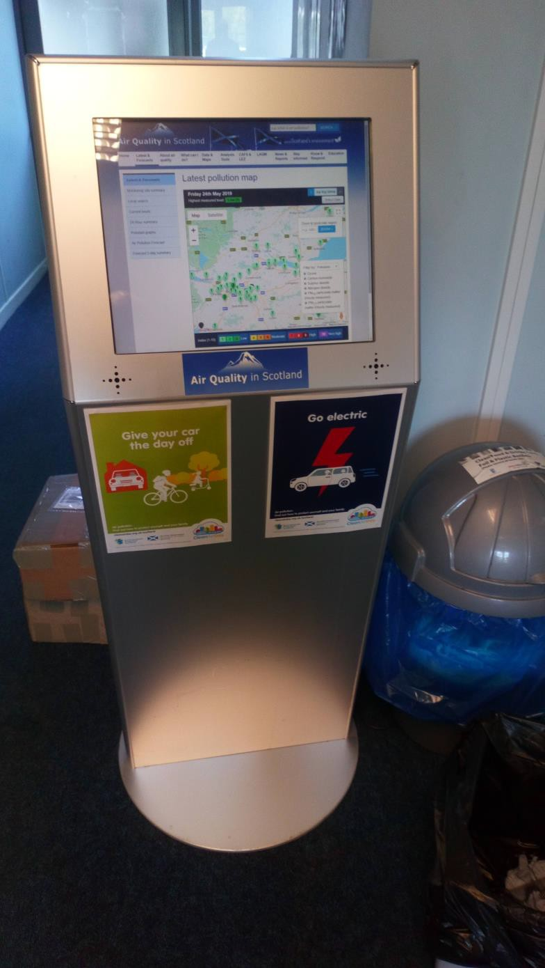

Falkirk Council
Measure 3: Improved Public Air Quality Information (cont.)
All Falkirk Council air quality stations have new mobile phone QR code posters displayed on their external walls for public (air quality specific) information access. The posters have been installed in prominent air quality station locations for ease of information access. See Photo 4 for details.

Photo 4: Falkirk West Bridge St Mobile Phone QR Code Posters
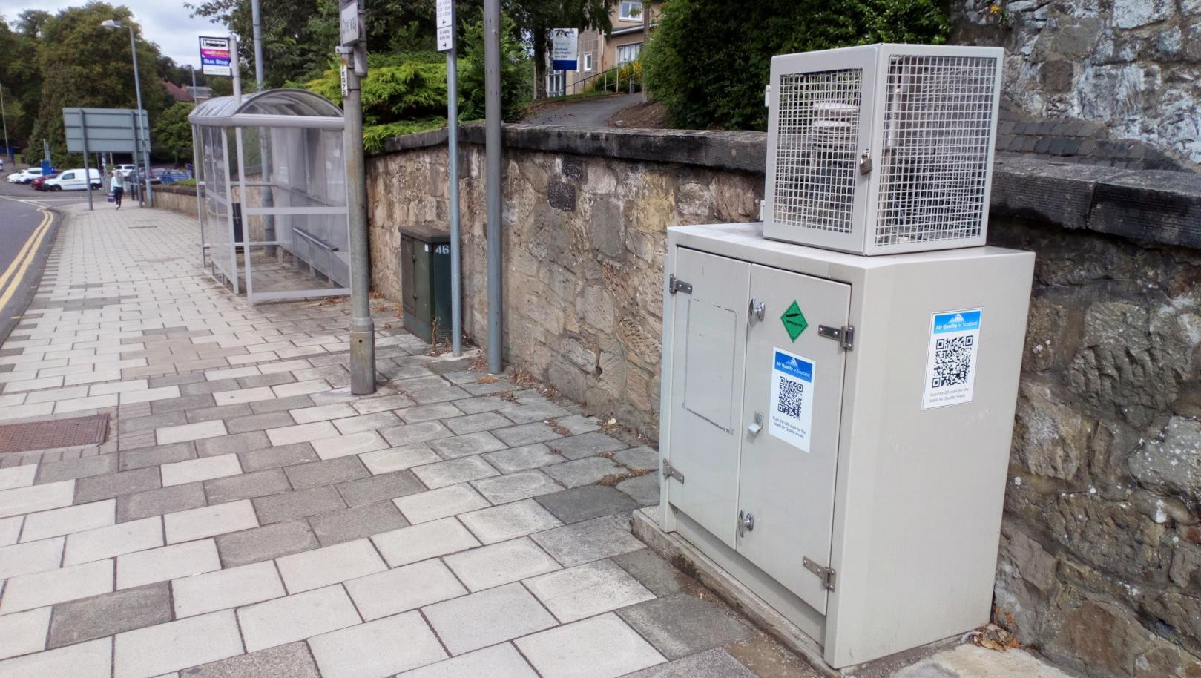

Measure 5: Electric Vehicles (EV) and Plug-ins
EV charging points located at Council depots and public places throughout the region can be shown in Table 2.2.

Table 2.2 Electric Vehicle Charging Points at Council Depots / Public Places in the Falkirk Council Area

Location | Type | Number of Bays | Available to the Public?
Municipal Buildings, West Bridge Street, Falkirk FK1 5RS | 2 x 7kW | 4 | No
Abbotsford House, David’s Loan, Falkirk, FK2 7YZ | 1 x 7kW | 2 | No
Dalgrain Depot, McCafferty Way, Grangemouth, FK3 8EB | 1 x 7kW  1 x 50kW | 2  1 | No
Inchyra Depot, Inchyra Road, Grangemouth, FK3 9XB | 2 x 7kW | 4 | No
Larbert Railway Station, Foundry Loan (East), Larbert, FK5 4PJ | 1 x 22kW | 2 | Yes
Grahamston Railway Station, Meeks Road, Falkirk, FK2 7EZ | 1 x 50kW | 2 | Yes
Town House Street, Denny, FK6 5DX | 1 x 22kW | 2 | Yes
Union Road Car Park, Grangemouth, FK3 8AB | 1 x 22kW | 2 | Yes
Falkirk Stadium, 4 Stadium Way, Falkirk, FK2 9EE | 2 x 22kW  1 x 50kW | 4  2 | Yes
Davies Row, Denny | 1 x 22kW | 2 | Yes
Herbertshire Castle Park, Dunipace | 1 x 22kW | 2 | Yes
Garrison Place (West),  Falkirk | 1 x 7kW  1 x 50kW | 2  2 | Yes
Grangemouth Sports Complex, Grangemouth | 1 x 22kW | 2 | Yes
Hallam Road, Stenhousemuir | 1 x 22kW | 2 | Yes
James St, Laurieston | 1 x 7kW | 2 | Yes
Meeks Road, Falkirk | 1 x 50kW | 2 | Yes
Melville St, Falkirk | 1 x 22kW  1 x 50kW | 2  2 | Yes
Polmont Station, Polmont | 1 x 22kW | 2 | Yes
Union St, Bo’ness | 1 x 22kW  1 x 50kW | 2  2 | Yes
Mariner Centre, Camelon | 1 x 7kW | 2 | Yes

The EV charge points located throughout the Falkirk Council area can be viewed using the following link:
https://www.chargeyourcar.org.uk/
The following chargepoint locations are planned to be installed for 2019/20 in the Falkirk Council area:

Table 2.3 Electric Vehicle Charging Points Planned in 2019/20

Location | Type | Number  of Bays | Available to  Public?
Forth Valley College, Falkirk | 1 x 22kW | 2 | Yes
Union Road, Grangemouth | 1 x 7kW  1 x 22kW  1 x 50kW | 2  2  2 | Yes
Abbotsgrange Road, Grangemouth | 1 x 22kW  1 x 50kW | 2  2 | Yes
Baird Street, Camelon | 1 x 22kW | 2 | Yes
Seaview Place, Bo’ness | 1 x 22kW | 2 | Yes
Bo’ness Recreation Centre, Bo’ness | 1 x 22kW | 2 | Yes
Falkirk Council will be planning to open a new Low Carbon Vehicle Hub within the grounds of the Falkirk Stadium in October 2019. The hub will provide five 50kW and eight 22kW EV chargers for public use. The hub will utilise a solar photovoltaic (PV) roof to aid the low carbon power generation at the site.
A 50kW charger is also planned to be installed by Falkirk Council at Larbert train station car park in 2019.
Falkirk Council has applied for Transport Scotland's Switched on Towns and Cities Travel Fund which (if approved) will provide additional EV chargepoints throughout the region thus increasing and extending the overall capacity for network users.
The Air Quality team within Falkirk Council Environmental Health department received a new Renault Kangoo ZE fully electric van in June 2019 for LAQM related work. Further details on this EV will be provided in the 2020 APR.

Measure 11: Take the Right Route / Promotion of Alternative Travel
Falkirk Council’s Take the Right Route completed the following local initiatives in 2018:

Abbotshaugh Bridge – Public Opening Event – 19th June 2018
A £842,000 cycle and pedestrian bridge was installed over the River Carron connecting the local communities of Langlees, Bainsford, Carron and Carronshore. The new bridge will also form part of the wider ‘Helix’ path network. The bridge was funded through Falkirk Council, Sustrans and the European Union (EU). A wild flower planting project was completed by four local schools with one hundred and ten pupils planting two hundred and fifty wild flowers near the new bridge. One hundred and twenty green travel maps were issued to participants to make them aware of the local walking and cycling path network.

Community Engagement Project - Maddiston Community Council
Falkirk Council worked with Maddiston Community Council to promote local walking and cycling path networks and highlighting local facilities. Nine granite way markers depicting the scenery of Maddiston were installed March 2018. Five hundred bike lights were issued to those who took part in project. This project helped encourage more walking and cycling for recreation and utility trips in the Maddiston area.

Forth Valley Royal Hospital Cycling Festival
Event to highlight benefits of cycling to visitors and users of the Forth Valley Royal Hospital was completed by Falkirk Council in September 2018. This included led local cycle rides, provision of sustainable travel information and advice including partner working with Forth Environment Link (FEL), the Forestry Commission, Get Out Get Active, Bells on Bikes, Recyke a Bike, Free Wheel and Sustrans.

Measure 12: Bike Hire Scheme
Forth Bike (in conjunction with Forth Environment Link) operates an electric bike hire scheme within the Falkirk and Stirling areas utilising the local path network. The Forth Bike system currently includes over one hundred electric pedal assist ‘Pedelec’ bikes distributed between their four local stations: the Falkirk Wheel, the Helix, Forth Valley Royal Hospital, and the University of Stirling.
The scheme operates using a smart phone app to aid in the selection of the electric bikes from one of the local stations. The user then rents the bike for the amount of time they require for their journey. The bikes can be picked up and dropped off any of the above stations. Further information can be found at: https://www.forthbike.co.uk/. The ‘Pedelec’ bikes can be shown in Photo 5.

Photo 5: Forth Bike ‘Pedelec’ Electric Bike
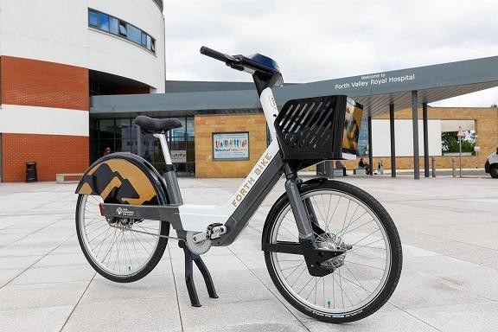

Measure 13: Soft Measures – Increased Falkirk Council Electric Pool Car Fleet
Falkirk Council has significantly increased their EV fleet in 2018. The Council now currently owns:
- Twenty seven electric cars (such as Kia Soul and Renault Zoe models); and
- Eight electric vans (such as Nissan e-NV200 and Renault Kangoo ZE models)
Photo 6 – Example of an EV Kia Soul located at Falkirk Council’s Abbotsford House
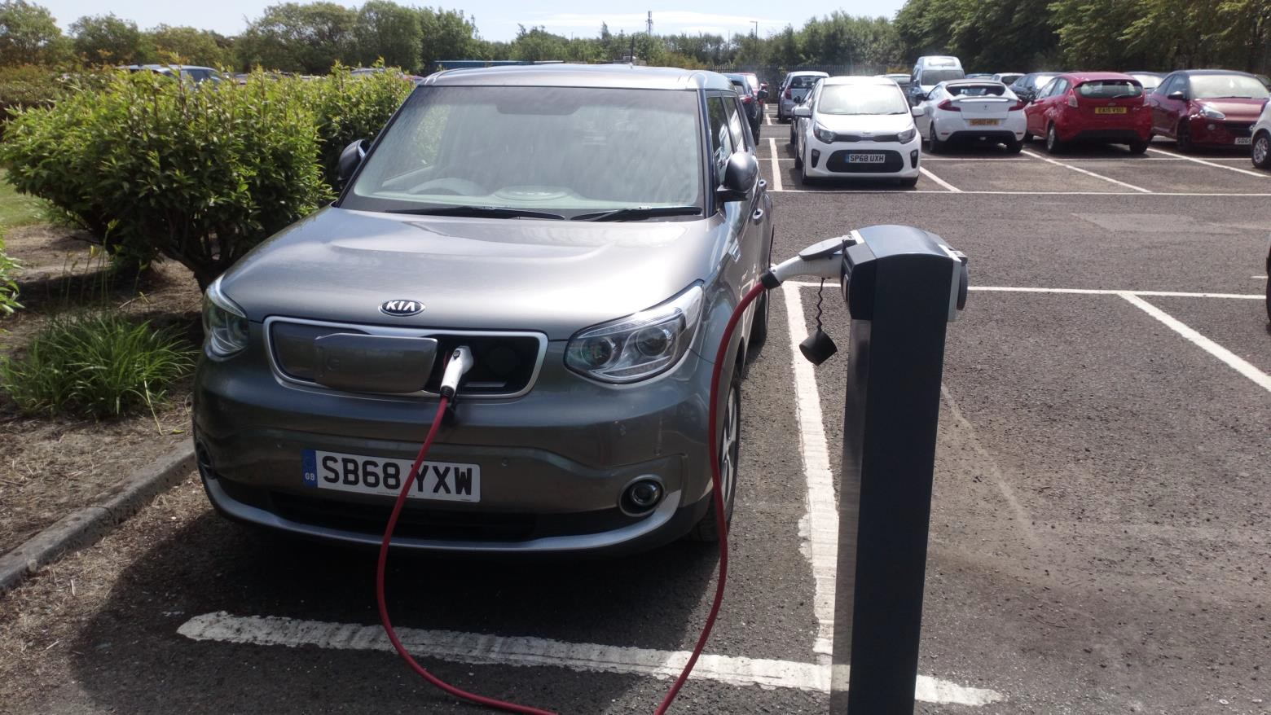

Table 2.4 – Progress on Measures to Improve Air Quality

Meas No. | Measure | Category | Focus | Lead Authority | Plannin  -g Phase | Impleme- ntation Phase | Key Performance Indicator | Target Pollution  Reduction in the AQMA | Progress to Date | Estimated Completio- n Date | Comments
1 | Improving SO2 data access | Public Information | Supplying SO2 monitoring data to SEPA, Petroineos, INEOS and other interested  organisations. | Falkirk Council | 2013 | 2013 | AQ Objectives met in 2013,  2014 and 2015. | Anticipated reduction in SO2 concentration/ breaches of NAQS  objectives. | Data sent after Grangemouth SO2  exceedances- monthly summary  reports sent with ongoing totals. | Completed and ongoing.
2 | Grangemouth Working Group | Policy Guidance and Developmen t Control | Bringing together: Petroineos, INEOS, S.Gov, SEPA  and Falkirk Council. | Falkirk Council | 2013 | 2013 | AQ Objectives met in 2013,  2014 and 2015. | Reduction in SO2 due to cooperative working and agreement of priorities. | Completed.  TGU fully commissioned in August 2013, meeting held in November 2013. Further meeting only if breach of  objective occurs. | Completed.

Meas No. | Measure | Category | Focus | Lead Authority | Plannin  -g Phase | Impleme- ntation Phase | Key Performance Indicator | Target Pollution  Reduction in the AQMA | Progress to Date | Estimated Completio- n Date | Comments
3 | Text Alert System | Public Information | Real-time notification of exceedances by SMS and Email. | Falkirk Council | 2013 | 2013 | Text alerts received by Falkirk Council, SEPA,  Petroineos and INEOS when an NAQS objective exceedance occurs within the Grangemouth AQMA. | Anticipated reduction in SO2 NAQS objective exceedances due to real time alerts of exceedances supplied to SEPA,  Petroineos and INEOS so action to rectify any plant emission / process issues can be addressed. | Completed and on-going. | Completed in 2013 / Upgraded in 2018 | Rather than a text alert system linked to individual analysers this system has been upgraded in 2018 to incorporate the Council’s data collection system and can be used for any  measured pollutant.
4 | Review Monitoring Network | Public Information | Grangemouth Moray SO2 in Scottish Air Quality Network (SAQN).  Monitoring conducted in Grangemouth Zetland Park. | Falkirk Council | Falkirk Park St ceased operation in April 2014.  Zetland Park commen ced operation April 2015. | 2014 and  2015 | All Grangemouth automatic monitoring sites are affiliated with the SAQN. | Affiliation with the SAQN increases data capture allowing better comparison to the NAQS objectives. | Completed.  In addition the Bo’ness, Falkirk Graham’s Rd and Main St, Bainsford stations were affiliated to the SAQN in 2016. | Completed.

Meas No. | Measure | Category | Focus | Lead Authority | Plannin  -g Phase | Impleme- ntation Phase | Key Performance Indicator | Target Pollution  Reduction in the AQMA | Progress to Date | Estimated Completio- n Date | Comments
5 | Electric Vehicles and Plug-ins | Promoting Low Emission Transport | Cars / Fleet | Falkirk Council | 2012 | 2012 and on-going | Charging points at Falkirk Council depots | Anticipated reduction in NOX and PM emissions due to increased use of electric vehicles. | In 2018, the EV charging point bays increased from 27 to 40. These are located at depots and public places across the Falkirk Council area. Falkirk Council also purchased an additional 20 EVs for it’s fleet in 2018 making a total of 27 electric pool cars and 8 electric pool vans available  for use by Council staff. | Completed and on-going | The Air Quality team within the Env. Health Department at Falkirk Council have received a new fully electric Renault Kangoo ZE van in June 2019 –  further details will be provided in the 2020 APR.
6 | Eco-advanced Driver Training | Promoting Low Emission Transport | All types of vehicle, fuel use and emissions | Falkirk Council | 2014 | 2015 | Offered to Council services by fleet | Anticipated reduction in NOX and PM emissions due to promotion of  efficient driving practices. | Offered to Council services by fleet. | Completed and on-going training offered.

Meas No. | Measure | Category | Focus | Lead Authority | Plannin  -g Phase | Impleme- ntation Phase | Key Performance Indicator | Target Pollution  Reduction in the AQMA | Progress to Date | Estimated Completio- n Date | Comments
7 | Review of School Bus Contracts with View to Raising EURO Engine Standards | Vehicle Fleet Efficiency | Buses | Falkirk Council | 2017 | 2020 | n/a | Anticipated reduction in NOX and PM emissions from buses operating within the Falkirk Council area. | Meetings to be arranged in 2019 with Public Transport Co- ordinator and Procurement Services to discuss the feasibility of raising the EURO  standards for local and school bus contracts from 2020  onwards. | 2020
8 | Improvements of Traffic Lights at Bankside | Transport Planning and Infrastructur e | Congestion | Falkirk Council | 2013 | 2014 | n/a | Anticipated reduction in NOX and PM emissions due to traffic queue reduction at  Bankside traffic lights. | Completed. | Completed.
9 | Feasibility Study of Haggs Infrastructure Changes | Transport Planning and Infrastructur e | Congestion | Falkirk Council | Depende nt on develope r contributi ons and planning applicatio  ns. | Dependent on developer contributio ns and planning application s. | n/a. | Anticipated reduction in NOX and PM emissions. | Dependent on developer contributions and planning applications. | Dependent on developer contributions and planning applications. Future action.

Meas No. | Measure | Category | Focus | Lead Authority | Plannin  -g Phase | Impleme- ntation Phase | Key Performance Indicator | Target Pollution  Reduction in the AQMA | Progress to Date | Estimated Completio- n Date | Comments
10 | Feasibility study of West Bridge St and Town Centre Traffic Management Changes (speed limits, TROs etc.) | Transport Planning and Infrastructur e | Congestion | Falkirk Council | n/a | n/a | n/a | Anticipated reduction in NOX and PM emissions. | This measure was linked to a planning application to build new council offices at Falkirk Town Centre Municipal Buildings.  However, this project is still being decided upon. However, traffic signals along West Bridge St have been altered to improve traffic  flows. | Completed
11 | Take the Right Route / Walk to School & School Travel Plan Pack | Promote Travel Alternatives | Car travel | Falkirk Council | 2009 | 2013 and ongoing | Scheme in place and publicly advertised on Falkirk Council website. | Anticipated reduction in NOX and PM emissions due to an increase in green travel such as walking and cycling. | In 2018 Take the Right Route continually promoted across the Falkirk Council area with on street interviews, online campaigns, bus and newspaper advertising and leaflets  distributed. | Completed and on- going.

Meas No. | Measure | Category | Focus | Lead Authority | Plannin  -g Phase | Impleme- ntation Phase | Key Performance Indicator | Target Pollution  Reduction in the AQMA | Progress to Date | Estimated Completio- n Date | Comments
12 | Bike Hire Scheme | Promote Travel Alternatives | Mode transfer | Falkirk Council | 2016 | 2018 | Unknown | Anticipated reduction in NO_{X} and PM emissions due to an increase in green travel alternatives. | Forth Bike (in conjunction with Forth Environment Link) operates an electric bike hire scheme within the Falkirk and Stirling area The Forth Bike system currently includes over one hundred electric pedal assist (Pedelec) bikes spread between their four local stations: the Falkirk Wheel, the Helix, Forth Valley Royal Hospital, and University of  Stirling. | Completed. Forth Bike scheme established and running in 2018.  Expansion of the scheme expected in future years.

Meas No. | Measure | Category | Focus | Lead Authority | Plannin  -g Phase | Impleme- ntation Phase | Key Performance Indicator | Target Pollution  Reduction in the AQMA | Progress to Date | Estimated Completio- n Date | Comments
13 | Soft Measures  e.g. travel planning (larger employers, schools), journey sharing, changes to mileage, home and mobile working. | Promote Travel Alternatives | Variety | Falkirk Council | 2006 | 2014 | Development of Travel Plans | Anticipated reduction in NOX and PM emissions due to promotion of travel alternatives. | Increased fuel efficient and electric pool car vehicles for staff use as part of Council’s travel plan  Operational car sharing database for  Falkirk Council area. | On-going
14 | Consideration of Air Quality in Local  Development Plan | Policy Guidance and  Developmen t Control | Development | Falkirk Council | 2015 | 2015 | Air quality policy statement in local  development plan | Air Quality Assessment required for  developments within AQMAs. | Air quality policy statement in plan. | Completed
15 | Appropriate Air Quality Monitoring in AQMAs. | Public Information | Improving data capture. | Falkirk Council | 2005 | 2005 | Good data capture (90%) in AQMAs | Good data capture will allow strict comparison of PM10, PM2.5, SO2, NOX  concentrations against the NAQS  objectives. | Monitoring maintained in AQMAs.  Equipment upgrades completed during 2018. | Completed and on-going

Meas No. | Measure | Category | Focus | Lead Authority | Plannin  -g Phase | Impleme- ntation Phase | Key Performance Indicator | Target Pollution  Reduction in the AQMA | Progress to Date | Estimated Completio- n Date | Comments
16 | Promotion of ECO Stars | Vehicle Fleet Efficiency | Commercial vehicles, taxis and private hire cars. | Falkirk Council | 2013 | 2013 and on-going | The latest Falkirk Eco Stars report shows that recruitment in Falkirk is over target with 84 members operating 4060 vehicles | Anticipated reduction in NOX and PM emissions due to promotion of efficient driving practices. | During 2018, reference to EcoStars is now included in the tender specification for Falkirk Council Adult and Children’s Service passenger transport.  Member meetings were  held regularly during 2018. | On-going
17 | Review of Park and Ride Facilities | Transport Planning and Infrastructur e | Cars | Falkirk Council | 2017 | 2018 | Unknown at time of writing. | Anticipated reduction in NOX and PM emissions. | There is currently no progress in taking forward any new bus park and ride facilities.  However, additional parking has been created at Falkirk High and Larbert train stations to help improve park and ride  facilities. | Completed and on-going

Meas No. | Measure | Category | Focus | Lead Authority | Plannin  -g Phase | Impleme- ntation Phase | Key Performance Indicator | Target Pollution  Reduction in the AQMA | Progress to Date | Estimated Completio- n Date | Comments
18 | Taxi Licensing | Vehicle Fleet Efficiency | Taxis | Falkirk Council | 2013 | 2015 | Increase in taxi services signed up to Eco Stars Scheme. | Anticipated reduction in NOX and PM emissions due to promotion of  efficient driving and vehicles. | Changes to licensing in May 2013 and Eco Stars extended to taxis and private hire cars. | On-going
19 | Vehicle Emissions Partnership (testing and idling) - enforcement and fines rather than raising awareness. | Promoting Low Emission Transport | Cars | Falkirk and other neighbouri ng authorities. | 2012 | 2012 and on-going | Maintain membership of the partnership. | Anticipated reduction in NOX and PM emissions through anti- idling enforcement. | The ESVEP  continues to assist in promoting anti idling in the Falkirk Council area.  Improvements of the associated ‘Switch Off and Breathe’ website have taken place. | On-going subject to annual funding allocation. | 16/06/2019:  Installation of new, more prominent Anti Idling signs on Upper Newmarket Street, Falkirk to remind bus / taxi drivers to minimise idling on this  street.

Meas No. | Measure | Category | Focus | Lead Authority | Plannin  -g Phase | Impleme- ntation Phase | Key Performance Indicator | Target Pollution  Reduction in the AQMA | Progress to Date | Estimated Completio- n Date | Comments
20 | Introduce Quality Bus Corridors | Transport Planning and Infrastructur e | Buses | Falkirk Council | 2017 | On-going depending on funding to complete the scheme. | Unknown | Anticipated reduction in NOX and PM emissions through improved public transport. | The Council has secured areas of land along the A803 Glasgow Road corridor in Camelon. In addition to this the Council has updated the traffic signals on the B902 Grahams Road corridor to “intelligent” traffic signals which better manage the flows of traffic increasing green time along the main corridor, the knock on effect of this improves bus journey times  into the town centre. | 2030

Cleaner Air for Scotland
Cleaner Air for Scotland – The Road to a Healthier Future (CAFS) is a national cross- government strategy that sets out how the Scottish Government and its partner organisations propose to reduce air pollution to protect human health and fulfil Scotland’s legal responsibilities as soon as possible. A series of actions across a range of policy areas are outlined, a summary of which is available at https://www.gov.scot/Publications/2015/11/5671/17. Progress by Falkirk Council against relevant actions within this strategy is demonstrated below.

Transport – Avoiding travel – T1
All local authorities should ensure that they have a corporate travel plan (perhaps within a carbon management plan) which is consistent with any local air quality action plan. Falkirk Council has a local transport strategy published in 2014 entitled Falkirk Council Local Transport Strategy. This strategy sets out the Council’s overall transport vision. This includes objectives directly related to providing sustainable transport options such as encouraging more travel by foot / bicycle / rail, and ensuring new transport infrastructure is delivered to support sustainable travel choices.
Falkirk Council has an active travel scheme which promotes alternative transport methods to car. Projects completed with local communities in 2018 include:
      - Take the Right Route: utilising online marketing campaigns, extensive local bus / newspaper / business advertising, social media presence with market research feedback concluded;
      - Provision of public static bike pumps: five static bike pumps installed at following locations: Helix Plaza, Kelpies Visitor Centre, Falkirk Town Centre, Stenhousemuir Town Centre, and Bo’ness Town Centre;
      - Local School Travel Plans: Four schools identified for ‘Daily Mile Tracks’: Shieldhill Primary, Avonbridge Primary, California Primary and Drumbowie Primary. ‘Daily Mile Tracks’ delivered to encourage walking as part of the school day;
      - Kelpies to Kick Off: Community walking event that takes participants around Helix Park / Kelpies and finishes at Falkirk Football Stadium. Participants get

a free ticket and pie voucher for the Falkirk football match, which starts at 3pm on the day;
      - Falkirk Active Travel Hub (Forth Environment Link) is located in Falkirk town centre and is open to the public to increase awareness of active travel throughout the region, more information can be found using the above link.

Climate Change – Effective co-ordination of climate change and air quality policies to deliver co-benefits – CC2
Scottish Government expects any Scottish local authority which has or is currently developing a Sustainable Energy Action Plan to ensure that air quality considerations are covered. Falkirk Council has a Sustainable Development and Climate Change Strategy 2012 - 2017. The strategy refers to air quality considerations throughout the document. Plans are being made by the Council to update this strategy in 2019.

Air Quality Monitoring Data and Comparison with Air Quality Objectives

Summary of Monitoring Undertaken

Automatic Monitoring Sites
This section sets out what monitoring has been completed and how local concentrations of the main air pollutants compare with the NAQS objectives.
Falkirk Council undertook automatic (continuous) monitoring at twelve sites during 2018. Table A.1 in Appendix A shows the details of the sites. National air quality monitoring results are available at http://www.scottishairquality.scot/.
Maps showing the location of the air quality monitoring sites are provided in Appendix A, Figure 26. Further details on how the analysers are calibrated and how data has been adjusted are included in Appendix C.

Non-Automatic Monitoring Sites
Falkirk Council undertook non-automatic (passive) monitoring of NO₂ at sixty one sites during 2018. Table A.2 in Appendix A shows the details of the NO₂ sites.
Falkirk Council also undertook non-automatic (passive) monitoring of 1, 3 butadiene at three sites during 2018. Table A.9 in Appendix A shows the details of the 1, 3 butadiene sites.
In addition, Falkirk Council also undertook non-automatic (passive) monitoring of benzene at sixteen sites during 2018. Table A.10 in Appendix A shows the details of the benzene sites.
Further details on Quality Assurance / Quality Control (QA/QC) and bias adjustment for the NO₂ diffusion tubes are included in Appendix C.

Individual pollutants
The air quality monitoring results presented in this section are, where relevant, adjusted for annualisation and bias. Further details on data adjustments are provided in Appendix C.

Nitrogen Dioxide (NO₂)
Table A.3 in Appendix A compares the ratified and adjusted monitored NO₂ annual mean concentrations for the past five years with the NAQS objective of 40µg/m³.

For NO₂ diffusion tubes, the full 2018 dataset of monthly mean values are provided in Appendix B.
Table A.4 in Appendix A compares the ratified continuous monitored NO₂ hourly mean concentrations for the past five years with the NAQS objective of 200µg/m³, not to be exceeded more than eighteen times per year.
NO₂ Automatic Analyser Fixed Station Results
The 2018 monitoring results (as displayed in Tables A.3 and A.4) show that all seven automatic NO₂ analysers in Falkirk Council’s network met both NO₂ NAQS objectives. The highest NO₂ annual mean result in 2018 was recorded at Falkirk West Bridge St site (39µg/m³) this has increased from 2017’s result (36µg/m³). The lowest result was recorded at the Grangemouth AURN site (14µg/m³) - this has remained at the same concentration as 2017’s result. Overall, most fixed station’s NO₂ concentrations have remained the same as 2017’s results however some sites have seen a marginal increase. The last exceedance in relation to NO₂ annual mean concentration was recorded in 2014 at the Falkirk West Bridge Street site (41µg/m³).
Over a five year period (from 2014 to 2018), five sites have recorded NO₂ concentration reductions: A4 Haggs, A5 Hope St, A7 Falkirk West Bridge St, A8 Grangemouth AURN and A10 Grangemouth Municipal Chambers. Two sites have recorded increased NO₂ concentrations: A9 Grangemouth and A15 Main St, Bainsford.
Long term NO₂ trend graphs are shown in Appendix A, Figures 1 to 7. There is an overall downward trend in NO₂ (annual mean) concentrations at the following sites: A4 Haggs (Figure 1), A5 Falkirk Hope St (Figure 2), A8 Grangemouth AURN (Figure 4) and A10 Grangemouth Municipal Chambers (Figure 6). A7 Falkirk West Bridge Street (Figure 3) trend has largely remained at the same level. A9 Grangemouth Moray (Figure 5) and A15 Main St, Bainsford show an overall upward increase in NO₂ (annual mean) concentrations.
Likely contributing factors to the reduction in NO₂ concentrations at the above sites include traffic light timing amendments (on Falkirk West Bridge Street) to minimise congestion and idling, road upgrades (M80 at Haggs) and speed limit enforcement measures (30mph on A803). Increased ownership of hybrid and electric vehicle may also have contributed to the overall NO₂ reduction. Likely contributing factors to the

increase in NO₂ at A9 Grangemouth Moray would be localised roadworks and frequent use of the car parks at the local schools near the monitoring station. At A15 Main St, Bainsford localised roadworks associated with increased building developments may have caused the increase in overall NO₂ concentrations.
Annual NO₂ Diffusion Tube Results
The 2018 annual NO₂ diffusion tube monitoring results (as displayed in Table A.3) show that one (non-automatic) NO₂ tube exceeded the NAQS objective of 40µg/m³ at NA27 Falkirk West Bridge Street. The remaining sixty tubes in Falkirk Council’s network met the objective.
Three diffusion tubes were close to the 40µg/m³ annual limit with the highest concentrations recorded at the following sites: NA36 Kerr Crescent, Haggs, NA111 Falkirk West Bridge Street Air Quality Station and NA114 Glasgow Rd, Camelon. These tubes are all located at roadside locations, two of which are located within AQMAs (NA36 Haggs AQMA and NA111 Falkirk Town Centre AQMA).
Diffusion tube NA27 is colocated with the Falkirk West Bridge Street fixed monitoring station. This site contains an automatic NO₂ reference method (API Teledyne T200 – Chemiluminescence) analyser which has recorded an annual NO₂ concentration of 39µg/m³ during 2018 which is comparable and representative (within the NAQS objective limit).
Historically, diffusion tube NA27 Falkirk West Bridge Street records a higher concentration than the automatic analyser despite the close proximity to one another. The most likely reason for a higher concentration at this location is that the automatic site is located further from the kerb than the NA27 tube and is therefore less exposed to traffic emissions.
The lowest NO₂ annual mean diffusion tube concentrations were recorded at the following locations: NA105 West of Shieldhill (Rural, 8µg/m³) and NA113 Union St, Bo’ness (Urban Background / Industrial, 15µg/m³).
In addition, the diffusion tubes are affected by several sources of interference which can cause substantial under or overestimation (often referred to as “bias”) compared to the automatic chemiluminescence NO₂ reference analyser (defined within the EU as the reference method) ^{ref} ¹. Due to this, NO₂ concentrations recorded using

diffusion tubes are typically of lower accuracy than that recorded by reference method using automatic (chemiluminescence) NO₂ analysers.

Particulate Matter (PM₁₀)
Table A.5 in Appendix A compares the ratified and adjusted monitored PM₁₀ annual mean concentrations for the past five years with the NAQS objective of 18µg/m³.
Table A.6 in Appendix A compares the ratified continuous monitored PM₁₀ daily mean concentrations for the past five years with the NAQS objective of 50µg/m³, not to be exceeded more than seven times per year.
Falkirk Council measured PM₁₀ concentrations at eight locations during 2018. The Scottish NAQS objectives for PM₁₀ were met at all eight locations. The PM₁₀ (R&P 1400 TEOM) analyser that was located at the Falkirk Grahams Road site was transferred to the nearby Falkirk Hope Street site on 10th October 2018. It was decided that the PM₁₀ monitoring location was more prominent and effective if housed within the nearby Falkirk Hope St site. The Falkirk Grahams Road roadside site was subsequently decommissioned and removed from street level on 11th March 2019.
The site with the highest recorded annual mean PM₁₀ concentration in 2018 (but within the Scottish NAQS PM₁₀ objective) was A4 Falkirk Haggs (Roadside, 14µg/m³). Data capture was reasonable for this site at 89%.
The two sites with the lowest annual mean PM₁₀ concentrations were: A7 Falkirk West Bridge Street (Roadside, 6µg/m³) and A14 Banknock 3 (Urban Background, 6.9µg/m³). Data capture rate was poor at the Falkirk West Bridge Street site at 67% and reasonable for the Banknock 3 site at 80%.
Over a five year period (from 2014 to 2018), all eight sites have recorded PM₁₀ (annual mean) reductions. A selection of long-term trend graphs which show these PM₁₀ reductions can be shown in Appendix A, Figures 8 to 13.
The A14 Banknock 3 monitoring site recorded the greatest number of daily exceedances (2) which is a marginal increase from 2017’s result of none. Further investigation into the daily exceedances of the 24-hr Scottish NAQS objective indicated that localised garden maintenance activities were the likely cause. The full results are shown in Appendix A, Table A.6.

Over a five year period (from 2014 to 2018), three sites have recorded PM₁₀ (24-hr mean) reductions: A4 Falkirk Haggs (Roadside), A7 Falkirk West Bridge Street (Roadside) and A13 Banknock 2 (Roadside). One site recorded increased PM₁₀ (24- hr mean) result: A14 Banknock 3 (Urban Background). Four sites have remained at the same PM₁₀ (24-hr mean) concentration: A8 Grangemouth AURN (Urban Background / Industrial), A10 Grangemouth Municipal Chambers (Urban Background
/ Industrial), A12 Falkirk Grahams Road (Roadside) and A15 Main Street, Bainsford (Roadside).

Particulate Matter (PM_{2.5})
Table A.7 in Appendix A compares the ratified and adjusted monitored PM_{2.5} annual mean concentrations for the past five years with the Scottish NAQS objective of 10µg/m³.
PM_{2.5} is measured at three locations within the Falkirk Council area, these are: A7 Falkirk West Bridge Street (Roadside), A8 Grangemouth AURN (Urban Background / Industrial) and A13 Banknock 2 (Roadside).
During 2018 there were no exceedances of the PM_{2.5} Scottish NAQS objective (10µg/m³) at any of the three monitoring sites.
Two sites (A7 Falkirk West Bridge St and A13 Banknock 2) recorded the same annual mean PM_{2.5} concentration (6µg/m³). The A8 Grangemouth AURN site recorded a concentration of 7µg/m³. Data capture was good for the A8 Grangemouth AURN (92%) and A13 Banknock 2 (99%) sites but poor for the A7 Falkirk West Bridge Street (67%) site.
The PM_{2.5} concentrations at the Grangemouth AURN site have gradually reduced from 9.2µg/m³ in 2015 to 6µg/m³ in 2016 and 2017. 2018 saw a marginal concentration increase to 7µg/m³ however this concentration remains reasonably low and within the Scottish NAQS objective. This reduction may be may be attributed to the commissioning of the tail gas treatment (TGT) unit at the INEOS Grangemouth complex in 2013. Since the commissioning of the TGT unit, SO₂ concentrations have reduced within the Grangemouth AQMA. As sulphate species are known to contribute towards the formation of secondary PM_{2.5}, a reduction in SO₂ could also impact local PM_{2.5} concentrations.

Long-term trend analysis has been completed on all three sites for PM_{2.5} and can be shown in Appendix A, Figures 14 to 16. In general terms, there has been a long-term reduction in PM_{2.5} concentrations at the Grangemouth AURN site since 2014 however, concentrations have remained stable at 6µg/m³ for the A7 Falkirk West Bridge Street and A13 Banknock 2 sites since they were commissioned (2015 onwards).
To appraise compliance with the new PM_{2.5} objective at locations that currently do not monitor PM_{2.5} concentrations, Falkirk Council has applied locally derived correction factors of 1 (urban roadside), 0.58 (urban background / industrial) and 0.55 (non- urban roadside) following guidance set out in LAQM TG (16)^{Ref1}. This methodology provides an estimation of PM_{2.5} data from PM₁₀ data where only one of the two metrics were available. For urban roadside sites the correction factor was derived using PM data from the A7 Falkirk West Bridge Street site, for the background / industrial sites the factor was derived using PM data from the A8 Grangemouth AURN site and for non-urban roadside sites the correction factor was derived using PM data from the A13 Banknock 2 site. For further details of these factors see Appendix C, Table C.1.
The PM_{2.5} estimations indicate that all five sites where the correction factor was applied met the PM_{2.5} annual mean objective in 2017. A10 Grangemouth Municipal Chambers recorded the highest estimated annual PM_{2.5} concentration of 8µg/m³. A15 Main Street, Bainsford recorded the second highest estimated annual concentration of 7.8µg/m³. See Appendix A, Table A.12 for a full comparison of estimated PM_{2.5} annual mean concentrations against the NAQS objective.
The PM_{2.5} estimations indicate that two sites: A5 Falkirk Hope Street (11µg/m³) and A15 Main Street, Bainsford (12µg/m³) exceeded the NAQS objective limit of 10µg/m³. Data capture was poor for the A15 Main Street, Bainsford site at 70%. Data capture was 20% for A5 Falkirk Hope Street however, the analyser was installed at this site (from the nearby A12 Falkirk Grahams Rd site) on 10th October 2018 so this low data capture rate was expected.
The remaining three monitoring sites where the PM_{2.5} correction factor was applied met the NAQS objective in 2018. See Appendix A, Table A12 in for full comparison of estimated PM_{2.5} annual mean concentrations against the Scottish NAQS objective.

Sulphur Dioxide (SO₂)
Appendix A, Table A8 compares the ratified continuous monitored SO₂ concentrations for 2018 with the NAQS objectives for SO₂.
In 2018, Falkirk Council monitored SO₂ at six locations. Four of the sites are located within the Grangemouth (15-minute NAQS objective) AQMA and two of the sites are located outwith the AQMA.
There were no exceedances of the SO₂ objectives (15-minute, hourly or daily) recorded at any of the Falkirk Council monitoring locations during 2018.
The site recording the only exceedance of the 15-minute NAQS objective during 2018 was at A9 Grangemouth Moray (1). No other SO₂ exceedances were recorded at any of the other sites during 2018.
This is the fifth consecutive year that no breaches of the SO₂ NAQS objectives (15- minute, hourly or daily) have been recorded at any site in the Grangemouth AQMA. It is important to stress that although there was an exceedance of the 15-minute NAQS objective, the number of exceedances were below the maximum permitted.
The Grangemouth Emission Study 2018 / 19 which has been contracted to Sweco is currently being prepared and expected to be published in late 2019. The study will include an assessment of the Grangemouth AQMA within this report.
Polar roses for the Grangemouth sites are shown in Appendix A, Figure 23, A) to F).

Carbon Monoxide, Lead and 1, 3-Butadiene Carbon Monoxide

No monitoring undertaken.

Lead

No monitoring undertaken.

1, 3-Butadiene

In 2018, Falkirk Council monitored 1, 3-butadiene at three locations using passive diffusion tubes. All the results were within the NAQS objective and are shown in Appendix A, Table A.9. No changes have occurred since the submission of the previous APR.

Benzene

In 2018, Falkirk Council monitored benzene at sixteen locations using passive diffusion tubes. In addition, at the A8 Grangemouth AURN site, a pumped diffusion tube operates as part of the AURN network. The results from the passive diffusion tubes are shown in Appendix A, Table A.10 with the pumped diffusion tube results shown in Table A.11 in Appendix A.
All the benzene concentrations recorded by the passive diffusion tubes were within the NAQS objectives. Seven of the sixteen benzene diffusion tubes achieved 100% data capture (NA27, NA37, NA41, NA42, NA44, NA57 and NA80), five tubes achieving 91% (NA3, NA21, NA38, NA81 and NA94), and three achieving 83% (NA55, NA77 and NA105).
In 2018, the pumped diffusion tube at the A8 Grangemouth AURN site recorded an annual average concentration of 0.74µg/m³. The concentration recorded continues to be within the relevant annual mean NAQS objective (of 3.25µg/m³) and is a slight increase (of 0.09µg/m³) compared to 2017’s result (0.65µg/m³).

New Local Developments

Road Traffic Sources

    - Narrow Congested Streets
There have been no changes from last year’s APR. There are no new locations that are likely to be congested residential streets that have not been considered before or are not already in AQMAs.

Busy Streets
Falkirk Council has not identified any streets where pedestrians may spend one hour or more in close proximity to road traffic.
For info: the Falkirk Council automatic monitoring network recorded no exceedances of the hourly NO₂ NAQS objective concentration and there was one exceedance of the NO₂ non-automatic diffusion tube NAQS objective concentration of 40µg/m³ at Falkirk West Bridge Street (44µg/m³). The remaining NO₂ non-automatic diffusion tubes (across the Falkirk Council network) recorded 2018 annual concentrations of below 40µg/m³.

Roads with a High Flow or Buses and / or HGVs
Since the closure of the Falkirk town centre bus station, additional buses are using Upper Newmarket Street. In anticipation of this increase in bus traffic, Falkirk Council have supplied additional NO₂ (diffusion tube) monitoring on Glebe St and worked with ECSVEP to locate more prominent anti-idling signs on Upper Newmarket Street.

Junctions
There were no new road junctions constructed during 2018 within the Falkirk Council area.

New Roads Constructed or Proposed
There were no new roads constructed or proposed during 2018 within the Falkirk Council area.

Roads with Significantly Changed Traffic Flows
There were no roads with significantly changed traffic flows during 2018 within the Falkirk Council area.

Bus or Coach Stations
The Falkirk town centre bus station was located adjacent to Meadow Street as indicated using this weblink, the station closed in August 2018 after many years of operation. Bus routes have been diverted via the Upper Newmarket St hub since the closure of the main town centre bus station. There are no new bus or coach stations constructed or planned for the foreseeable future within the Falkirk Council area
Photos of Falkirk Bus Station are shown in Photos 7 and 8.
Photo 7 – Falkirk Bus Station after Closure in August 2018 (1)
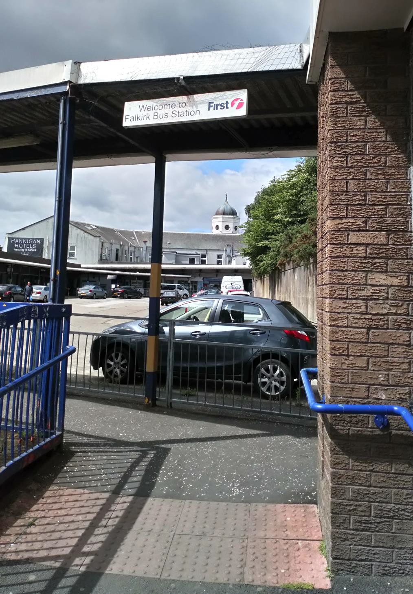

Falkirk Council
Photo 8 – Falkirk Bus Station after Closure in August 2018 (2)
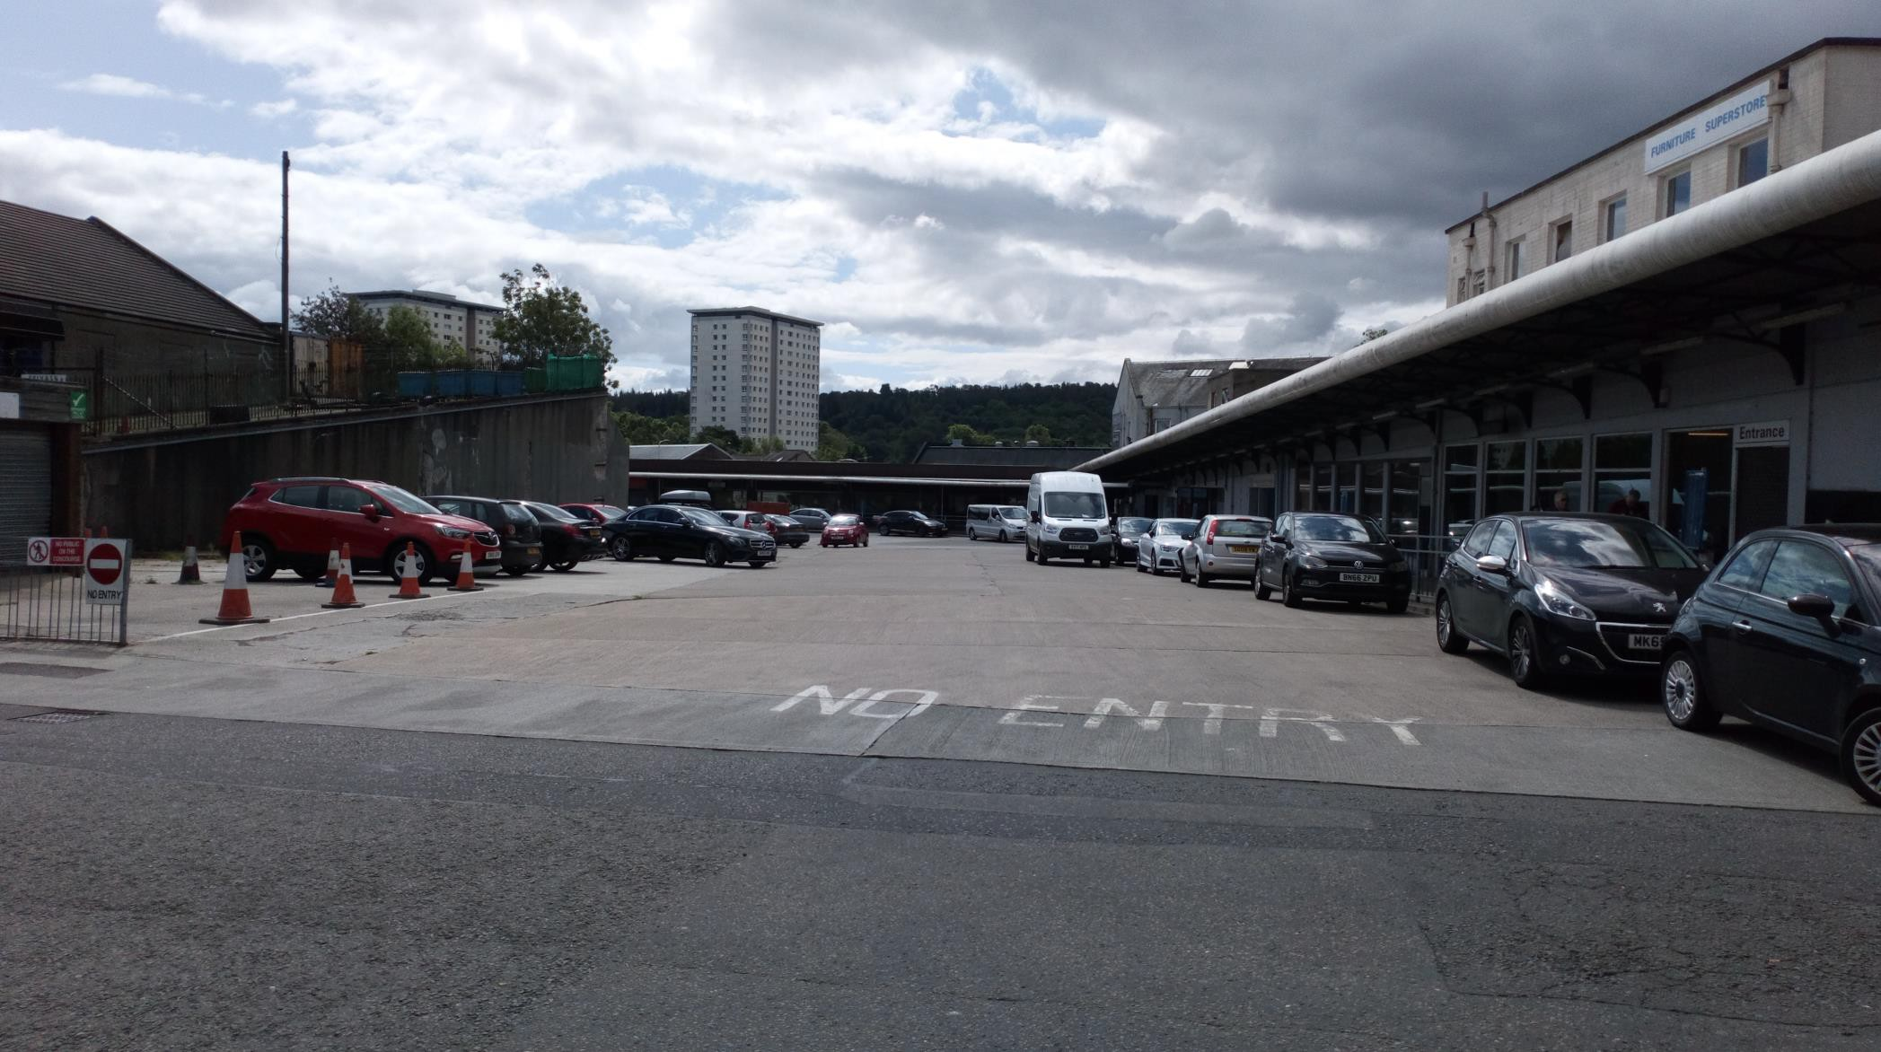

Other Transport Sources
    - Airports
The nearest major airport to the Falkirk Council area is Edinburgh. Airport passenger movements between January 2017 and 2018 have increased by 7.1% from 781,072 in 2017 to 836,943^{Ref} ² in 2018. This airport does not need considering further as it is greater than 1km from the Falkirk Council boundary.
Falkirk Council is not aware of any significant changes to Cumbernauld airport. This is small airport situated near to the Falkirk Council boundary.
No other new airports are constructed or planned for the foreseeable future.

Stationary trains
Falkirk Council has not identified any new locations where locomotives or trains are stationary for more than 15-minutes that would not have been assessed in previous APRs.

Railways (diesel and steam trains)
Falkirk Council confirms that there are no new locations with a large number of movements of diesel locomotives, and potential long-term relevant exposure within 30m.

Ports for Shipping
Falkirk Council confirms that there are no ports or shipping that requires further consideration. The Grangemouth Port is the nearest major port within Falkirk Council area and this has been operating for many years.

Industrial Sources
Industrial Installations – New / Proposed Installations

New KG Plant Extension (Furnace 10) – Ineos Chemicals Grangemouth Ltd. During October 2017, Falkirk Council received a planning application for a proposed development of installing a new, tenth furnace (similar to the nine existing furnaces onsite) at Ineos Chemicals Grangemouth complex. The additional furnace is required to extend the processing capability of the existing KG Plant. As described in the associated Jacobs Supporting Environmental Appraisal Document:
‘This development would increase stack extensions to three of the adjacent furnaces to the proposed new furnace. Furnace ten will be sited adjacent to the most southerly side of the existing bank of furnaces that make up the KG Plant. The requirement for the Proposed Development is to compensate for the reduced availability of the existing units and allow the production of ethylene to return to the site’s nameplate production rate.’
As stated in Section 3.2.7 of the Jacobs – Supporting Environmental Appraisal Document:
‘No net increase in air emissions is anticipated as a result of the Proposed Development. The combination of the extended stack height of the Proposed Development along with the extension of stacks belonging to three existing furnaces is expected to result in greater overall dispersion of pollutants, resulting in a reduction in the potential for ground level pollutant concentrations and an overall improvement in local air quality.’
As noted in section 3.2, the proposed development is located within the Grangemouth AQMA and adjacent areas, declared for exceedances of the SO₂ 15- min mean NAQS objective.
In accordance with Falkirk Council’s Local Development Plan Policy RW07 ‘Air Quality’, the Supporting Environmental Appraisal assesses the potential impacts of this development on the AQMA and the wider environment.
The Supporting Environmental Appraisal concludes that the additional KG Furnace would have no net increase in air emissions as a result of the Proposed Development. As stated within section 3.2.7 ‘The combination of the extended stack height of the Proposed Development along with the extension of stacks belonging to

three existing furnaces is expected to result in greater overall dispersion of pollutants, resulting in a reduction in the potential for ground level pollutant concentrations and an overall improvement in local air quality.’
The operation of the plant falls within the remit of the Pollution Prevention and Control (PPC) (Scotland) regulations and will require a variation of the existing PPC Part A permit which SEPA will have responsibility for.
Within section 3.2.5 of the Supporting Environmental Appraisal states that the “level of risk due to emissions of dust during the construction phase is negligible and no further assessment is required”. The appraisal document recommends that Ineos Chemicals Grangemouth Limited adopt best practice and follow recommended Institute of Air Quality Management (IAQM) mitigation measures during the construction phase. If any dust complaints are received within this area during the planned works Falkirk Council would have an obligation to investigate and ensure the mitigation measures are being followed.

New Small-Scale Gas Peaking Plant, Caledon Green, Grangemouth – Forsa Energy
During August 2018, Falkirk Council received a planning application for a proposed gas peaking plant comprising of ten container units, each of which contains a gas engine and electricity generator. The proposed site is located adjacent to Caledon Green in Grangemouth. The intention of the proposed development is to export electricity to the local electrical grid at times of peak demand or when the grid requires various forms of electrical support.
The air quality report was submitted to Falkirk Council to provide an assessment of potential air quality impacts of emissions of nitrogen from the operation of the proposed development. The proposed development is located within the Grangemouth AQMA (declared for SO₂ 15-min mean). The air quality assessment report was completed by Arcus Consultancy Services on behalf of Forsa Energy.
The report states that in relation to the proposed development the baseline air quality is substantially below the NAQS objectives in the absence of the development, and remains so with the development included. The long term impacts at the six assessed receptors have been assessed as negligible. The short-term impacts at

three of the assessed receptors are moderate, two are slight and one receptor is negligible.
Overall, a scenario assuming operation of the development for 3,000 hours per year has been used to predict worst case concentrations of NO₂ at the nearest receptor locations. The report concludes that after adding background concentrations of NO₂ to the dispersed emissions from the proposed development and from the nearby M9 and A905 roads the total concentrations of NO₂ at the worst case receptor (21 Stuart Grove, Grangemouth) would comply with short-term and long-term NAQS objectives. The proposed development will be designed and operate with the new requirements of the Medium Combustion Plant Directive (MCPD).
Since the publication of the air quality assessment, a consultation between Arcus, SEPA and Falkirk Council on the suitability of dispersion of emissions and relevant stack height have taken place. A further assessment report is due to be issued in 2019.

Commercial and Domestic Sources
    - Biomass Combustion Plants
Proposed Renewable Energy Plant – Grangemouth Renewable Energy Plant, Port of Grangemouth – Forth Energy – Air Quality Assessment – June 2018
Falkirk Council received an air quality assessment for a proposed commercial development of Grangemouth Renewable Energy Plant in the Port of Grangemouth via a planning enquiry in June 2018.
The air quality report was submitted to Falkirk Council to provide an assessment of point source emissions of combustion gases from the main and auxiliary boilers, emissions of acidic compounds and nitrogen-containing species from the main and auxiliary boilers, emissions of pollutants from road traffic, dust generated during the construction / decommissioning of the plant and fugitive emissions from the biomass handling / storage areas (dust and odours). The development is proposed to be located within the Grangemouth AQMA (declared for SO₂ 15-min mean). The air quality assessment report was completed by Forth Energy which is a joint venture formed by Scottish and Southern Energy (SSE) and Forth Ports.
The main pollutants that were (long-term) impact assessed within the report included: emissions of nitrogen, carbon monoxide, particulate matter (primarily PM₁₀ and PM_{2.5}), sulphur dioxide as well as some trace species (such as metals and volatile organic compounds). The shorter term impacts associated with emissions of particulate matter from the proposed development’s construction and decommissioning have been assessed against the current legislative NAQS objectives.
The air quality assessment concludes by stating that that the proposed biomass plant will incorporate a number of mitigation measures to reduce or remove potential impacts during the construction and operational phases such as suitable dust control and monitoring, the selection of efficient combustion technology, carefully selected stack height and the continuous monitoring of stack emissions. The report states that the impacts of dust generation on sensitive receptors in the area will be minimised and no significant impact is predicted during the construction or decommissioning phases. The potential impact due to road traffic emissions during the construction and operational phases of the biomass plant is forecast not to be significant.

If any dust complaints are received within this area during any of proposed development works Falkirk Council would have an obligation to investigate and ensure the stated mitigation measures are being followed. The operation of the proposed plant will fall within the remit of the Pollution Prevention and Control (PPC) (Scotland) regulations, and would require a permit which SEPA would have responsibility for.

Biomass Combustion Plants – Combined Sources
Falkirk Council has assessed domestic biomass or other fuel burning in previous reports. Falkirk Council has received no significant number of complaints about particular areas in relation to or changes to the following:
      - Complaints about nuisance dust or odour relating to burning;
      - Visual signs of chimney smoke being emitted from several properties in close proximity to each other;
      - Significant odours of burning biomass fuel;
      - Known high levels of sales of biomass or other fuels via home delivery or local outlets;
      - Areas known to have limited or no access to mains gas.

Domestic Solid Fuel Burning
Falkirk Council has assessed domestic solid fuel burning in previous reports and has not identified any new areas that would need consideration.
A map of the smoke control areas in the Falkirk Council area is available to view via Falkirk Council website at: http://www.falkirk.gov.uk/services/environment/environmental-policy/air- quality/smoke-control-areas.aspx

Combined Heat and Power (CHP) Plant
There are no new individual CHP plant installations that require consideration.

New Developments with Fugitive or Uncontrolled Sources
Landfill sites are regulated by SEPA licences and no changes with respect to the pollutants covered in this report have been indicated by SEPA.

Falkirk Council is not aware of any other changes to unmade haulage roads on industrial sites, waste transfer stations or other potential sources of fugitive particulate emissions.

Planning Applications

Proposed Residential Development – Williamson St, Falkirk – Air Quality Assessment – November 2018
Falkirk Council received an air quality assessment for a proposed residential development at Williamson St, Falkirk in November 2018. The proposed development is for the erection of thirty six flatted dwellings (for use as retirement housing) with external courtyards and associated parking provision.
The air quality report was submitted to Falkirk Council to provide an assessment of construction dust and potential traffic impacts of the proposed development. The proposed development is located within the Falkirk AQMA (declared for NO₂ and PM₁₀ annual mean and PM₁₀ 24-hour mean). The air quality assessment report was completed by Surface Property on behalf of Link Group.
The report demonstrates that the construction dust effect will not exceed the NAQS PM₁₀ objective of 18µg/m³. A risk assessment for construction dust effects was also detailed in accordance with Institute of Air Quality Management (IAQM). No significant effects are predicted if the stated best practice mitigation measures are implemented.
The results from the Design Manual for Roads and Bridges (DMRB) assessment (section 5.2) demonstrate that although the development will introduce new receptors to the AQMA this will not result in exposing new residents to poor air quality. The predicted 2023 concentrations of NO₂ and PM₁₀ at the worst case receptor (DMRB R1) with traffic generated from development are predicted to be 26.4% and 54.2% of the NO₂ and PM₁₀ (annual mean) NAQS objectives respectively. It was also stated that NO₂ and PM₁₀ concentrations in 2023 (with the development included) were 2.06µg/m³ and 0.18µg/m³ lower than the 2018 baseline concentrations; this indicated that whilst traffic numbers increased during this period the background concentrations will reduce.
The assessment concludes that the development will have a negligible impact on local air quality.

Proposed Residential Development – Standrigg Road, Wallacestone, Falkirk – Air Quality Assessment – March 2018
Falkirk Council received an air quality assessment for a proposed residential development at Standrigg Road, Wallacestone, Falkirk in March 2018. The proposed development is for the erection of approximately two hundred new dwellings including a site for a local community facility, alongside associated infrastructure and landscaping.
The air quality report was submitted to Falkirk Council to provide an assessment of construction dust and potential traffic impacts of the development. The development is located out with any Falkirk Council AQMA (the nearest being the Grangemouth AQMA approximately 3km east of the proposed development). The air quality assessment report was completed by REC on behalf of Persimmon Homes Limited.
The report assesses the construction phase air quality impacts from fugitive dust emissions. The report states that the ‘use of good practice control measures would provide suitable mitigation for a development of this size and nature and reduce potential impacts to an acceptable level.’
The report states that dispersion modelling was utilised to quantify existing pollutant concentrations at the site and predict air quality impacts as a result of road vehicle exhaust emissions associated with traffic generated by the development. The results indicated that pollutant levels across the site were below relevant air quality standards. The assessment concluded that overall impact on pollutant levels as a result of operational phase vehicle emissions were predicted to be not significant at any sensitive location in the vicinity of the site.

Proposed Residential Development – Garngrew Road, Banknock– Air Quality Assessment – June 2018
Falkirk Council received an air quality assessment for a proposed residential development at Garngrew Road, Banknock via a planning enquiry in June 2018. The proposed development is for the erection of approximately forty new dwellings alongside associated infrastructure.
The air quality report was submitted to Falkirk Council to provide an assessment of potential traffic impacts of the development. The development is partially located

within the Banknock AQMA. The air quality assessment report was completed by Energised Environments on behalf of S. Brown Builders.
The report states that the main aim of the assessment is to consider existing air quality on the site, particularly in the context of the existing AQMA and emissions from road traffic on the M80 – the assessment considers emissions of NO₂ and PM₁₀ as the principal emissions from road traffic.
The report states that dispersion modelling study was undertaken to predict air quality concentrations across the development site. These predictions indicated that NO₂ and PM₁₀ concentrations on the western portion of the site near the M80 are higher than the eastern portion of the site. Predicted concentrations across all parts of the site are below NAQS objectives for both NO₂ and PM₁₀ based on a minimum stand-off distance of 15m from the motorway.
The reports concludes that ‘the levels of traffic generated by the site will be directly proportional to the number of houses in the development, however it is considered unlikely that traffic levels, and the resulting emissions, will be at a level likely to cause adverse effect to local air quality.’

Proposed Commercial Development – Rosebank Distillery, Falkirk – Air Quality Assessment – August 2018
Falkirk Council received an air quality assessment for a proposed commercial development at the former Rosebank Distillery in Falkirk via a planning enquiry in August 2018. The proposed development is for a new distillery within the area of the former Rosebank distillery.
The air quality report was submitted to Falkirk Council to provide an assessment of air quality impacts from construction activities, post development changes to road traffic and the new boiler plant within the development. The proposed development is not located within any Falkirk Council AQMA – the closest being the Falkirk town centre AQMA (approx. distance 340m east of site). The air quality assessment report was completed by ITP Energised on behalf of Blyth and Blyth Consulting Engineers.
The report states that the number of heavy (construction) goods vehicle movements associated with the development will vary on a daily basis; however the maximum number of movements is expected to be less than one hundred per day during the construction period. This is lower than the IAQM guidance criteria to establish the

need for an air quality assessment for the construction phase traffic. The effect on local air quality at sensitive receptors has been assessed as not significant.
Construction phase fugitive emissions have been assessed for the following development activities: demolition work, earthworks, construction and transfer of dust-making materials from the site onto the local road network. The full dust assessment (including PM₁₀ short term 24hr mean NAQS objective) in accordance with IAQM guidance is presented within the report and concludes that with the implementation of good-practice mitigation measures the residual impact of construction generated dust negligible.
The operational phase of the distillery has been assessed in relation to associated traffic emissions and considers the relevant traffic-related pollutants of interest (NO₂ and PM₁₀). A traffic statement has been included within the report which quantifies the traffic flows as two hundred and twenty four Light Duty Vehicle (LDV) Annual Average Daily Traffic (AADT) movements and twenty two Heavy Duty Vehicle (HDV) AADT movements. This section concludes by stating that when the projected traffic flows are considered in conjunction with locally measured NO₂ and PM₁₀ concentrations it is considered unlikely that the proposed development will have no significant adverse effect on local air quality.
The proposed distillery’s new boiler plant will captured under the Medium Combustion Plant Directive (MCPD) as the thermal input will be above 1 MW_{th} which is regulated by SEPA. The air quality impact at all sensitive receptors for long and short term exposure to NO₂ concentrations from boiler operation has been assessed as negligible / not significant.
The report concludes that proposed development will therefore not result in any significant adverse impacts to local air quality.

5.4 Proposed Construction Project – Grangemouth Flood Protection Scheme (Piled Viaduct on Kincardine Bridge Refurb) – EIA Scoping Report – Air Quality and Climate – July 2018
Falkirk Council received an Environmental Impact Assessment (EIA) report in July 2018 with an air quality and climate section for a proposed construction project of a piled viaduct as part of the Kincardine Bridge refurbishment. The proposed works are detailed within the Grangemouth Flood Prevention Scheme (FPS): EIA Scoping Report. The EIA report was submitted to Falkirk Council to provide an assessment of

air quality and climate change impacts from the emissions of dust and vehicles during the construction phase of the scheme. The proposed development is partially located within the Grangemouth AQMA and within approx. 1.5km of the Falkirk Town Centre AQMA. The EIA scoping report was completed by Jacobs on behalf of Transport Scotland.
The construction phase of the FPS will include various activities and the potential effects have been assessed with the EIA scoping report which follows stated EPUK guidance. The main construction activities generate and deposit dust (PM₁₀ fraction stated) closer to their sources. It is acknowledged that dust deposition onto nearby properties can lead to complaints, may constitute a statutory notice as well as permanent ecological and adverse human health effects.
Construction impacts were assessed by following the stated IAQM guidance. The guidance on the assessment of dust from construction and demolition activities uses the most recent publication stated and guidance provided in the DMRB HA207/07.
It is anticipated that the works will not change the traffic flow, speed or composition of vehicles on the road network so the (vehicle emissions) pollution contribution will not change.
The proposed scheme is also unlikely to change any human receptors location in relation to the works so the effect during operation is negligible.

Conclusions and Proposed Actions

Conclusions from New Monitoring Data
Falkirk Council has assessed its automatic and non-automatic 2018 monitoring data and results.
All seven automatic NO₂ analysers in Falkirk Council’s network met both NO₂ NAQS objectives. There has been an overall reduction in NO₂ levels at all sites since 2014 apart from the A15 Main St, Bainsford site which recorded 24µg/m³ NO₂ (annual mean) concentrations in 2016 and has shown a downward trend to 22µg/m³ in 2018. Since 2016, there has been an overall downward trend in NO₂ (annual mean) concentrations at four of the seven sites. The A7 Falkirk West Bridge St site recorded an increased concentration of 39µg/m³ in 2018 which has increased by 3µg/m³ from 2017’s result (36µg/m³).
The 2018 annual NO₂ diffusion tube monitoring results (as displayed in Table A.3) show that one (non-automatic) NO₂ diffusion tube exceeded the NAQS objective of 40µg/m³ at NA27 Falkirk West Bridge Street. The remaining sixty tubes in the Falkirk Council’s network met the NAQS objective. This is a slight decline from 2017 as all sixty one NO₂ diffusion tubes in the Falkirk Council’s network met the NO₂ (annual mean) NAQS objective. Three diffusion tubes were close to the 40µg/m³ NAQS annual mean objective limit with the highest recorded concentrations at the following sites: NA36 Kerr Crescent, Haggs, NA111 Falkirk West Bridge Street air quality station and NA114 Glasgow Rd, Camelon. These tubes are all located at roadside locations, two of these are located within AQMAs (NA36 Haggs AQMA and NA111 Falkirk Town Centre AQMA).
The NA27 Falkirk West Bridge Street tube has recorded exceedances of the NAQS NO₂ (annual mean) objective in 2014, 2015, 2016 and 2018. The NA111 Falkirk West Bridge Street tube has recorded only one exceedance in the past five years (in 2016).
Falkirk Council measured PM₁₀ concentrations at eight monitoring locations during 2018. The Scottish NAQS objectives for PM₁₀ were met at all eight monitoring locations.
The site with the highest annual mean PM₁₀ concentration (but within the Scottish NAQS PM₁₀ objective) was A4 Falkirk Haggs (Roadside, 14µg/m³). Over a five year

period (from 2014 to 2018), three sites have recorded PM₁₀ (24-hr mean) reductions: A4 Falkirk Haggs (Roadside), A7 Falkirk West Bridge St (Roadside) and A13 Banknock 2 (Roadside). One site recorded an increased PM₁₀ (24-hr mean) concentration: A14 Banknock 3 (Urban Background). Four sites have remained at the same PM₁₀ (24-hr mean) concentration: A8 Grangemouth AURN (Urban Background
/ Industrial), A10 Grangemouth Municipal Chambers (Urban Background / Industrial), A12 Falkirk Grahams Rd (Roadside) and A15 Main St, Bainsford (Roadside).
During 2018, there were no exceedences of the PM_{2.5} Scottish NAQS objective (10µg/m³) at any of the three automatic monitoring sites. All three sites recorded the same annual mean PM_{2.5} concentration (within the Scottish NAQS PM_{2.5} objective) of 6µg/m³. During 2018 there were no exceedances of the PM_{2.5} Scottish NAQS objective (10µg/m³) at any of the three automatic monitoring sites. Two sites (A7 Falkirk West Bridge St and A13 Banknock 2) recorded the same annual mean PM_{2.5} concentration (6µg/m³). A8 Grangemouth AURN site recorded a concentration of 7µg/m³. Data capture was good at A8 Grangemouth AURN (92%) and A13 Banknock 2 (99%) but poor for A7 Falkirk West Bridge Street (67%).The PM_{2.5} concentrations at the Grangemouth AURN site have gradually reduced from 9.2µg/m³ in 2015 to 6µg/m³ in 2016 and 2017. 2018 saw a marghinal increase to 7µg/m³ however this concentration remains reasonably low and within the NAQS objective.
There were no exceedances of the SO₂ NAQS objectives (15-minute, hourly or daily) recorded at any of the Falkirk Council monitoring locations during 2018. The site that recorded the only exceedance of the 15-minute NAQS objective during 2018 was A9 Grangemouth Moray (1). No other SO₂ exceedances were recorded at any of the other sites during 2018. This is the fifth consecutive year that no breaches of the SO₂ NAQS objectives (15-minute, hourly or daily) have been recorded at any site in the Grangemouth AQMA. It is important to stress that although there was an exceedance of the 15-minute objective concentration, the number of exceedances were below the maximum permitted by the respective NAQS objective.
In 2018, Falkirk Council monitored 1, 3-butadiene at three locations and sixteen locations using passive diffusion tubes, all the results were within the NAQS objective. In 2018, the pumped diffusion tube at the A8 Grangemouth AURN site recorded an annual average concentration of 0.74µg/m³. This concentration continues to be within the relevant 1, 3-butadiene (annual mean) NAQS objective (of

3.25µg/m³) and is a slight increase (of 0.09µg/m³) compared to the 2017 result (0.65µg/m³).
Local Air Quality Policy PG (S) 16^{Ref3} states that “There are no set criteria on which a revocation decision will be based, and the Scottish Government considers each request on a case by case basis. A minimum requirement however will normally be at least three consecutive years where the objectives of concern are being achieved.”
Although SO₂ NAQS objectives have been achieved within the Grangemouth AQMA for five consecutive years; Falkirk Council considers the AQMA remains justified based upon continual exceedances of the 15min NAQS objective concentration recorded at the A9 Grangemouth Moray and A10 Grangemouth Municipal Chambers sites for the past four consecutive years. It is to be noted that an assessment of the Grangemouth AQMA (in conjunction with a comprehensive pollution modelling study) will be completed by Sweco, due to be published by late 2019.
The Falkirk town centre AQMA remains justified as there was one exceedance of the NO₂ (annual mean) NAQS objective recorded at NA27 Falkirk West Bridge Street (within the Falkirk town centre AQMA). The automatic station result for A7 Fallkirk West Bridge recorded 39µg/m³ which is also close to the NAQS objective. An additional (town centre) located diffusion tube was close to the 40µg/m³ limit - this was NA111 Falkirk West Bridge Street air quality station (37µg/m³). The PM₁₀ annual mean and 24-hour concentrations continue to be meeting the relevant NAQS objectives.
The Haggs AQMA will be reviewed in 2019 as the results (recorded at the automatic station) for NO₂ and PM₁₀ (annual mean) NAQS objectives have been met for five consecutive years. It is noted that a relatively high concebtration (37µg/m³) was recorded at (non automatic NO₂ diffusion tube) site: NA36 Kerr Crescent, Haggs. A detailed assessment will be completred in 2019 to understand whether an application to revoke is appropriate.
The roadside and background monitoring within the Banknock AQMA has shown compliance with the PM₁₀ (24-hour mean and annual mean) NAQS objectives for more than five years. This AQMA was declared in August 2011 when Cowdenhill quarry was indentified as the primary PM₁₀ source. Falkirk Council has produced an AQMA revocation proposal report for the Banknock AQMA; this is currently being reviewed and will be published once approved. If the (PM₁₀ 24-hour mean and

annual mean) NAQS objectives continue to be met within this AQMA in 2019 it is anticipated that it will be revoked.
Site A15 Main St, Bainsford met all NAQS objectives for NO₂ and PM₁₀ in 2018. There was a PM_{2.5} (annualised estimation) NAQS (annual mean) exceedance (12 µg/m³) recorded at this site in 2018. Falkirk Council undertook a detailed assessment of NO₂, PM₁₀ and PM_{2.5} in Main St, Bainsford in 2016. Falkirk Council will update this assessment in 2019 which will inform future management of the air quality in relation to a potential AQMA process.

Conclusions Relating to New Local Developments
Falkirk Council has assessed new and proposed local developments in the Falkirk and Grangemouth area during 2018 and concludes that none of the developments have the potential to introduce new exceedances of relevant pollutant levels, or exacerbate existing ones.
A Supporting Environmental Appraisal (SEA) was received in relation to a planning application for installing a new, tenth furnace (similar to the nine existing furnaces onsite) at Ineos Chemicals Grangemouth complex. The additional furnace is required to extend the processing capability of the existing KG Plant.
The conclusions from the SEA were as follows:
- No net increase in air emissions as a result of the proposed development;
- Anticipated greater dispersion of pollutants through the combination of extended stack height of the proposed development and the extension of three existing stacks;
- Level of risk due to emissions of dust during the construction phase is negligible;
The operation of the plant falls within the remit of the PPC (Scotland) regulations and will require a variation of the existing PPC Part A permit (which SEPA will have responsibility for) if planning permission is granted.
Falkirk Council Environmental Health was satisfied with outcomes of the air quality section (3. Specific Environmental Impact Areas) relating to the construction phase of the proposed development.
An air quality assessment was received in relation to a planning application for installing a proposed gas peaking plant comprising of ten container units, each of which contains a gas engine and electricity generator. The proposed site is located adjacent to Caledon Green in Grangemouth. The intention of the proposed development is to export electricity to the local electrical grid at times of peak demand or when the grid requires various forms of electrical support.
The conclusions from the air quality assessment were as follows:
- The baseline air quality is substantially below the NAQS objectives in the absence of the development, and remains so with the development included;

- With the addition of background concentrations of NO₂ to the dispersed emissions from the proposed development and traffic emissions from the nearby M9 and A905 roads the total concentrations of NO₂ at the worst case receptor would comply with short-term and long-term NAQSA Objectives;
- The proposed development will be designed and operate with the new requirements of the Medium Combustion Plant Directive (MCPD).
Since the publication of the air quality assessment, a consultation between Arcus, SEPA and Falkirk Council on the dispersion of emissions and a suitable stack height have taken place. A further assessment report is due to be issued in 2019, which will then be further reviewed by Falkirk Council.
An air quality assessment was received in relation to a planning application for a proposed commercial development of Grangemouth Renewable Energy Plant in the Port of Grangemouth. This report provides an assessment of point source emissions of combustion gases from the main and auxiliary boilers, emissions of acidic compounds and nitrogen-containing species from the main and auxiliary boilers, emissions of pollutants from road traffic, dust generated during the construction / decommissioning of the plant and fugitive emissions from the biomass handling / storage areas (dust and odours)
The conclusions from the air quality assessment were as follows:
- The proposed biomass plant will incorporate a number of mitigation measures to reduce or remove potential impacts during the construction and operational phases such as suitable dust control and monitoring, the selection of efficient combustion technology, carefully selected stack height and the continuous monitoring of stack emissions;
- The impacts of dust generation on sensitive receptors in the area will be minimised and no significant impact is predicted during the construction or decommissioning phases;
- The potential impact due to road traffic emissions during the construction and operational phases of the biomass plant is forecast not to be significant.
Falkirk Council Environmental Health were satisfied with outcomes of the air quality assessment relating to the construction phase of the proposed development. The

operational phase of the proposed development will be regulated under the control of a SEPA PPC permit.
An air quality assessment was received in relation to a planning application for a proposed residential development at Williamson St, Falkirk for the erection of thirty six flatted dwellings (for use as retirement housing) with external courtyards and associated parking provision.
The air quality report was submitted to Falkirk Council to provide an assessment of construction dust and potential traffic impacts of the development.
The conclusions from the air quality assessment were as follows:
- The construction dust effect will not exceed the NAQS PM₁₀ objective of 18µg/m³. A risk assessment for construction dust effects was also detailed in accordance with Institute of Air Quality Management (IAQM). No significant effects are predicted if the stated best practice mitigation measures are implemented;
- The results from the Design Manual for Roads and Bridges (DMRB) assessment (section 5.2) demonstrate that although the development will introduce new receptors to the AQMA this will not result in exposing new residents to poor air quality;
- The assessment concludes that the development will have a negligible impact on local air quality.
Falkirk Council Environmental Health requested some improvements from the air quality assessment report which were then provided, assessed and then deemed satisfactory.
An air quality assessment was received in relation to a planning application for a proposed residential development at Standrigg Road, Wallacestone, Falkirk for the erection of two hundred new dwellings including a site for a local community facility, alongside associated infrastructure and landscaping.
The air quality report was submitted to Falkirk Council to provide an assessment of construction dust and potential traffic impacts of the development.
The conclusions from the air quality assessment were as follows:

- Dispersion modelling was utilised to quantify existing pollutant concentrations at the site and predict air quality impacts as a result of road vehicle exhaust emissions associated with traffic generated by the development. The results indicated that pollutant levels across the site were below relevant air quality standards;
- Overall impact on pollutant levels as a result of operational phase vehicle emissions were predicted to be not significant at any sensitive location in the vicinity of the site
Falkirk Council Environmental Health were satisfied with outcomes of the air quality assessment.
An air quality assessment was received in relation to a planning application for a proposed residential development at Garngrew Road, Banknock for the erection of forty two new dwellings alongside associated infrastructure.
The air quality report was submitted to Falkirk Council to provide an assessment of potential traffic impacts of the development.
The conclusion from the air quality assessment was as follows:
- The levels of traffic generated by the proposed site will be directly proportional to the number of houses in the development, however it is considered unlikely that traffic levels, and the resulting emissions, will be at a level likely to cause adverse effect to local air quality.
Overall, Falkirk Council Environmental Health were satisfied with outcomes of the air quality assessment however, some of the stated legislation / guidance documents required to be updated.
An air quality assessment was received in relation to a planning application for a proposed commercial development at the former Rosebank Distillery in Falkirk.
The air quality report was submitted to Falkirk Council to provide an assessment of air quality impacts from construction activities, post development changes to road traffic and the new boiler plant within the development.
The conclusions from the air quality assessment were as follows:
- The full dust assessment (including PM₁₀ short term 24hr mean NAQS objective) in accordance with IAQM guidance is presented within the report

and concludes that with the implementation of good-practice mitigation measures the residual impact of construction generated dust negligible;
- The full dust assessment (including PM₁₀ short term 24hr mean NAQS objective) in accordance with IAQM guidance is presented within the report and concludes that with the implementation of good-practice mitigation measures the residual impact of construction generated dust as negligible;
- The projected traffic flows were considered in conjunction with locally measured NO₂ and PM₁₀ concentrations and concluded that it is unlikely that the proposed development will have no significant adverse effect on local air quality;
- The air quality impact at all sensitive receptors for long and short term exposure to NO₂ concentrations from boiler operation has been assessed as negligible / not significant.
Falkirk Council Environmental Health were satisfied with outcomes of the air quality assessment if stated mitigation measures were implemented if necessary.
An EIA was received in relation to a proposed construction project of a piled viaduct as part of the Kincardine Bridge refurbishment. The EIA report was submitted to Falkirk Council to provide an assessment of air quality and climate change impacts from the emissions of dust and vehicles during construction phase of the scheme.
The conclusions from the air quality assessment were as follows:
- It is anticipated that the works will not change the traffic flow, speed or composition of vehicles on the road network so the (vehicle emissions) pollution contribution will not change;
- The proposed scheme is also unlikely to change any human receptors location in relation to the works so the effect during operation is negligible.
Falkirk Council Environmental Health requested some additional information to be added to the EIA air quality section prior to further assessment.

Proposed Actions
Falkirk Council has examined its automatic and non-automatic monitoring results for 2018. One (non-automatic) NO₂ tube exceeded the NAQS objective of 40µg/m³ at NA27 Falkirk West Bridge Street. The remaining sixty tubes in Falkirk Council’s network met the NAQS objective. This NO₂ diffusion tube is located within the Falkirk town centre AQMA. No new Detailed Assessment is required on this occasion for this pollutant.
The 2014 updating and screening assessment identified the need for a Detailed Assessment of PM₁₀ and NO₂ concentrations at Main Street, Bainsford. Automatic monitoring commenced in June 2015. The monitoring data so far indicates that the NAQS objectives for both NO₂ and PM₁₀ are being met and for this reason Falkirk Council will not be declaring Main Street, Bainsford as an AQMA. It is noted in 2018 the estimated annual mean PM_{2.5} NAQS objective concentration of 10µg/m³ was exceeded at the A15 Main St, Bainsford site. As this result is an estimation based on the automatic PM₁₀ monitoring results, further monitoring will be undertaken and reviewed to ensure compliance with the future NAQS objectives.
The Banknock AQMA (PM₁₀ 24-hr and annual mean) revocation report has been drafted and will be progressed by Falkirk Council in 2019. If the decision to revoke the Banknock AQMA is made it is highly likely that the Palas Fidas 200 combined particulate (PM₁₀+PM_{2.5}) analyser will be transferred to a more appropriate monitoring location such as the A15 Main St, Bainsford location (due to PM_{2.5} estimated concentration exceedances).
Monitoring data for 2018 has highlighted that the Haggs AQMA will be reviewed in 2019 as the site continues to meet the NAQS objectives over a five year period.
Sweco have been commissioned by Falkirk Council to complete the Grangemouth Emissions Study 2018/19, it is anticipated this will be published late 2019. The report will include a review of the Grangemouth AQMA.

The Air Quality Progress Report (APR) as required by the Scottish Government shall be submitted in June 2020. This report will include the results from Falkirk Council’s National Low Emission Framework Stage 1 Screening Exercise.

Appendix A: Monitoring Results

Table A.1 – Details of Automatic Monitoring Sites

Site ID | Site Name | Site Type | X OS  Grid Ref | Y OS  Grid Ref | Pollutants Monitored | In AQMA? | Monitoring Technique | Distance to Relevant  Exposure  (m) (1) | Distance to kerb of nearest road (m)  (2) | Inlet Height (m)
A3 | Bo’ness | Urban Background /  Industrial | 299815 | 681481 | SO₂ | N | SO₂: Horiba, APSA 370,  UV Fluorescence. | 5 | 22 | 1.2
A4 | Falkirk Haggs | Roadside | 278977 | 679271 | NO₂, PM₁₀ | Y (NO₂) | NO₂: API Teledyne T200, Chemiluminescence. PM₁₀: R&P 1400 TEOM,  Gravimetric. | 5 | 2 | 1.2
A5 | Falkirk Hope Street | Roadside | 288688 | 680218 | SO₂, NO₂, PM₁₀ | Y (NO₂  and PM₁₀) | SO₂: Horiba APSA 360,  UV Fluorescence.  NO₂: Horiba APNA 360,  Chemiluminescence. PM₁₀: R&P 1400 TEOM,  Gravimetric. | 1 | 5 | 1.5
A7 | Falkirk West Bridge Street | Roadside | 288457 | 680064 | NO₂, PM₁₀ | Y (NO₂  and PM₁₀) | NO₂: API Teledyne T200, Chemiluminescence. PM₁₀: Palas Fidas 200  (Optical). | 1 | 2 | 1.2

Site ID | Site Name | Site Type | X OS  Grid Ref | Y OS  Grid Ref | Pollutants Monitored | In AQMA? | Monitoring Technique | Distance to Relevant  Exposure  (m) (1) | Distance to kerb of nearest road (m)  (2) | Inlet Height (m)
A8 | Grangemouth Automatic Urban and Rural Network (AURN) | Urban Background / Industrial | 293830 | 681022 | Benzene, SO₂, NO₂,  PM₁₀ and PM2.5 | Y (SO₂) | Benzene: Pumped absorption tube.  SO₂: Monitor Europe MLME, UV Fluorescence.  NO₂: Monitor Europe MLME,  Chemiluminescence. PM₁₀: Jan – June 2018: R&P 1400 TEOM,  Gravimetric. June 2018 – present: Met One 1020 Beta Attenuation Monitor (BAM).  PM_{2.5}: Jan – June 2018: R&P 1400 TEOM,  Gravimetric. June 2018 – present: Met One 1020 Beta Attenuation Monitor  (BAM). | 5 | 20 | 3.5
A9 | Grangemouth Moray | Urban Background / Industrial | 293469 | 681321 | SO₂, NO₂ | Y (SO₂) | SO₂: Horiba APSA 370,  UV Fluorescence. NO₂: Monitor Europe MLME,  Chemiluminescence. | 1 | 25 | 3.5
A10 | Grangemouth Municipal Chambers | Urban Background / Industrial | 292816 | 682009 | SO₂, NO₂, PM₁₀ | Y (SO₂) | SO₂: Horiba APSA 370,  UV Fluorescence.  NO₂: Horiba APNA 360,  Chemiluminescence. PM₁₀: R&P 1400 TEOM,  Gravimetric | 1 | 40 | 3.5

Site ID | Site Name | Site Type | X OS  Grid Ref | Y OS  Grid Ref | Pollutants Monitored | In AQMA? | Monitoring Technique | Distance to Relevant  Exposure  (m) (1) | Distance to kerb of nearest road (m)  (2) | Inlet Height (m)
A11 | Grangemouth Zetland Park | Urban Background / Industrial | 292969 | 681106 | SO₂ | Y (SO₂) | SO₂: Horiba APSA 360,  UV Fluorescence. | 1 | 135 | 3.5
A12 | Falkirk Grahams Road | Roadside | 288823 | 680242 | PM₁₀ | Y (NO₂  and PM₁₀) | PM₁₀: R&P 1400 TEOM,  Gravimetric.  PM₁₀ analyser transferred to nearby Falkirk Hope St on 10/10/2018, site decommissioned  thereafter. | 1 | 10 | 1.2
A13 | Banknock 2 | Roadside | 277247 | 679027 | PM₁₀ | Y (PM₁₀) | Palas Fidas 200 (Optical). | 7 | 3 | 1.2
A14 | Banknock 3 | Urban Background | 277168 | 679254 | PM₁₀ | Y (PM₁₀) | Turnkey Osiris (Optical) | 19 | 17 | 1.3
A15 | Main St, Bainsford | Roadside | 288566 | 681508 | NO₂, PM₁₀ | N | NO₂: Horiba APNA 360,  Chemiluminescence. PM₁₀: R&P 1400 TEOM,  Gravimetric. | 1 | 2 | 1.2
- 0 if the monitoring site is at a location of exposure (e.g. installed on the façade of a residential property).
- N/A if not applicable.

Table A.2 – Details of Non-Automatic Monitoring Sites

Site ID | Site Name | Site Type | X OS  Grid Ref | Y OS  Grid Ref | Pollutants Monitored | In AQMA? | Distance to Relevant  Exposure  (m) (1) | Distance to kerb of nearest road (m) ⁽²⁾ | Tube collocated with a Continuous Analyser?
NA3 | Tinto Drive,  Grangemouth | Urban  Background | 293427 | 680386 | Benzene,  NO₂ | N | <5 | 2.6 | N
NA5 | Copper Top pub, Camelon | Roadside | 287332 | 680333 | NO₂ | N | <2 | 0.6 (Traffic Island) | N
NA7 | Irving Parish Church, Camelon | Urban Background | 287324 | 680442 | NO₂ | N | <5 | 1.4 | N
NA9 | Bellsdyke Rd, Larbert | Roadside | 286048 | 683542 | NO₂ | N | <2 | 0.7 | N
NA19 | Kilsyth Rd, Banknock | Roadside | 278779 | 679301 | NO₂ | Y | <2 | 2.2 | N
NA20 | Garngrew Rd, Haggs | Urban Background | 278957 | 679172 | NO₂ | N | <5 | 1.5 | N
NA21 | Grangemouth Rd, Falkirk College | Roadside | 290112 | 680500 | Benzene, NO₂ | N | <2 | 1.8 | N
NA24 | Kerse Lane, Falkirk | Roadside | 289189 | 680018 | NO₂ | Y | <2 | 3 | N
NA26 | Weir St, Falkirk | Urban Background | 289207 | 680123 | NO₂ | Y | <5 | 1.7 | N
NA27 | West Bridge St, Falkirk | Roadside | 288490 | 680055 | Benzene, NO₂ | Y | <2 | 0.5 | Y
NA29 | Wellside Place, Falkirk | Urban Background | 288467 | 680220 | NO₂ | N | <5 | 1.6 | N
NA36 | Kerr Crescent, Haggs | Roadside | 278985 | 679273 | NO₂ | Y | <5 | 2.1 | N
NA37 | Denny Town House | Urban Centre | 281226 | 682526 | Benzene, NO₂ | N | <5 | 8.9 | N
NA38 | Larbert Village Primary School | Urban Background | 285937 | 682309 | Benzene, NO₂ | N | <5 | 2.3 | N

Site ID | Site Name | Site Type | X OS  Grid Ref | Y OS  Grid Ref | Pollutants Monitored | In AQMA? | Distance to Relevant  Exposure  (m) (1) | Distance to kerb of nearest road (m) ⁽²⁾ | Tube collocated with a  Continuous Analyser?
NA41 | Seaview Place, Bo’ness | Roadside | 299722 | 681594 | Benzene, 1,3 Butadiene, NO₂ | N | <2 | 0.1 | N
NA42 | Municipal Chambers, Grangemouth | Urban Centre / Industrial | 292817 | 682000 | Benzene, NO₂ | N | <5 | 37.5 | Y
NA44 | Harvey Avenue, Polmont | Urban Background | 293720 | 678911 | Benzene, NO₂ | N | <5 | 1.6 | N
NA48 | Hayfield, Falkirk | Urban Background | 289197 | 681564 | NO₂ | N | <5 | 3.1 | N
NA50 | Upper Newmarket St, Falkirk | Urban Background | 288671 | 680047 | NO₂ | Y | <5 | 9 | N
NA51 | Mary St, Laurieston | Roadside | 290965 | 679490 | NO₂ | N | 1 | 4.5 | N
NA52 | Main St, Larbert | Roadside | 285866 | 682356 | NO₂ | N | <2 | 4.4 | N
NA53 | Denny Cross | Roadside | 281211 | 682727 | NO₂ | N | <2 | 0.8 | N
NA57 | Inchyra Road, Grangemouth | Urban Background  / Industrial | 294028 | 680829 | Benzene, NO₂ | N | <5 | 1.2 | N
NA58 | Callendar Rd, Falkirk | Roadside | 290194 | 679624 | NO₂ | N | <2 | 0.5 | N
NA59 | Carron Rd, Bainsford | Roadside | 288392 | 681931 | NO₂ | N | <2 | 1.2 | N
NA60 | Ronades Rd, Carron | Roadside | 288133 | 681587 | NO₂ | N | <2 | 1.6 | N
NA61 | Canal Rd, Falkirk | Roadside | 287976 | 680656 | NO₂ | Y | <2 | 1.5 | N
NA62 | Arnot St, Falkirk | Roadside | 289125 | 679705 | NO₂ | Y | <2 | 1.2 | N

Site ID | Site Name | Site Type | X OS  Grid Ref | Y OS  Grid Ref | Pollutants Monitored | In AQMA? | Distance to Relevant  Exposure  (m) (1) | Distance to kerb of nearest road (m) ⁽²⁾ | Tube collocated with a  Continuous Analyser?
NA63 | Camelon Rd, Falkirk | Urban Background | 288055 | 680134 | NO₂ | On FTC AQMA  boundary | <5 | 1.4 | N
NA64 | New Hallglen Rd, Falkirk | Roadside | 288807 | 678422 | NO₂ | N | <2 | 1.7 | N
NA65 | Redding Rd, Redding | Roadside | 291356 | 678644 | NO₂ | N | <2 | 0.6 | N
NA67 | Queen St, Falkirk | Urban Background | 289430 | 680433 | NO₂ | N | <5 | 1.8 | N
NA68 | Bellevue St, Falkirk | Roadside | 289234 | 679945 | NO₂ | Y | <2 | 1.7 | N
NA69 | Kerse Lane, Falkirk | Roadside | 289025 | 679991 | NO₂ | Y | <2 | 2.3 | N
NA71 | Park St, Falkirk | Roadside | 288910 | 680112 | NO₂ | Y | <2 | 1.5 | N
NA72 | Vicar St, Falkirk | Roadside | 288824 | 680120 | NO₂ | Y | <2 | 1.5 | N
NA73 | West Bridge St RHS, Falkirk | Roadside | 288467 | 680048 | NO₂ | Y | <2 | 0.3 | N
NA76 | Tryst Rd, Stenhousemuir | Roadside | 286851 | 683229 | NO₂ | N | <2 | 1.8 | N
NA77 | Kinnaird Village | Roadside | 286490 | 683775 | Benzene, NO₂ | N | <2 | 3.9 | N
NA78 | Glen Brae, Falkirk | Roadside | 288525 | 678991 | NO₂ | N | <2 | 2.6 | N
NA80 | Cow Wynd, Falkirk | Roadside | 288765 | 679456 | Benzene,  NO₂ | N | <2 | 1.8 | N
NA81 | Grahams Rd, Falkirk | Roadside | 288817 | 680911 | Benzene, NO₂ | N | <2 | 0.5 | N
NA82 | Castings Av, Falkirk | Roadside | 288858 | 681036 | NO₂ | N | <2 | 1 | N

Site ID | Site Name | Site Type | X OS  Grid Ref | Y OS  Grid Ref | Pollutants Monitored | In AQMA? | Distance to Relevant  Exposure  (m) (1) | Distance to kerb of nearest road (m) ⁽²⁾ | Tube collocated with a  Continuous Analyser?
NA83 | Main St, Bainsford | Roadside | 288614 | 681415 | NO₂ | N | <2 | 0.5 | N
NA85 | Auchinloch Dr, Banknock | Roadside | 278752 | 679049 | NO₂ | Y | <2 | 0.8 | N
NA86 | Wolfe Rd, Falkirk | Urban Background | 289667 | 679871 | NO₂ | N | <2 | 2 | N
NA87 | M80 Slip South, Haggs | Roadside | 279017 | 679305 | NO₂ | Y | <2 | 1.6 | N
NA88 | Ure Crescent, Bonnybridge | Roadside | 282444 | 681074 | NO₂ | N | <2 | 1.7 (16 to M876) | N
NA89 | Grahams Rd / Meeks Rd, Falkirk | Roadside | 288856 | 680336 | NO₂ | Y | <2 | 2.2 | N
NA94 | A905 (Glensburgh Rd), Grangemouth | Roadside | 291213 | 681927 | Benzene, NO₂ | N | 7 | 5.4 | N
NA98 | Arnothill, Falkirk | Urban Background | 288080 | 680073 | NO₂ | N | 23 | 1.6 | N
NA99 | St Crispins Pl, Falkirk | Roadside | 288924 | 679675 | NO₂ | Y | 7.6 | 2.7 | N
NA101 | Glensburgh Rd (2), Grangemouth | Roadside | 291127 | 682007 | NO₂ | N | 7 | 0.9 | N
NA105 | West of Shieldhill | Rural | 288279 | 676875 | Benzene, NO₂ | N | Background Rural Site | 1.7 | N
NA107 | Main St (East), Bainsford | Roadside | 288640 | 681396 | NO₂ | N | 4 | 0.5 | N
NA110 | Banknock 2 Air Quality Station | Roadside | 277247 | 679027 | NO₂ | Y | 5.2 | 2.6 | N
NA111 | Falkirk West Bridge St, Air Quality Station | Urban Centre | 288457 | 680064 | NO₂ | Y | 4.3 | 2.3 | Y
NA112 | Phillip St, Bainsford | Urban Background | 288505 | 681443 | NO₂ | N | 5.4 | 1.1 | N

Site ID | Site Name | Site Type | X OS  Grid Ref | Y OS  Grid Ref | Pollutants Monitored | In AQMA? | Distance to Relevant  Exposure  (m) (1) | Distance to kerb of nearest road (m) ⁽²⁾ | Tube collocated with a  Continuous Analyser?
NA113 | Union St, Bo’ness | Urban Background  / Industrial | 300133 | 681780 | NO₂,  Benzene | N | 4 | 2.3 | N
NA114 | Glasgow Rd, Camelon | Roadside | 286624 | 680577 | NO₂ | N | 2 | 0.5 | N
NA115 | Brown St, Camelon | Urban Background | 286761 | 680413 | NO₂ | N | 2 | 1.5 | N
- 0 if the monitoring site is at a location of exposure (e.g. installed on/adjacent to the façade of a residential property).
- N/A if not applicable.

Table A.3 – Annual Mean NO₂ Monitoring Results

Site ID | Site Type | Monitoring Type | Valid Data Capture for Monitoring Period (%) ⁽¹⁾ | Valid Data Capture 2018  (%) (2) | NO₂ Annual Mean Concentration (µg/m³) ⁽³⁾
 |  |  |  |  | 2014 | 2015 | 2016 | 2017 | 2018
A4 | Falkirk Haggs | Automatic | 93 | 93 | 32 | 30 | 33 | 28 | 28
A5 | Falkirk Hope St | Automatic | 94 | 94 | 23 | 21 | 23 | 19 | 21
A7 | Falkirk West Bridge St | Automatic | 85 | 85 | 41 | 37 | 37 | 36 | 39
A8 | Grangemouth AURN | Automatic | 93 | 93 | 16 | 14 | 16 | 14 | 14
A9 | Grangemouth Moray | Automatic | 94 | 94 | 15 | 15 | 18 | 17 | 17
A10 | Grangemouth Municipal Chambers | Automatic | 98 | 98 | 19 | 18 | 21 | 17 | 18
A15 | Main St, Bainsford | Automatic | 96 | 96 | Not Operating | 15 | 24 | 23 | 22
NA3 | Tinto Drive, Grangemouth | Diffusion Tube | 100 | 100 | 19 | 20 | 19 | 18 | 18
NA5 | Copper Top pub, Camelon | Diffusion Tube | 100 | 100 | 27 | 27 | 25 | 24 | 24
NA7 | Irving Parish Church, Camelon | Diffusion Tube | 100 | 100 | 18 | 17 | 16 | 15 | 17
NA9 | Bellsdyke Rd, Larbert | Diffusion Tube | 91 | 91 | 29 | 26 | 25 | 24 | 22
NA19 | Kilsyth Rd, Banknock | Diffusion Tube | 83 | 83 | 36 | 26 | 33 | 26 | 28
NA20 | Garngrew Rd, Haggs | Diffusion Tube | 83 | 83 | 22 | 23 | 24 | 22 | 22
NA21 | Grangemouth Rd, Falkirk College | Diffusion Tube | 100 | 100 | 28 | 28 | 28 | 28 | 28
NA24 | Kerse Lane, Falkirk | Diffusion Tube | 91 | 91 | 37 | 38 | 35 | 39 | 34
NA26 | Weir St, Falkirk | Diffusion Tube | 100 | 100 | 18 | 17 | 18 | 17 | 20
NA27 | West Bridge St, Falkirk | Diffusion Tube | 100 | 100 | 45 | 47 | 48 | 38 | 44
NA29 | Wellside Pl, Falkirk | Diffusion Tube | 100 | 100 | 17 | 15 | 17 | 17 | 18
NA36 | Kerr Crescent, Haggs | Diffusion Tube | 91 | 91 | 38 | 37 | 38 | 35 | 37
NA37 | Denny Town House | Diffusion Tube | 100 | 100 | 20 | 18 | 17 | 15 | 17

Site ID | Site Type | Monitoring Type | Valid Data Capture for Monitoring  Period (%) ⁽¹⁾ | Valid Data Capture 2018  (%) (2) | NO₂ Annual Mean Concentration (µg/m³) ⁽³⁾
 |  |  |  |  | 2014 | 2015 | 2016 | 2017 | 2018
NA38 | Larbert Village Primary School | Diffusion Tube | 100 | 100 | 18 | 16 | 17 | 15 | 17
NA41 | Seaview Pl, Bo’ness | Diffusion Tube | 91 | 91 | 21 | 21 | 21 | 20 | 22
NA42 | Municipal Chambers, Grangemouth | Diffusion Tube | 100 | 100 | 19 | 20 | 20 | 17 | 19
NA44 | Harvey Av, Polmont | Diffusion Tube | 83 | 83 | 16 | 12 | 12 | 16 | 19
NA48 | Hayfield, Falkirk | Diffusion Tube | 100 | 100 | 20 | 19 | 19 | 16 | 18
NA50 | Upper Newmarket St, Falkirk | Diffusion Tube | 100 | 100 | 27 | 22 | 24 | 20 | 24
NA51 | Mary St, Laurieston | Diffusion Tube | 100 | 100 | 25 | 19 | 25 | 22 | 24
NA52 | Main St, Larbert | Diffusion Tube | 100 | 100 | 21 | 24 | 24 | 21 | 23
NA53 | Denny Cross | Diffusion Tube | 100 | 100 | 31 | 28 | 29 | 23 | 26
NA57 | Inchyra Rd, Grangemouth | Diffusion Tube | 100 | 100 | 26 | 20 | 23 | 19 | 21
NA58 | Callendar Rd, Falkirk | Diffusion Tube | 83 | 83 | 26 | 20 | 23 | 19 | 23
NA59 | Carron Rd, Bainsford | Diffusion Tube | 100 | 100 | 26 | 29 | 26 | 28 | 28
NA60 | Ronades Rd, Carron | Diffusion Tube | 100 | 100 | 27 | 24 | 26 | 23 | 24
NA61 | Canal Rd, Falkirk | Diffusion Tube | 100 | 100 | 25 | 24 | 24 | 20 | 24
NA62 | Arnot St, Falkirk | Diffusion Tube | 100 | 100 | 38 | 39 | 39 | 34 | 34
NA63 | Camelon Rd, Falkirk | Diffusion Tube | 100 | 100 | 36 | 36 | 36 | 33 | 35
NA64 | New Hallglen Rd, Falkirk | Diffusion Tube | 100 | 100 | 18 | 18 | 18 | 14 | 16
NA65 | Redding Rd, Redding | Diffusion Tube | 100 | 100 | 18 | 27 | 26 | 23 | 24
NA67 | Queen St, Falkirk | Diffusion Tube | 91 | 91 | 28 | 25 | 29 | 27 | 27
NA68 | Bellevue St, Falkirk | Diffusion Tube | 83 | 83 | 29 | 35 | 31 | 27 | 25
NA69 | Kerse Lane, Falkirk | Diffusion Tube | 100 | 100 | 35 | 30 | 34 | 30 | 32
NA71 | Park St, Falkirk | Diffusion Tube | 100 | 100 | 33 | 35 | 29 | 30 | 31
NA72 | Vicar St, Falkirk | Diffusion Tube | 91 | 91 | 32 | 30 | 32 | 25 | 26
NA73 | West Bridge St RHS, Falkirk | Diffusion Tube | 100 | 100 | 33 | 31 | 22 | 28 | 31
NA76 | Tryst Rd, Stenhousemuir | Diffusion Tube | 100 | 100 | 23 | 23 | 22 | 19 | 20

Site ID | Site Type | Monitoring Type | Valid Data Capture for Monitoring  Period (%) ⁽¹⁾ | Valid Data Capture 2018  (%) (2) | NO₂ Annual Mean Concentration (µg/m³) ⁽³⁾
 |  |  |  |  | 2014 | 2015 | 2016 | 2017 | 2018
NA77 | Kinnaird Village | Diffusion Tube | 100 | 100 | 22 | 23 | 33 | 21 | 22
NA78 | Glen Brae, Falkirk | Diffusion Tube | 100 | 100 | 30 | 32 | 31 | 28 | 30
NA80 | Cow Wynd, Falkirk | Diffusion Tube | 100 | 100 | 30 | 32 | 27 | 29 | 28
NA81 | Grahams Rd, Falkirk | Diffusion Tube | 100 | 100 | 29 | 26 | 19 | 28 | 30
NA82 | Castings Av, Falkirk | Diffusion Tube | 100 | 100 | 18 | 20 | 38 | 17 | 19
NA83 | Main St, Bainsford | Diffusion Tube | 66 | 66 | 34 | 35 | 21 | 31 | 34
NA85 | Auchinloch Dr, Banknock | Diffusion Tube | 100 | 100 | 21 | 20 | 16 | 17 | 19
NA86 | Wolfe Rd, Falkirk | Diffusion Tube | 100 | 100 | 15 | 18 | 32 | 15 | 16
NA87 | M80 Slip South, Haggs | Diffusion Tube | 91 | 91 | 32 | 32 | 30 | 27 | 28
NA88 | Ure Crescent, Bonnybridge | Diffusion Tube | 100 | 100 | 29 | 29 | 30 | 28 | 27
NA89 | Grahams Rd / Meeks Rd, Falkirk | Diffusion Tube | 100 | 100 | 30 | 31 | 32 | 28 | 30
NA94 | A905 (Glensburgh Rd), Grangemouth | Diffusion Tube | 100 | 100 | 31 | 24 | 21 | 30 | 31
NA98 | Arnothill, Falkirk | Diffusion Tube | 100 | 100 | 22 | 15 | 26 | 19 | 18
NA99 | St Crispins Pl, Falkirk | Diffusion Tube | 100 | 100 | 25 | 22 | 21 | 24 | 25
NA101 | Glensburgh Rd (2), Grangemouth | Diffusion Tube | 100 | 100 | 25 | 22 | 21 | 24 | 23
NA105 | West of Shieldhill | Diffusion Tube | 100 | 100 | 9 | 10 | 8 | 7 | 8
NA107 | Main St (East), Bainsford | Diffusion Tube | 91 | 91 | 30 | 28 | 30 | 26 | 27
NA110 | Banknock 2 Air Quality Station | Diffusion Tube | 100 | 100 | 18 | 19 | 19 | 16 | 16
NA111 | Falkirk West Bridge  St, Air Quality Station | Diffusion Tube | 94 | 94 | 33 | 33 | 43 | 36 | 37
NA112 | Phillip St, Bainsford | Diffusion Tube | 100 | 100 | 16 | 16 | 17 | 16 | 17
NA113 | Union St, Bo’ness | Diffusion Tube | 100 | 100 | New Location for 2018 |  |  |  | 15
NA114 | Glasgow Rd, Camelon | Diffusion Tube | 100 | 100 | New Location for 2018 |  |  |  | 39

Site ID | Site Type | Monitoring Type | Valid Data Capture for Monitoring  Period (%) ⁽¹⁾ | Valid Data Capture 2018  (%) (2) | NO₂ Annual Mean Concentration (µg/m³) ⁽³⁾
 |  |  |  |  | 2014 | 2015 | 2016 | 2017 | 2018
NA115 | Brown St, Camelon | Urban Background | 75 | 75 | New Location for 2018 |  |  |  | 18

Notes: Exceedances of the NO₂ annual mean objective of 40µg/m³ are shown in bold.
NO₂ annual means exceeding 60µg/m³, indicating a potential exceedance of the NO₂ 1-hour mean objective are shown in bold and underlined.
- Data capture for the monitoring period, in cases where monitoring was only carried out for part of the year.
- Data capture for the full calendar year (e.g. if monitoring was carried out for 6 months, the maximum data capture for the full calendar year is 50%).
- Means for diffusion tubes have been corrected for bias. All means have been “annualised” as per LAQM.TG (16) if valid data capture for the full calendar year is less than 75%. See Appendix C for details.

Table A.4 – 1-Hour Mean NO₂ Monitoring Results

Site ID | Site Type | Monitoring Type | Valid Data Capture for  Monitoring Period (%) (1) | Valid Data Capture 2018  (%) (2) | NO₂ 1-Hour Means > 200µg/m³ ⁽³⁾
 |  |  |  |  | 2014 | 2015 | 2016 | 2017 | 2018
A4 Falkirk Haggs | Roadside | Automatic | 85 | 85 | 0 | 0 | 0 (119) | 0 (107) | 0
A5 Falkirk Hope St | Urban Background | Automatic | 95 | 95 | 0 | 0 | 0 | 0 (82) | 0
A7 Falkirk West Bridge St | Roadside | Automatic | 85 | 85 | 0 | 0 (115) | 0 (107) | 0 | 0
A8 Grangemouth AURN | Urban Background / Industrial | Automatic | 94 | 94 | 0 | 0 | 0 | 0 | 0
A9 Grangemouth Moray | Urban Background /  Industrial | Automatic | 94 | 94 | 0 | 0 | 0 | 0 | 0
A10  Grangemouth Municipal  Chambers | Urban Background / Industrial | Automatic | 99 | 99 | 0 | 0 (86) | 0 (72) | 0 | 0
A15 Main St, Bainsford | Roadside | Automatic | 96 | 96 | Not Operating | 0 (45) | 0 (94) | 0 | 0

Notes: Exceedances of the NO₂ 1-hour mean objective (200µg/m³ not to be exceeded more than 18 times/year) are shown in bold.
- Data capture for the monitoring period, in cases where monitoring was only carried out for part of the year.
- Data capture for the full calendar year (e.g. if monitoring was carried out for 6 months, the maximum data capture for the full calendar year is 50%).
- If the period of valid data is less than 85%, the 99.8th percentile of 1-hour means is provided in brackets.

Figure 1 – A4 Falkirk Haggs Long Term NO₂ Concentrations
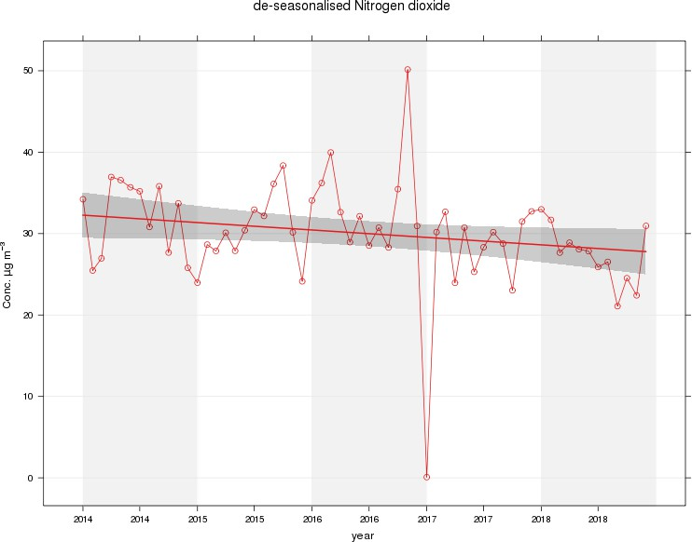

Figure 2 – A5 Falkirk Hope St Long Term NO₂ Concentrations
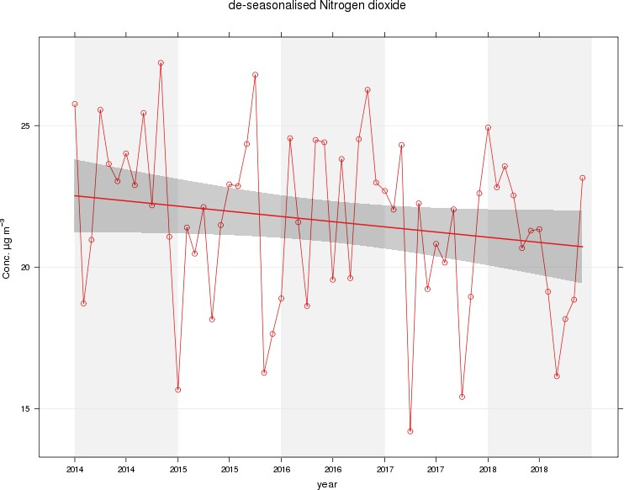

Figure 3 – A7 Falkirk West Bridge St Long Term NO₂ Concentrations
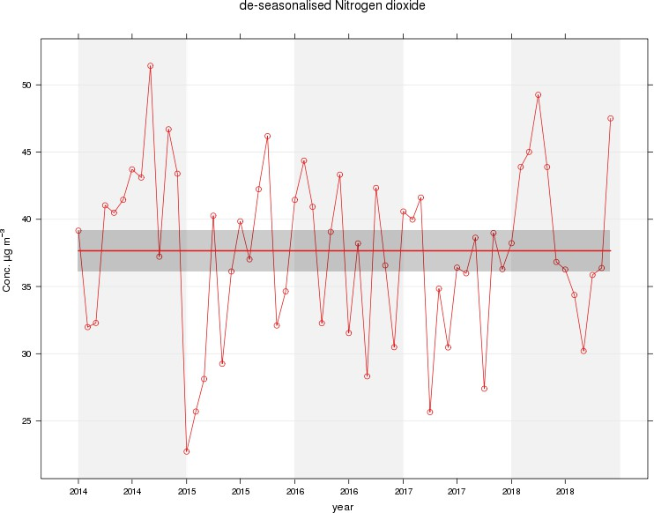

Figure 4 – A8 Grangemouth AURN Long Term NO₂ Concentrations
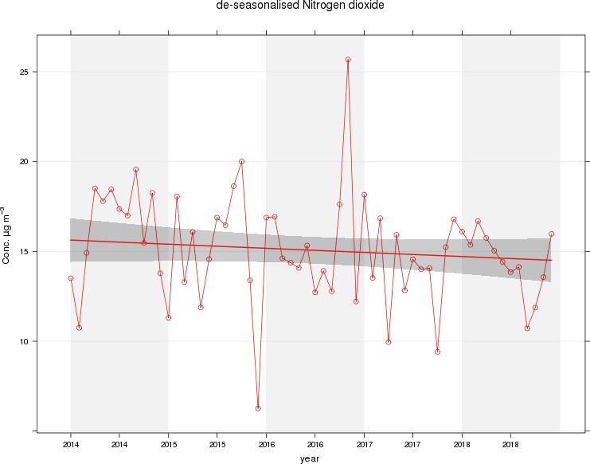

Figure 5 – A9 Grangemouth Moray Long Term NO₂ Concentrations
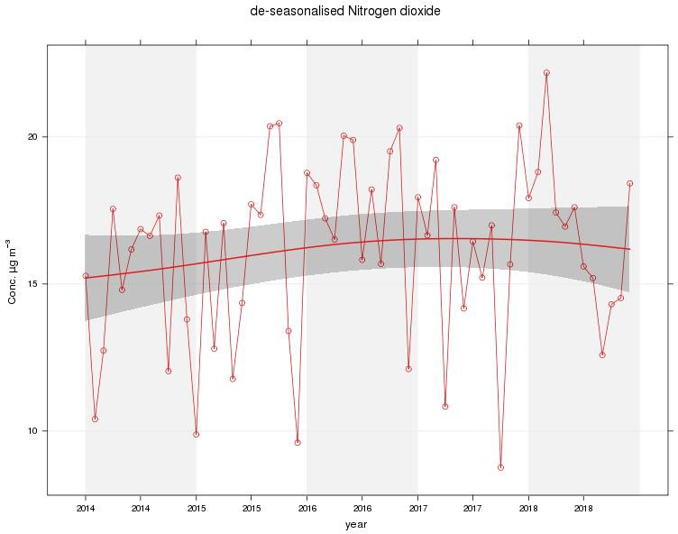

Figure 6 – A10 Grangemouth Municipal Chambers Long Term NO₂ Concentrations
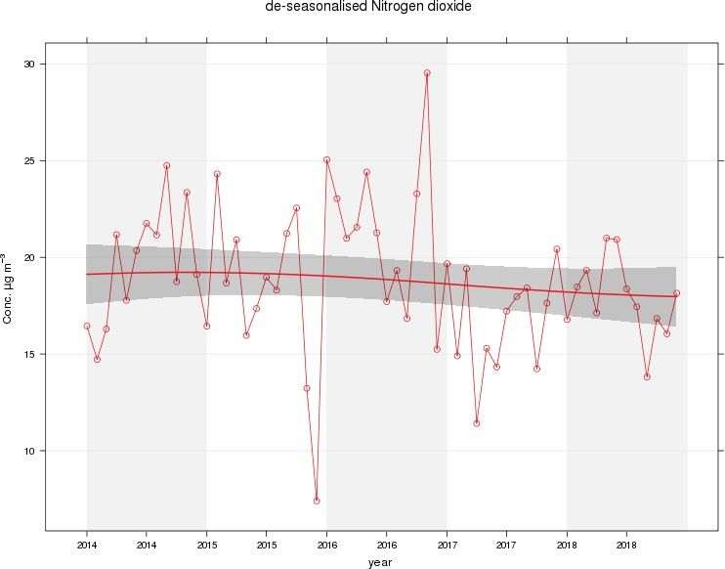

Figure 7 – A15 Main St, Bainsford Long Term NO₂ Concentrations
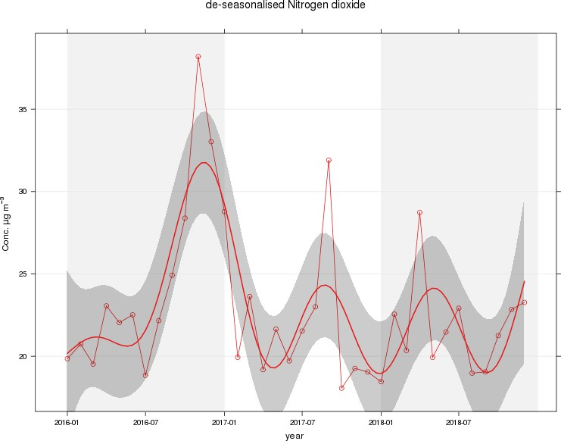

Table A.5 – Annual Mean PM₁₀ Monitoring Results

Site ID | Site Type | Valid Data Capture for Monitoring Period (%) ⁽¹⁾ | Valid Data Capture 2018  (%) (2) | PM₁₀ Annual Mean Concentration (µg/m³) ⁽³⁾
 |  |  |  | 2014 | 2015 | 2016 | 2017 | 2018
A4 | Falkirk Haggs | 89 | 89 | 16.5 | 15 | 14 | 12 | 14
A5 | Falkirk Hope St | 19 (1) | 19 (1) | PM₁₀ analyser transferred from Falkirk Grahams Rd to Hope St site on 10/10/2018 |  |  |  | 11
A7 | Falkirk West Bridge St | 67 | 67 | 17.7 | 15 | 15 | 10 | 6
A8 | Grangemouth AURN | 90 | 90 | 12.4 | 12.2 | 11 | 9 | 12
A10 | Grangemouth Municipal Chambers | 88 | 88 | 14.6 | 13 | 13 | 12 | 12
A12 | Falkirk Grahams Rd | 73 | 73 | 13.2 | 11.8 | 13 | 12 | 14
A13 | Banknock 2 | 99 | 99 | 13.2 | 11 | 11 | 13 | 11
A14 | Banknock 3 | 80 | 80 | 15 | 8.2 | n/n | 7 | 6.9
A15 | Main St, Bainsford | 70 | 70 | Not Operating | 12.8 | 10 | 13 | 12
Notes: Exceedances of the PM₁₀ annual mean objective of 18µg/m³ are shown in bold.
- Data capture for the monitoring period, in cases where monitoring was only carried out for part of the year.
- Data capture for the full calendar year (e.g. if monitoring was carried out for 6 months, the maximum data capture for the full calendar year is 50%).
- All means have been “annualised” as per LAQM.TG (16); valid data capture for the full calendar year is less than 75%. See Appendix C for details.

Table A.6 – 24-Hour Mean PM₁₀ Monitoring Results

Site ID | Site Type | Valid Data Capture for Monitoring Period (%)  (1) | Valid Data Capture 2018 (%)  (2) | PM₁₀ 24-Hour Means > 50µg/m³ ⁽³⁾
 |  |  |  | 2014 | 2015 | 2016 | 2017 | 2018
A4 | Falkirk Haggs | 90 | 90 | 1 | 1 | 0 | 0 | 0
A5 | Falkirk Hope St | 20 (1) | 20 (1) | PM10 analyser transferred from Grahams Rd to Hope St on 10/10/2018 |  |  |  | 0 (30)
A7 | Falkirk West Bridge St | 67 | 67 | 2 (40) | 2 (29) | 0 | 0 | 0 (47)
A8 | Grangemouth AURN | 90 | 90 | 0 | 1 (21) | 0 | 1 | 0
A10 | Grangemouth Municipal  Chambers | 89 | 89 | 0 | 0 | 0 | 0 | 0
A12 | Falkirk Grahams Rd | 73 | 73 | 0 | 0 (18) | 0 | 0 | 0
A13 | Banknock 2 | 100 | 100 | 3 | 4 | n/m | 7 | 0
A14 | Banknock 3 | 80 | 80 | 0 (24) | 1 | 3 | 0 | 2 (10)
A15 | Main St, Bainsford | 70 | 70 | Not Operating | 0 (16) | 0 (16) | 0 | 0 (33)
Notes: Exceedances of the PM₁₀ 24-hour mean objective (50µg/m³ not to be exceeded more than 7 times/year) are shown in bold.
- Data capture for the monitoring period, in cases where monitoring was only carried out for part of the year.
- Data capture for the full calendar year (e.g. if monitoring was carried out for 6 months, the maximum data capture for the full calendar year is 50%).
- If the period of valid data is less than 85%, the 98.1st percentile of 24-hour means is provided in brackets.

Figure 8 – A4 Haggs Long Term PM₁₀ (24-hour mean) Concentrations
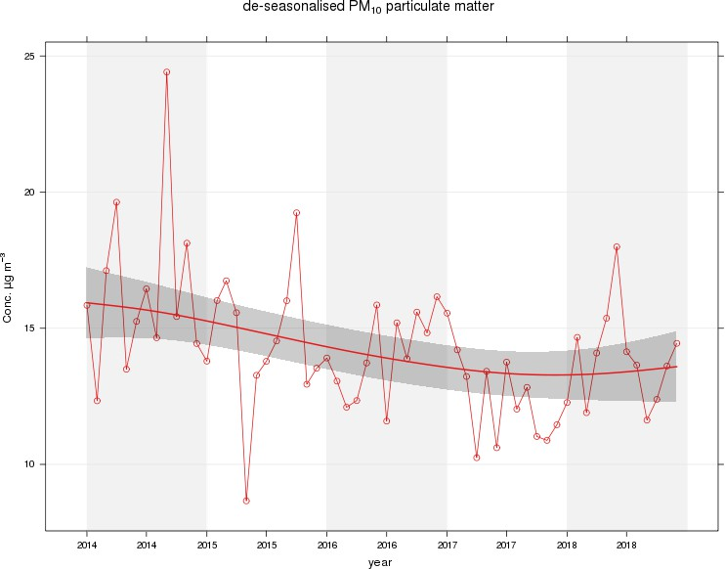

Figure 9 – A5 Falkirk West Bridge St Long Term PM₁₀ (24-hour mean) Concentrations
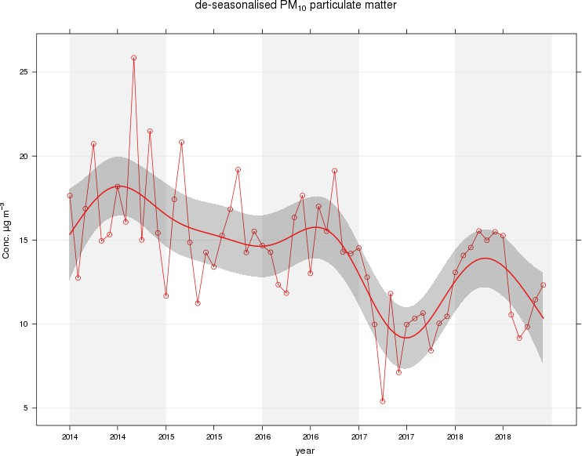

Figure 10 – A8 Grangemouth AURN Long Term PM₁₀ (24-hour mean) Concentrations
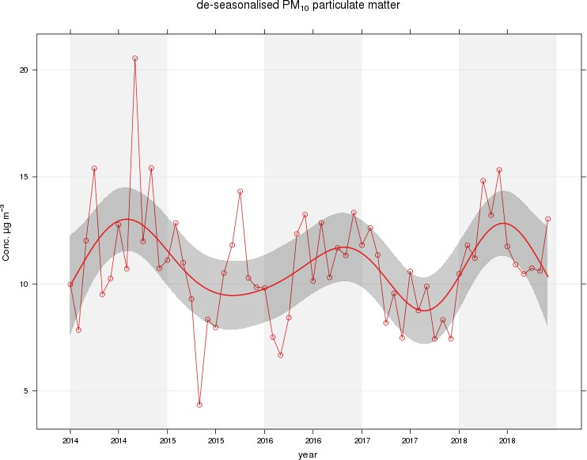

Figure 11 – A10 Grangemouth Municipal Chambers Long Term PM₁₀ (24-hour mean) Concentrations
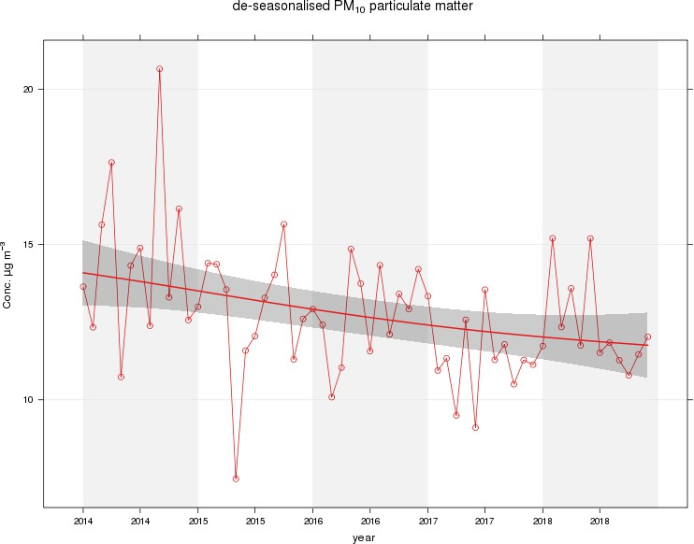

Figure 12 – A13 Banknock 2 Long Term PM₁₀ (24-hour mean) Concentrations
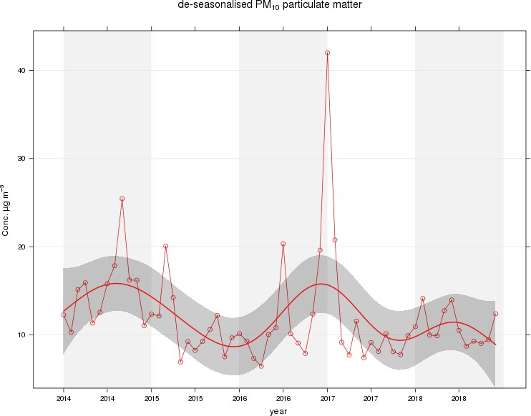

Figure 13 – A15 Main St, Bainsford Long Term PM₁₀ (24-hour mean) Concentrations
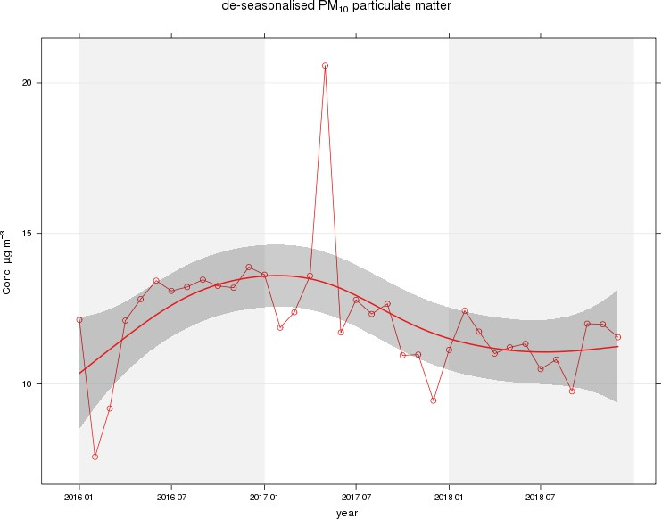

Table A.7 – Annual Mean PM_{2.5} Monitoring Results

Site ID | Site Type | Valid Data Capture for Monitoring Period (%) ⁽¹⁾ | Valid Data Capture 2018  (%) (2) | PM_{2.5} Annual Mean Concentration (µg/m³) ⁽³⁾
 |  |  |  | 2014 | 2015 | 2016 | 2017 | 2018
A7 | Falkirk West Bridge St | 67 | 67 | Not Operating |  | 6 | 6 | 6
A8 | Grangemouth AURN | 92 | 92 | 8 | 9.2 | 6 | 6 | 7
A13 | Banknock 2 | 99 | 99 | Not Operating | 6 | 5 | 6 | 6
Notes: Exceedances of the PM₁₀ annual mean objective of 10µg/m³ are shown in bold.
- Data capture for the monitoring period, in cases where monitoring was only carried out for part of the year.
- Data capture for the full calendar year (e.g. if monitoring was carried out for 6 months, the maximum data capture for the full calendar year is 50%).
- All means have been “annualised” as per LAQM.TG (16); valid data capture for the full calendar year is less than 75%. See Appendix C for details.

Figure 14 – A7 Falkirk West Bridge St Long Term PM_{2.5} Concentrations
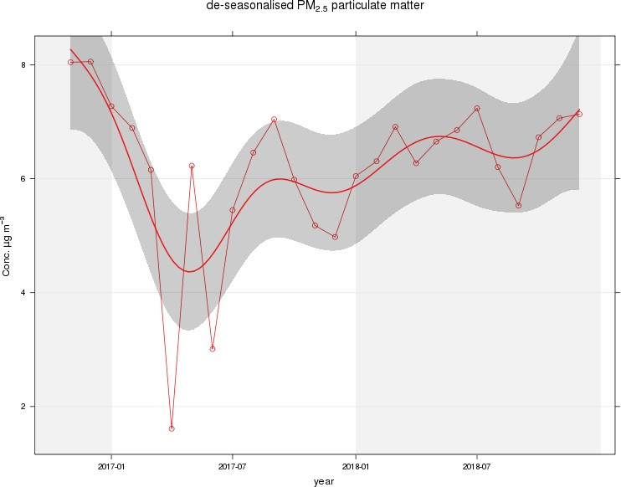

Figure 15 – A8 Grangemouth AURN Long Term PM_{2.5} Concentrations
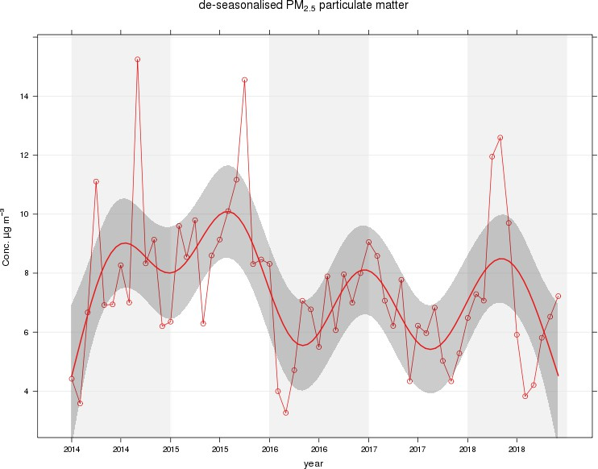

Figure 16 – A13 Banknock 2 Long Term PM_{2.5} Concentrations
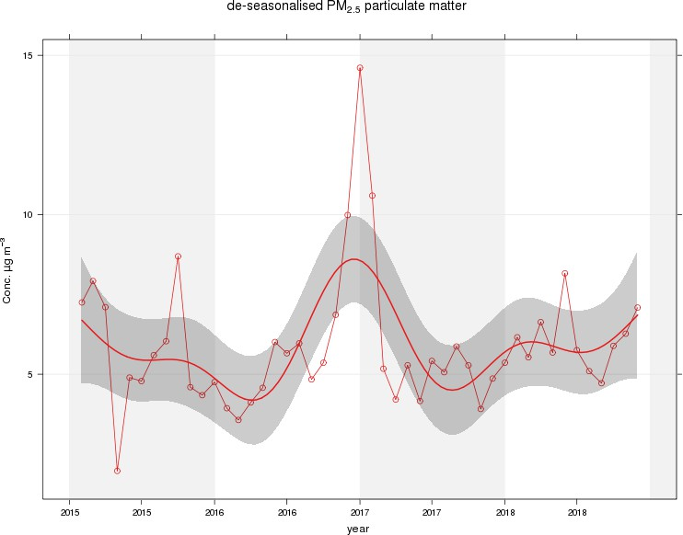

Table A.8 – SO₂ Monitoring Results

Site ID | Site Type | Valid Data Capture for monitoring Period (%) ⁽¹⁾ | Valid Data Capture 2018 (%) ⁽²⁾ | Number of Exceedances (percentile in bracket) ⁽³⁾
 |  |  |  | 15-minute Objective (266 µg/m³) | 1-hour Objective (350 µg/m³) | 24-hour Objective (125 µg/m³)
A3 | Bo’ness | 97 | 97 | 0 | 0 | 0
A5 | Falkirk Hope St | 93 | 93 | 0 | 0 | 0
A8 | Grangemouth AURN | 95 | 95 | 0 | 0 | 0
A9 | Grangemouth Moray | 93 | 93 | 1 | 0 | 0
A10 | Grangemouth Municipal  Chambers | 97 | 97 | 0 | 0 | 0
A11 | Grangemouth Zetland Park | 90 | 90 | 0 | 0 | 0
Notes: Exceedances of the SO₂ objectives are shown in bold (15-min mean = 35 allowed a year, 1-hour mean = 24 allowed a year, 24-hour mean = 3 allowed a year)
- Data capture for the monitoring period, in cases where monitoring was only carried out for part of the year.
- Data capture for the full calendar year (e.g. if monitoring was carried out for 6 months, the maximum data capture for the full calendar year is 50%)
- If the period of valid data is less than 85%, the relevant percentiles are provided in brackets.

Figure 17 – A3 Bo’ness Long Term SO₂ Concentrations
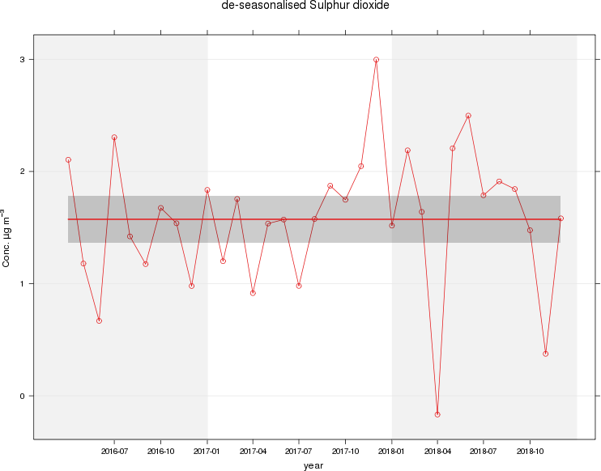

Figure 18 – A5 Falkirk Hope St Long Term SO₂ Concentrations
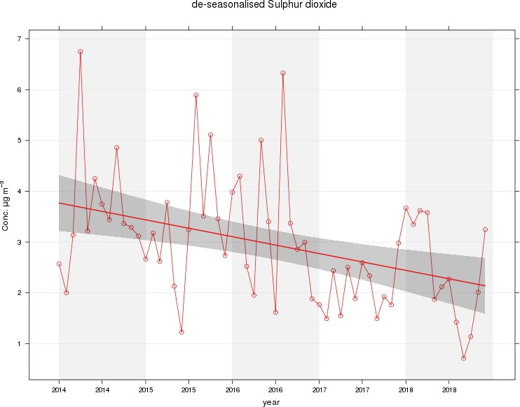

Figure 19 – A8 Grangemouth AURN Long Term SO₂ Concentrations
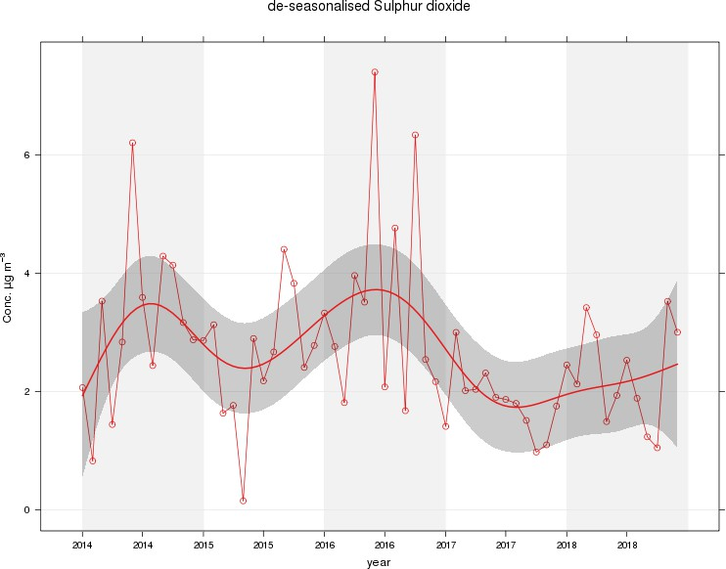

Figure 20 – A9 Grangemouth Moray Long Term SO₂ Concentrations
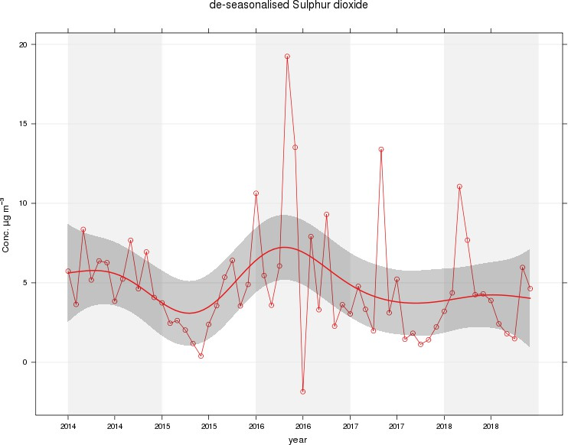

Figure 21 – A10 Grangemouth Municipal Chambers Long Term SO₂ Concentrations
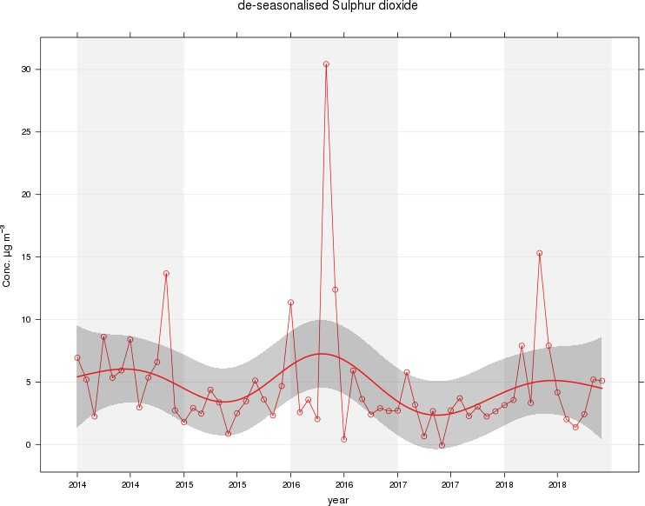

Figure 22 – A11 Grangemouth Zetland Park Long Term SO₂ Concentrations
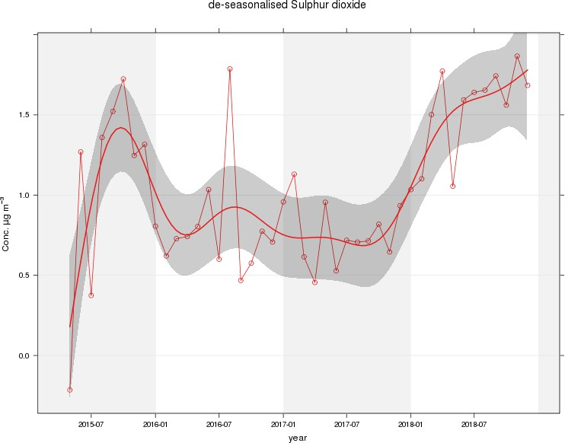

Figure 23 – Polar Plots of Average SO₂ Concentrations Recorded at the Grangemouth Sites
A) Grangemouth AURN: 2018 B) Grangemouth AURN: 2014 – 2018

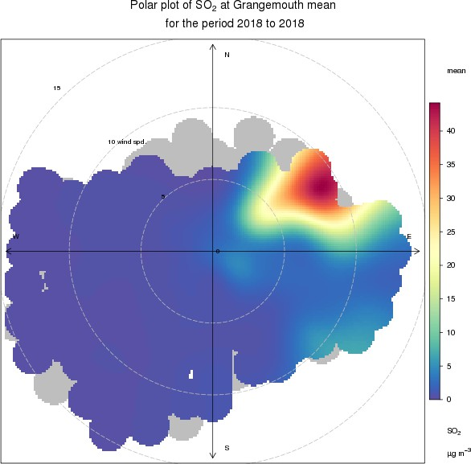
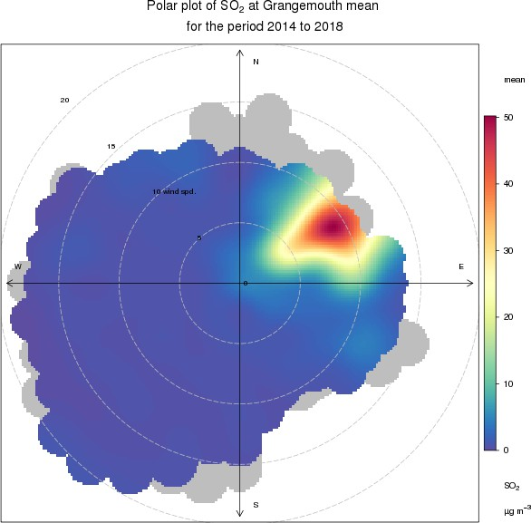

C) Grangemouth Moray: 2018 D) Grangemouth Moray 2014 – 2018
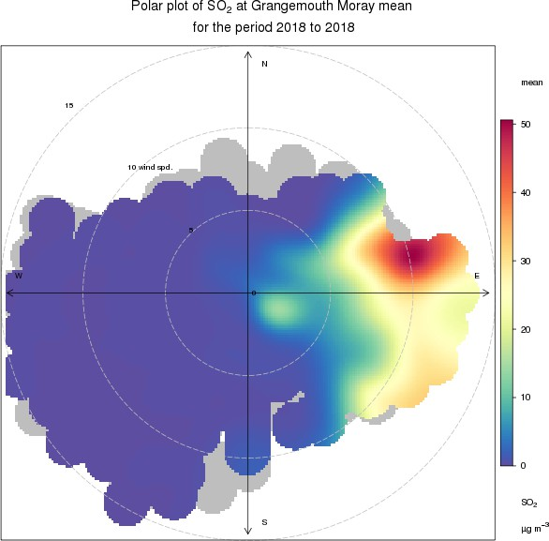
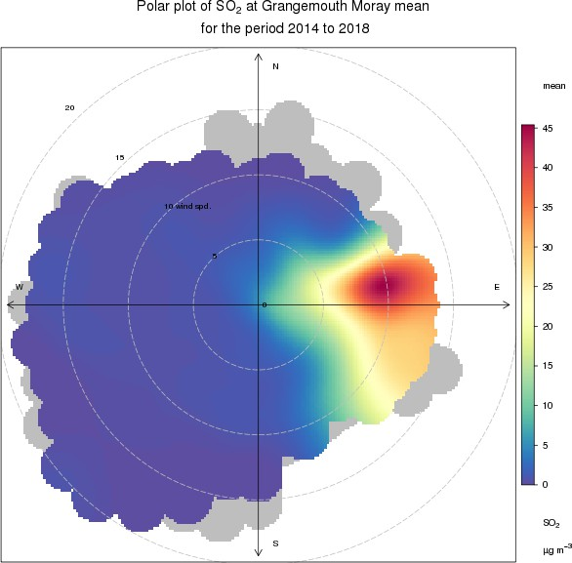

E) Grangemouth Municipal Chambers: 2018 F) Grangemouth Municipal Chambers: 2014 – 2018
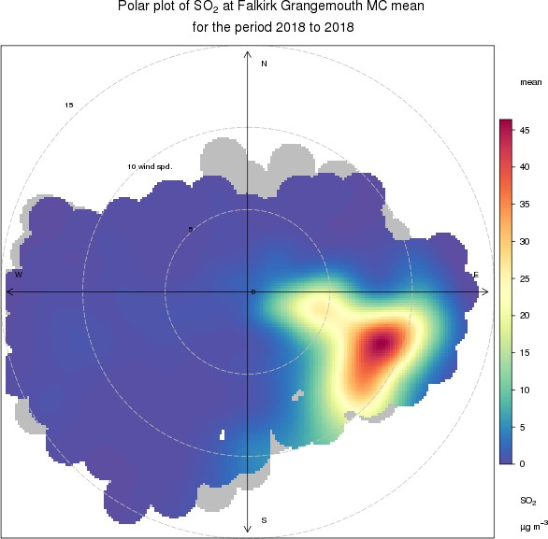
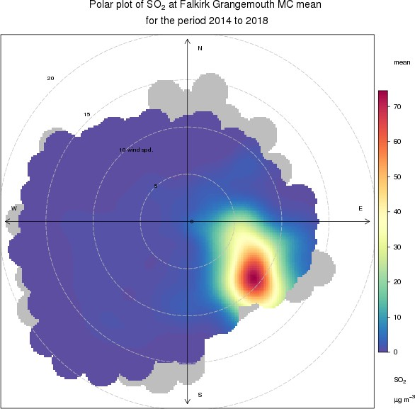

Figure 24 – Exceedances of the 15 Minute SO₂ NAQS Objective Concentration at the Grangemouth Sites 2014 – 2018
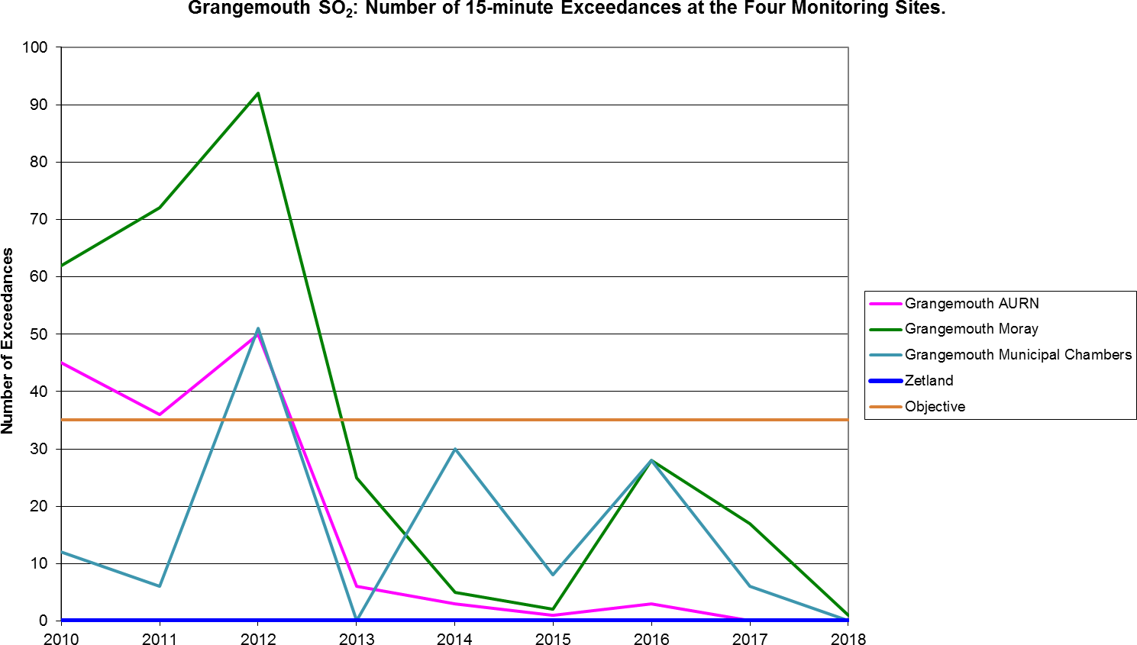

Table A.9 – 1, 3 Butadiene Annual Mean Diffusion Tube Results for 2018

Site ID | Location | Within 1, 3 butadiene AQMA? | Data capture in 2018,  %.(1) | Annual Mean concentrations (µg/m³)
 |  |  |  | 2014 | 2015 | 2016 | 2017 | 2018
NA41 | Seaview Place, Bo’ness | N | 91.7 | 0.42 | 0.11 | 0.10 | 0.1 | 0.06
NA55 | Inchyra Station,  Grangemouth | N | 91.7 | 0.48 | 0.09 | 0.10 | 0.07 | 0.07
NA104 | Powdrake  Road, Grangemouth | N | 100 | 0.47 | 0.13 | 0.11 | 0.1 | 0.11

Note: Exceedances of the 1, 3 butadiene running annual mean NAQS objective are shown in bold.

Table A.10 – Benzene Annual Mean Diffusion Tube Results for 2018

Site ID | Location | Within Benzene AQMA? | Data capture in 2018, %.(1) | Annual mean concentrations (µg/m³)
 |  |  |  | 2014 | 2015 | 2016 | 2017 | 2018
NA3 | Tinto Drive, Grangemouth | N | 91.7 | 1.3 | 1.16 | 0.51 | 0.58 | 0.66
NA21 | Grangemouth Road, Falkirk College | N | 91.7 | 1.13 | 0.72 | 0.46 | 0.56 | 0.6
NA27 | West Bridge Street, Falkirk | N | 100 | 2.39 | 0.69 | 0.78 | 0.68 | 0.7
NA37 | Denny Town House | N | 100 | 1.09 | 0.59 | 0.58 | 0.56 | 0.49
NA38 | Larbert Village Primary School | N | 91.7 | 1.04 | 0.55 | 0.51 | 1.01 | 0.5
NA41 | Seaview Place, Bo’ness | N | 100 | 1.97 | 0.91 | 1.11 | 0.82 | 0.91
NA42 | Municipal Chambers, Grangemouth | N | 100 | 1.25 | 0.69 | 0.79 | 0.47 | 0.63
NA44 | Harvey Avenue, Polmont | N | 100 | 1.34 | 0.56 | 0.48 | 0.39 | 0.52
NA55 | Inchyra AQ Station, Grangemouth | N | 83.3 | 1.32 | 0.5 | 0.46 | 0.52 | 0.52
NA57 | Inchyra Road, Grangemouth | N | 100 | 1.96 | 0.69 | 0.90 | 0.57 | 0.91
NA77 | Kinnaird Village | N | 83.3 | 1.04 | 0.65 | 0.44 | 0.51 | 0.44
NA80 | Cow Wynd, Falkirk | N | 100 | 1.33 | 0.81 | 0.56 | 0.57 | 0.52
NA81 | Grahams Road, Falkirk | N | 91.7 | 1.25 | 0.88 | 0.95 | 0.7 | 0.81
NA94 | A905 (Glensburgh Rd), Grangemouth | N | 91.7 | 1.13 | 0.68 | 0.78 | 0.64 | 0.68
NA105 | West of Shieldhill | N | 83.3 | 0.74 | 0.34 | 0.19 | 0.69 | 0.3
NA113 | Union St, Bo’ness | N | 100 | New site for 2018 |  |  |  | 0.64
Note: Exceedances of the Benzene running annual mean objective of 3.25µg/m³ are shown in bold.

Table A.11 – Pumped Benzene Annual Mean Results for 2018

Site ID | Location | Within Benzene AQMA? | Data capture in 2018, % (1) | Annual mean concentrations (µg/m³)
 |  |  |  | 2014 | 2015 | 2016 | 2017 | 2018
A8 | Grangemouth AURN | N | 100 | 0.99 | 0.73 | 0.64 | 0.65 | 0.74
Note: Exceedences of the Benzene running annual mean objective of 3.25µg/m³ are shown in bold.

Table A.12 – Estimated Annual Mean PM_{2.5} Results for 2018

Site ID | Site Type | Valid Data Capture for Monitoring Period (%) (1) | Valid Data Capture in 2018 (%)  (2) | Correction Factor | Estimated PM_{2.5} Annual Mean Concentration (µg/m³) (3)
 |  |  |  |  | 2014 | 2015 | 2016 | 2017 | 2018
A4 Falkirk Haggs | Roadside (Non-urban) | 89 | 89 | 0.55 | 7.62 | 6.92 | 6.46 | 5.54 | 7.7
A5 Falkirk Hope St | Roadside  (Urban) | 19 (1) | 19 (1) | 1 | PM₁₀ analyser not operating at this  site |  |  |  | 11
A10 Grangemouth Municipal Chambers | Urban  Background / Industrial | 88 | 88 | 0.58 | 9.73 | 8.67 | 8.67 | 8.00 | 6.96
A14 Banknock 3 | Roadside (Non-urban) | 80 | 80 | 0.55 | 6.92 | 3.78 | n/m | 3.05 | 4
A15 Main St, Bainsford | Roadside (Urban) | 70 | 70 | 1 | n/m | 7.68 | 6.00 | 7.80 | 12
Note: Exceedences of the PM_{2.5} annual mean objective of 10µg/m³ are shown in bold.
- Data capture for the monitoring period, in cases where monitoring was only carried out for part of the year.
- Data capture for the full calendar year (e.g. if monitoring was carried out for 6 months, the maximum data capture for the full calendar year is 50%)
- All means have been estimated using a local correction factor as per LAQM.TG (16). See Appendix C for details.

Figure 25 – Maps of the AQMA Boundaries in the Falkirk Council Area
- Grangemouth AQMA (SO₂, 15min mean), declared November 2005
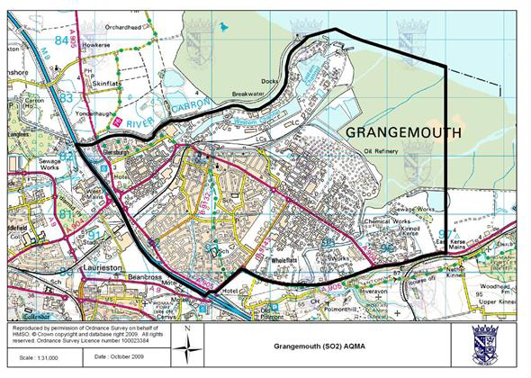
- Falkirk Town Centre AQMA (NO₂ Annual Mean, PM₁₀ annual and 24-hour mean), declared March 2010
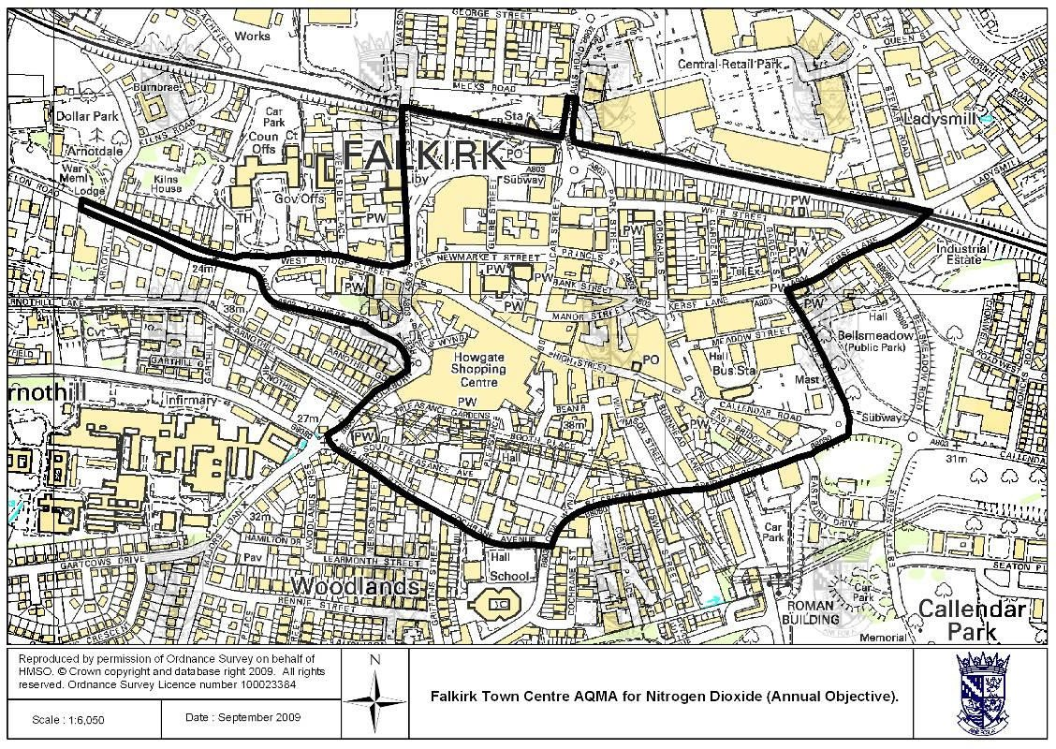

- Haggs AQMA (NO₂ annual mean), declared March 2010
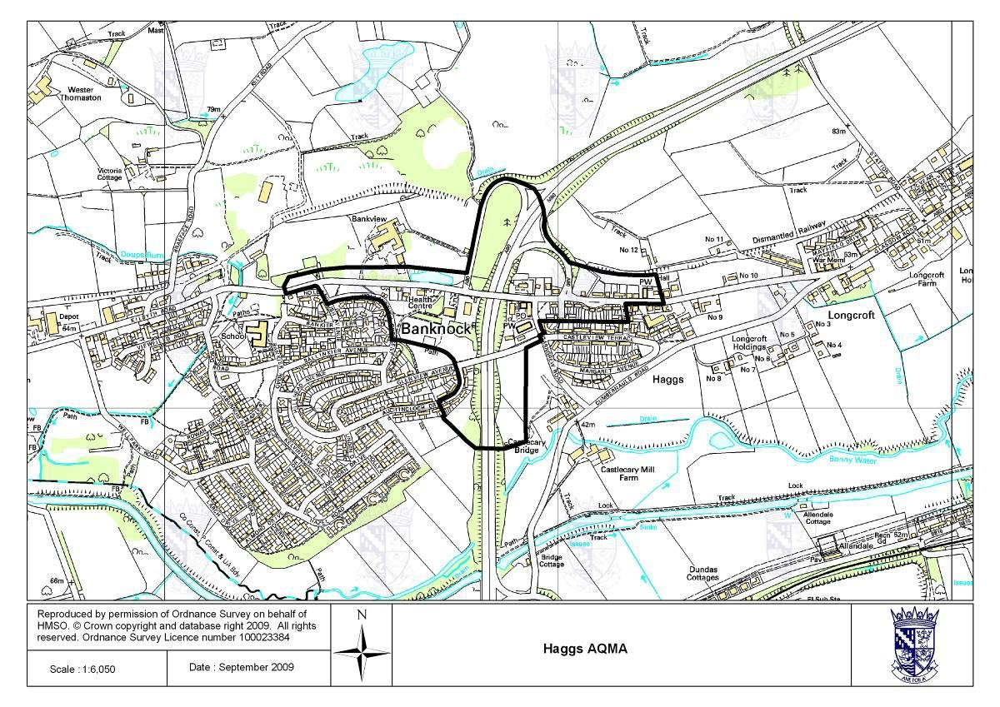
- Banknock AQMA (PM₁₀ 24-hour mean), declared August 2011
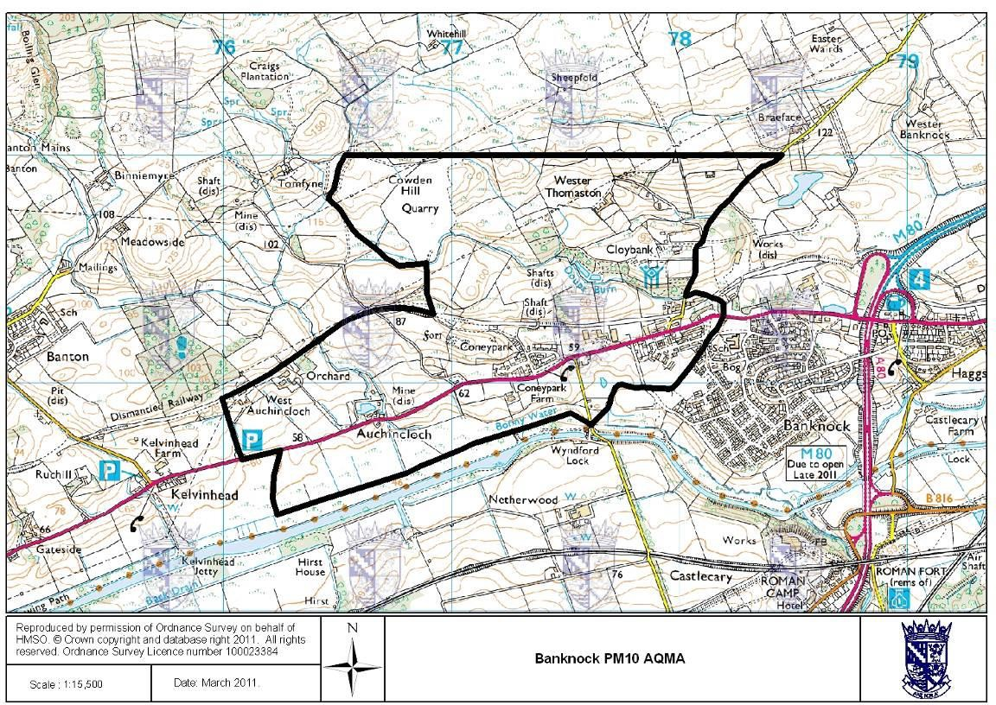

Figure 26 – Maps Showing Automatic Monitoring Locations
  - Grangemouth Air Quality (AQ) Stations
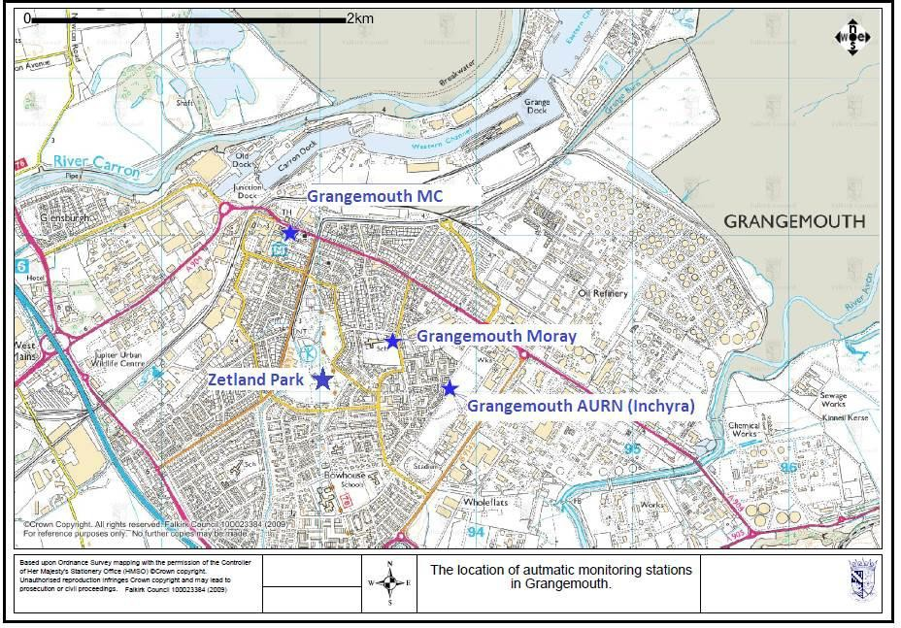

  - Falkirk Hope St AQ Station
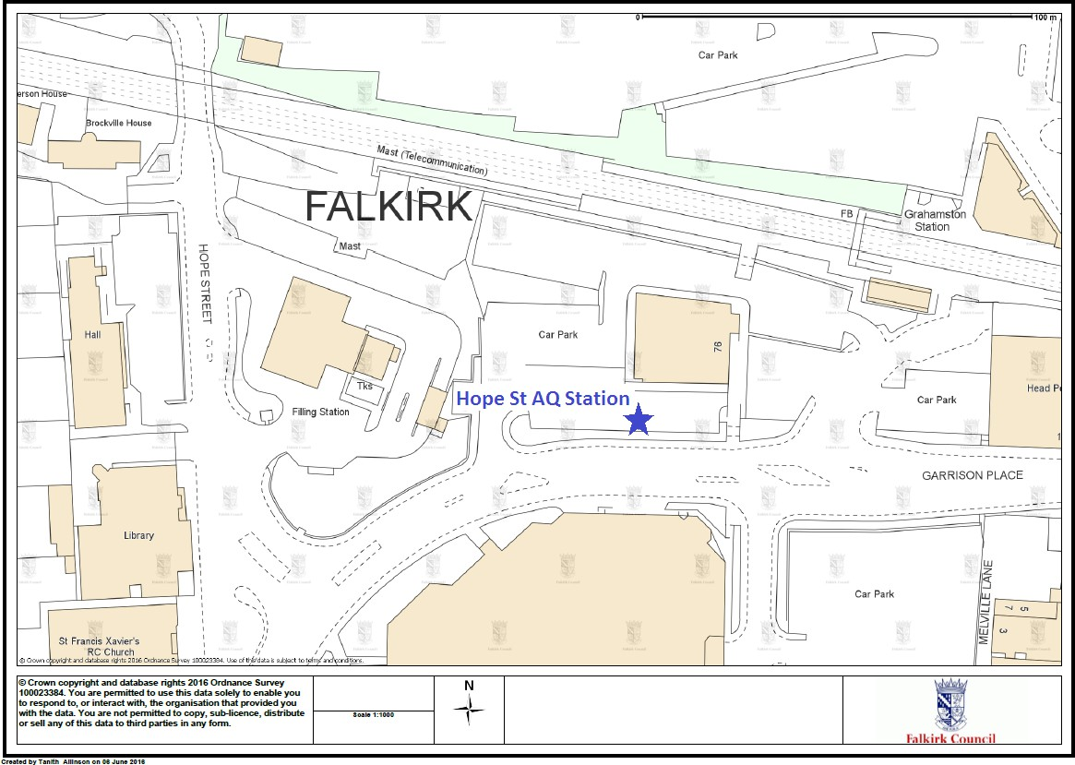

  - Falkirk West Bridge St AQ Station
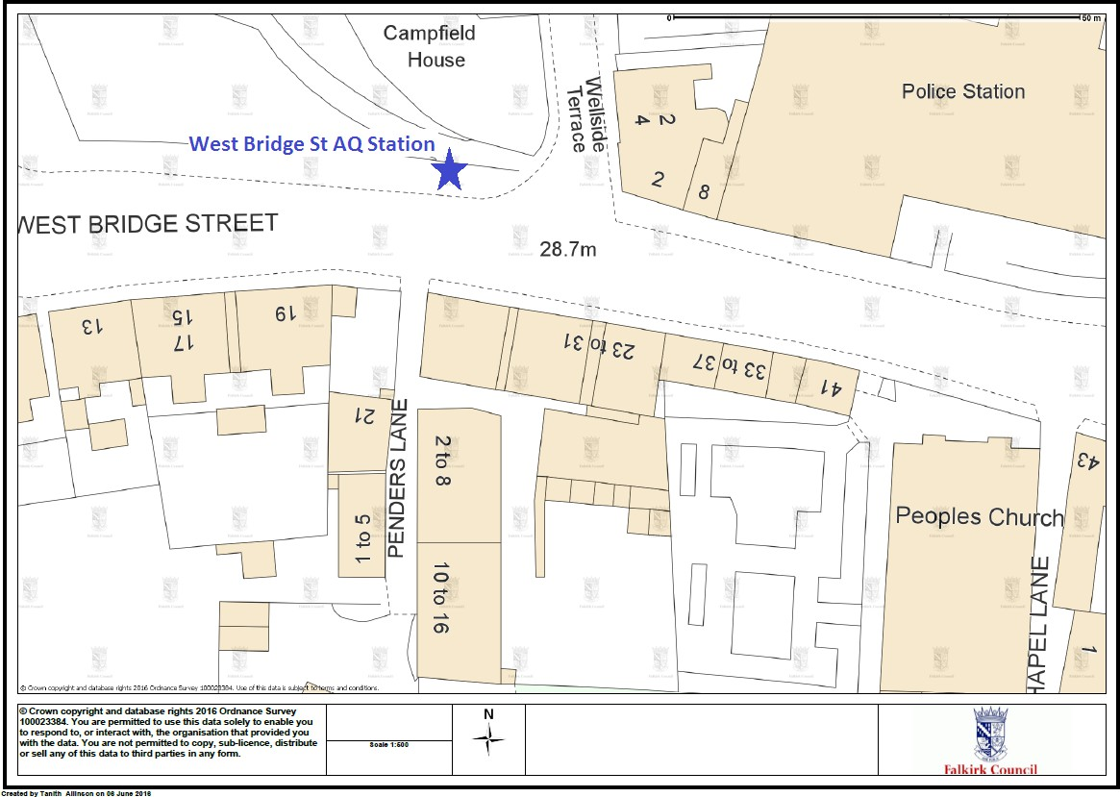

  - Bo’ness AQ Station
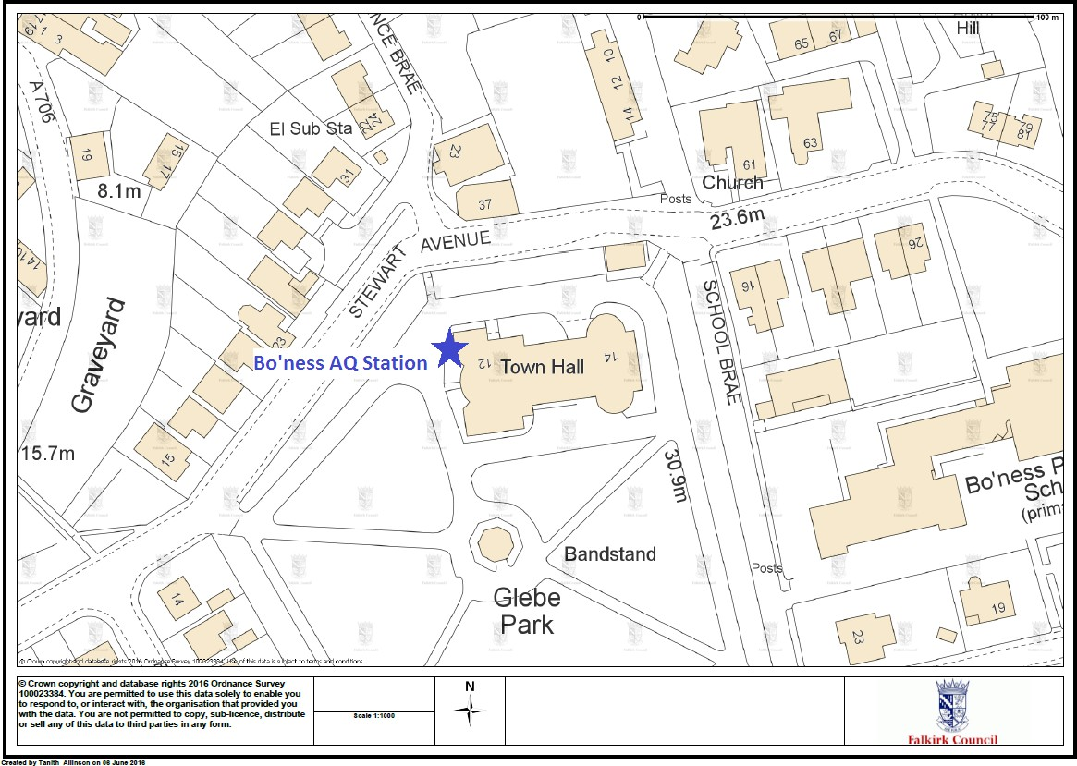

  - Falkirk Haggs AQ Station
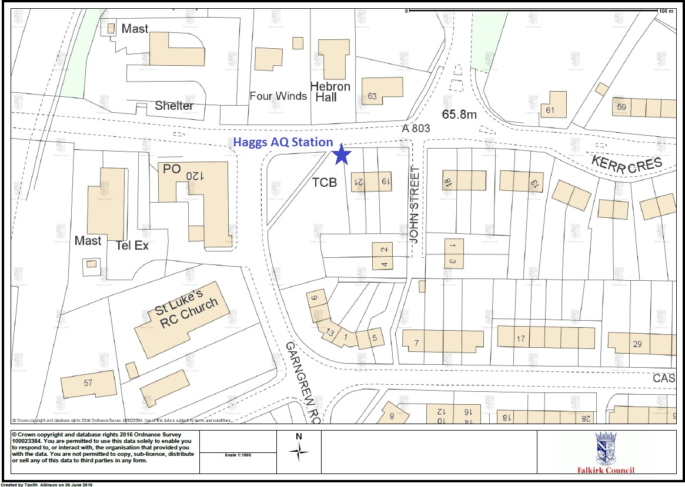
  - Banknock 2 AQ Station
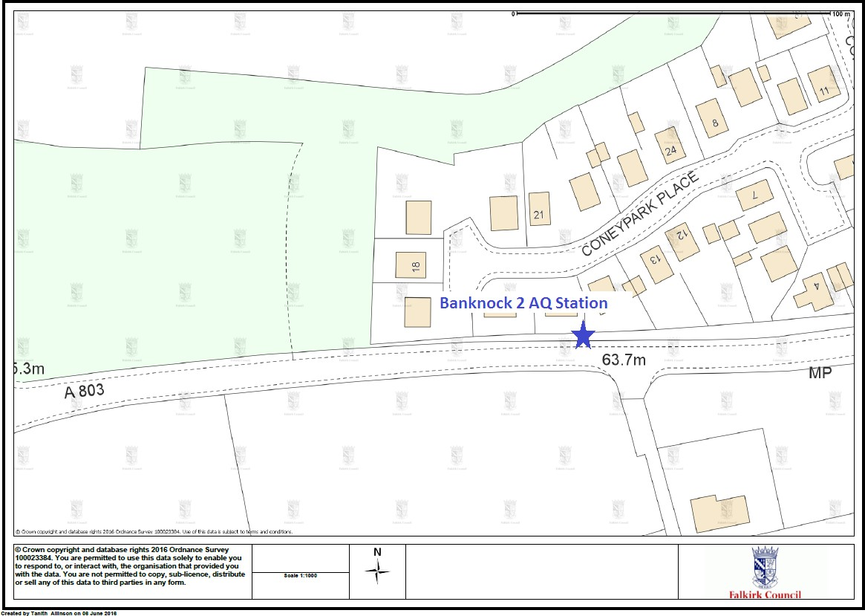

  - Main St, Bainsford, Falkirk AQ Station
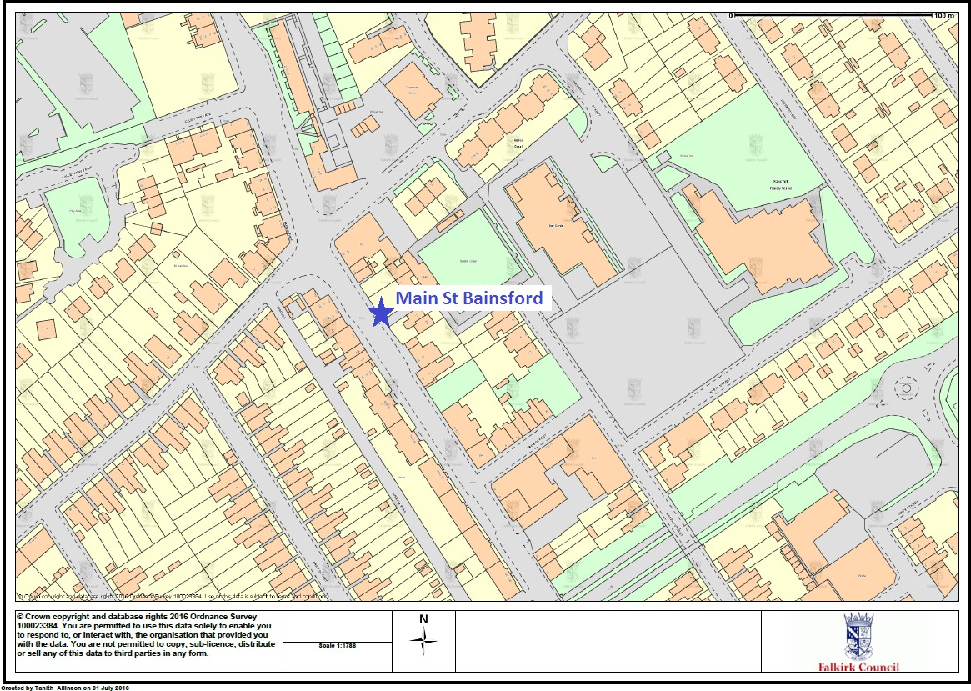

Appendix B: Full Monthly Diffusion Tube Results for 2018

Table B.1 – NO₂ Monthly Diffusion Tube Results for 2018

Site ID | NO₂ Mean Concentrations (µg/m³)
Site ID | Jan | Feb | Mar | Apr | May | Jun | Jul | Aug | Sep | Oct | Nov | Dec | Annual Mean
 |  |  |  |  |  |  |  |  |  |  |  |  | Raw Data | Bias Adjusted  (1)
NA3 | 25.02 | 25.34 | 21.89 | 19.33 | 20.49 | 16.48 | 14.29 | 12.48 | 14.29 | 21.93 | 30.20 | 26.99 | 21 | 18
NA5 | 34.59 | 29.48 | 27.28 | 25.69 | 21.92 | 24.42 | 22.23 | 22.26 | 23.85 | 29.24 | 37.01 | 35.74 | 28 | 24
NA7 | 28.46 | 22.67 | 21.38 | 17.02 | 16.63 | 14.46 | 13.08 | 12.35 | 11.61 | 17.25 | 24.51 | 25.81 | 19 | 17
NA9 | - | 30.17 | 24.81 | 21.32 | 21.71 | 19.44 | 19.41 | 21.69 | 21.01 | 28.34 | 33.57 | 36.82 | 25 | 22
NA19 | 40.41 | - | 36.88 | 33.65 | 34.04 | 17.97 | 24.15 | 21.54 | - | 29.22 | 42.91 | 38.35 | 32 | 28
NA20 | 30.91 | 29.16 | - | 21.30 | 20.03 | 18.99 | 17.53 | 19.93 | - | 25.61 | 33.70 | 32.79 | 25 | 22
NA21 | 30.56 | 31.24 | 40.15 | 32.71 | 26.37 | 31.22 | 27.99 | 26.58 | 24.39 | 31.78 | 40.67 | 38.41 | 32 | 28
NA24 | 42.30 | 49.32 | 35.64 | 38.50 | - | 34.89 | 35.87 | 33.56 | 34.99 | 35.53 | 39.11 | 46.37 | 39 | 34
NA26 | 26.70 | 30.69 | 26.62 | 24.14 | 20.25 | 17.94 | 15.20 | 15.16 | 14.84 | 21.10 | 28.41 | 31.21 | 23 | 20
NA27 | 50.34 | 48.75 | 58.30 | 57.35 | 48.09 | 45.15 | 42.56 | 36.77 | 37.04 | 47.12 | 66.39 | 59.77 | 50 | 44
NA29 | 29.52 | 23.93 | 22.92 | 20.09 | 18.75 | 16.09 | 13.52 | 13.46 | 9.21 | 19.51 | 28.39 | 27.34 | 20 | 18
NA36 | 51.75 | 41.01 | 41.76 | 39.09 | - | 40.17 | 34.01 | 35.74 | 32.25 | 44.95 | 52.36 | 44.90 | 42 | 37
NA37 | 25.83 | 23.23 | 22.24 | 15.78 | 17.64 | 15.90 | 12.81 | 13.11 | 11.88 | 19.31 | 25.31 | 25.19 | 19 | 17
NA38 | 29.87 | 22.36 | 20.04 | 15.22 | 16.77 | 15.07 | 11.79 | 12.75 | 12.08 | 19.16 | 25.17 | 28.76 | 19 | 17
NA41 | 27.22 | 29.05 | 23.74 | - | 24.91 | 21.19 | 20.47 | 20.25 | 21.44 | 21.56 | 29.79 | 35.25 | 25 | 22

Site ID | NO₂ Mean Concentrations (µg/m³)
Site ID | Jan | Feb | Mar | Apr | May | Jun | Jul | Aug | Sep | Oct | Nov | Dec | Annual Mean
 |  |  |  |  |  |  |  |  |  |  |  |  | Raw Data | Bias Adjusted  (1)
NA42 (3 Tubes) | 23.52 | 23.40 | 24.12 | 17.80 | 22.80 | 18.32 | 14.76 | 14.88 | 15.76 | 19.75 | 26.81 | 30.91 | 21 | 19
NA42 (3 Tubes) | 25.41 | 26.81 | 21.18 | 19.76 | 23.58 | 19.40 | 14.19 | 14.49 | 15.96 | 19.89 | 27.83 | 30.78 | 21 | 19
NA42 (3 Tubes) | 25.74 | 24.80 | 21.90 | 19.90 | 22.81 | 18.38 | 14.78 | 14.39 | 14.92 | 20.15 | 27.67 | 30.92 | 21 | 19
NA44 | 25.07 | 25.18 | 22.35 | 17.48 | 19.15 | - | - | 14.68 | 14.76 | 18.37 | 26.42 | 28.35 | 21 | 19
NA48 | 28.91 | 22.30 | 26.07 | 18.94 | 20.27 | 20.32 | 15.20 | 13.55 | 12.41 | 18.09 | 28.48 | 27.60 | 21 | 18
NA50 | 28.50 | 29.66 | 36.00 | 30.43 | 27.68 | 26.70 | 20.02 | 17.55 | 16.24 | 25.81 | 33.80 | 30.16 | 27 | 24
NA51 | 33.59 | 30.70 | 27.84 | 27.93 | 24.39 | 20.32 | 21.15 | 22.03 | 19.02 | 26.60 | 34.35 | 35.24 | 27 | 24
NA52 | 35.05 | 27.55 | 27.92 | 24.31 | 24.18 | 19.87 | 19.52 | 21.59 | 17.61 | 27.61 | 33.57 | 33.91 | 26 | 23
NA53 | 34.56 | 30.00 | 37.40 | 32.58 | 33.77 | 28.28 | 21.24 | 19.13 | 17.31 | 25.20 | 41.17 | 34.23 | 30 | 26
NA57 | 28.29 | 30.57 | 25.23 | 24.13 | 19.08 | 17.46 | 17.97 | 16.32 | 16.79 | 25.63 | 33.87 | 35.20 | 24 | 21
NA58 | 35.68 | 29.89 | 23.43 | 23.23 | 20.72 | 19.53 | - | - | 16.99 | 28.63 | 30.02 | 28.62 | 26 | 23
NA59 | 42.46 | 35.35 | 32.10 | 26.82 | 31.50 | 25.33 | 22.96 | 24.61 | 26.51 | 33.70 | 38.74 | 46.01 | 32 | 28
NA60 | 35.85 | 31.01 | 28.89 | 24.58 | 24.58 | 24.36 | 19.50 | 19.35 | 22.05 | 28.70 | 37.40 | 37.61 | 28 | 24
NA61 | 36.11 | 28.67 | 30.11 | 22.04 | 23.01 | 23.06 | 19.27 | 19.34 | 19.06 | 28.83 | 37.50 | 34.57 | 27 | 24
NA62 | 43.94 | 43.58 | 36.79 | 42.59 | 34.84 | 33.37 | 31.99 | 26.89 | 33.22 | 37.97 | 49.20 | 43.60 | 38 | 34
NA63 | 56.05 | 40.46 | 39.40 | 38.63 | 35.27 | 38.20 | 31.99 | 30.10 | 24.44 | 41.01 | 46.22 | 48.91 | 39 | 35
NA64 | 23.86 | 21.15 | 24.58 | 18.75 | 18.44 | 17.55 | 12.16 | 11.55 | 11.81 | 11.36 | 29.05 | 24.65 | 19 | 16
NA65 | 35.34 | 28.41 | 30.45 | 26.98 | 26.27 | 26.16 | 19.37 | 19.60 | 20.85 | 26.79 | 34.26 | 36.48 | 28 | 24
NA67 | 36.29 | 35.09 | 37.86 | 33.67 | 27.39 | 29.05 | 23.71 | - | 27.13 | 33.18 | 38.23 | 12.79 | 30 | 27
NA68 | 40.37 | 38.76 | 29.20 | 26.67 | 21.72 | 25.60 | 27.17 | 22.23 | 17.74 | - | - | 34.30 | 28 | 25

Site ID | NO₂ Mean Concentrations (µg/m³)
Site ID | Jan | Feb | Mar | Apr | May | Jun | Jul | Aug | Sep | Oct | Nov | Dec | Annual Mean
 |  |  |  |  |  |  |  |  |  |  |  |  | Raw Data | Bias Adjusted  (1)
NA69 | 41.07 | 44.55 | 41.68 | 39.94 | 38.30 | 36.60 | 31.97 | 27.68 | 23.78 | 29.66 | 40.55 | 39.87 | 36 | 32
NA71 | 36.47 | 43.20 | 37.88 | 31.05 | 30.99 | 27.66 | 26.83 | 28.20 | 31.22 | 38.58 | 38.82 | 47.55 | 35 | 31
NA72 | 32.64 | - | 38.10 | 32.93 | 32.35 | 28.69 | 25.20 | 23.94 | 18.86 | 34.53 | 17.40 | 38.87 | 29 | 26
NA73 | 38.77 | 33.42 | 39.66 | 38.89 | 36.59 | 30.65 | 28.41 | 29.10 | 25.86 | 33.87 | 48.27 | 44.47 | 36 | 31
NA76 | 32.50 | 26.16 | 21.33 | 16.63 | 19.16 | 16.00 | 15.08 | 16.89 | 17.98 | 23.29 | 29.62 | 33.05 | 22 | 20
NA77 | 35.57 | 29.35 | 24.71 | 19.32 | 22.14 | 17.35 | 19.06 | 18.72 | 19.80 | 26.02 | 32.17 | 31.38 | 25 | 22
NA78 | 41.14 | 39.49 | 34.94 | 34.46 | 32.42 | 27.20 | 30.39 | 29.99 | 29.39 | 31.24 | 42.56 | 38.63 | 34 | 30
NA80 | 45.61 | 33.47 | 35.05 | 17.94 | 27.78 | 24.74 | 28.39 | 28.08 | 30.05 | 33.86 | 37.50 | 40.18 | 32 | 28
NA81 | 33.71 | 37.95 | 37.44 | 36.76 | 32.42 | 30.73 | 24.64 | 27.21 | 25.06 | 33.34 | 47.11 | 42.08 | 34 | 30
NA82 | 26.92 | 28.60 | 26.72 | 20.34 | 19.16 | 16.08 | 14.46 | 14.48 | 11.53 | 21.78 | 27.92 | 29.49 | 21 | 19
NA83 | 45.83 | 39.19 | 32.27 | 28.59 | - | - | - | 29.70 | 52.42 | - | 41.08 | 42.01 | 39 | 34
NA85 | 28.34 | 23.22 | 22.55 | 25.17 | 21.01 | 21.04 | 14.82 | 13.52 | 9.93 | 19.59 | 31.24 | 29.81 | 22 | 19
NA86 | 27.58 | 22.56 | 22.82 | 18.77 | 15.46 | 12.71 | 10.84 | 11.20 | 10.22 | 18.50 | 23.66 | 27.11 | 18 | 16
NA87 | 36.70 | 32.39 | 29.74 | 28.36 | - | 26.55 | 27.83 | 26.61 | 29.73 | 32.80 | 39.48 | 36.81 | 32 | 28
NA88 | 44.05 | 32.18 | 30.80 | 32.56 | 23.24 | 25.79 | 23.22 | 23.39 | 27.67 | 31.54 | 36.12 | 37.39 | 31 | 27
NA89 | 38.26 | 38.47 | 36.66 | 32.46 | 30.38 | 26.42 | 25.93 | 26.94 | 29.52 | 36.84 | 41.24 | 41.77 | 34 | 30
NA94 | 36.97 | 48.21 | 35.64 | 31.41 | 36.40 | 27.15 | 30.05 | 31.04 | 30.06 | 34.90 | 37.60 | 48.37 | 36 | 31
NA98 | 30.55 | 24.05 | 20.86 | 19.63 | 18.33 | 15.48 | 13.59 | 14.30 | 13.76 | 21.31 | 22.88 | 28.01 | 20 | 18
NA99 | 31.95 | 32.93 | 32.11 | 28.11 | 26.03 | 24.08 | 23.09 | 20.23 | 22.67 | 25.38 | 35.88 | 36.17 | 28 | 25

Site ID | NO₂ Mean Concentrations (µg/m³)
Site ID | Jan | Feb | Mar | Apr | May | Jun | Jul | Aug | Sep | Oct | Nov | Dec | Annual Mean
 |  |  |  |  |  |  |  |  |  |  |  |  | Raw Data | Bias Adjusted  (1)
NA101 | 28.26 | 31.66 | 30.45 | 26.05 | 28.32 | 19.49 | 19.21 | 17.52 | 16.90 | 24.54 | 34.29 | 35.04 | 26 | 23
NA105 | 16.67 | 10.69 | 10.48 | 8.68 | 7.93 | 8.17 | 7.58 | 5.92 | 4.26 | 6.18 | 13.75 | 11.81 | 9 | 8
NA107 | 41.91 | 33.03 | 32.24 | - | 29.50 | 27.10 | 23.06 | 23.09 | 21.97 | 33.41 | 38.57 | 39.52 | 31 | 27
NA110 | 25.43 | 22.17 | 19.47 | 15.41 | 18.05 | 15.39 | 13.52 | 14.93 | 13.31 | 17.08 | 23.49 | 25.47 | 19 | 16
NA111 (3 tubes) | 41.09 | 41.21 | 48.78 | 50.68 | 45.06 | 37.67 | 29.49 | 32.76 | 31.33 | 44.72 | 49.81 | 47.52 | 42 | 37
NA111 (3 tubes) | 43.41 | 44.22 | 53.42 | - | 41.06 | 41.95 | 36.59 | 28.46 | 34.38 | 44.72 | 48.98 | 49.52 | 42 | 37
NA111 (3 tubes) | 45.46 | 45.81 | 45.35 | - | 41.87 | 38.62 | 34.42 | 28.94 | 33.84 | 42.84 | 51.09 | 48.47 | 42 | 37
NA112 | 29.65 | 22.77 | 23.23 | 15.19 | 17.50 | 16.04 | 12.85 | 11.87 | 11.00 | 20.15 | 28.95 | 26.29 | 20 | 17
NA113 | 20.36 | 21.64 | 16.19 | 14.36 | 14.71 | 13.92 | 13.98 | 13.84 | 16.07 | 15.52 | 20.75 | 28.39 | 17 | 15
NA114 | 54.49 | 44.49 | 41.99 | 40.41 | 42.21 | 41.12 | 38.96 | 38.06 | 34.70 | 46.36 | 57.22 | 50.79 | 44 | 39
NA115 | 29.02 | 21.15 | 25.41 | 16.30 | - | - | - | 11.23 | 11.80 | 17.68 | 27.71 | 26.90 | 21 | 18
(1) See Appendix C for details on bias adjustment

Table B.2 – 1, 3 Butadiene Monthly Diffusion Tube Results for 2018

Site ID | 1,3 Butadiene Mean Concentrations
Site ID | Jan | Feb | Mar | Apr | May | Jun | Jul | Aug | Sep | Oct | Nov | Dec | Annual Mean | Annual Mean
 |  |  |  |  |  |  |  |  |  |  |  |  | Raw Data | Raw Data
Site ID | ppb | ppb | ppb | ppb | ppb | ppb | ppb | ppb | ppb | ppb | ppb | ppb | ppb | µg/m³
41 | 0.03 | 0.05 | 0.02 | 0.02 | 0.02 | 0.02 | 0.02 | 0.02 | 0.04 | 0.04 | 0.03 | 0.02 | 0.03 | 0.06
55 | 0.03 | 0.02 | 0.02 | 0.02 | 0.02 | 0.10 | 0.02 | 0.02 | 0.02 | 0.02 | - | 0.07 | 0.03 | 0.07
104 | 0.03 | 0.23 | 0.04 | 0.05 | 0.04 | 0.02 | 0.03 | 0.02 | 0.02 | 0.07 | 0.02 | 0.02 | 0.05 | 0.11

Table B.3 – Benzene Monthly Diffusion Tube Results for 2018

Site ID | Benzene Mean Concentrations
Site ID | Jan | Feb | Mar | Apr | May | Jun | Jul | Aug | Sep | Oct | Nov | Dec | Annual Mean | Annual Mean
 |  |  |  |  |  |  |  |  |  |  |  |  | Raw Data | Raw Data
Site ID | ppb | ppb | ppb | ppb | ppb | ppb | ppb | ppb | ppb | ppb | ppb | ppb | ppb | µg/m³
3 | 0.39 | 0.28 | 0.18 | 0.2 | 0.23 | 0.15 | 0.09 | - | 0.09 | 0.13 | 0.28 | 0.23 | 0.20 | 0.66
21 | 0.3 | 0.27 | 0.29 | - | 0.23 | 0.17 | 0.08 | 0.14 | 0.11 | 0.16 | 0.05 | 0.22 | 0.18 | 0.60
27 | 0.42 | 0.34 | 0.15 | 0.19 | 0.22 | 0.2 | 0.09 | 0.14 | 0.13 | 0.25 | 0.05 | 0.39 | 0.21 | 0.70
37 | 0.33 | 0.21 | 0.07 | 0.13 | 0.19 | 0.15 | 0.09 | 0.1 | 0.1 | 0.15 | 0.05 | 0.23 | 0.15 | 0.49
38 | 0.28 | 0.19 | 0.07 | 0.15 | 0.15 | 0.13 | 0.07 | - | 0.11 | 0.1 | 0.24 | 0.19 | 0.15 | 0.50
41 | 0.47 | 0.35 | 0.3 | 0.28 | 0.23 | 0.21 | 0.09 | 0.16 | 0.16 | 0.26 | 0.4 | 0.44 | 0.28 | 0.91
42 | 0.34 | 0.07 | 0.26 | 0.23 | 0.14 | 0.2 | 0.1 | 0.1 | 0.1 | 0.12 | 0.43 | 0.24 | 0.19 | 0.63
44 | 0.26 | 0.15 | 0.17 | 0.23 | 0.14 | 0.19 | 0.07 | 0.07 | 0.14 | 0.12 | 0.22 | 0.16 | 0.16 | 0.52
55 | 0.3 | 0.07 | - | - | 0.2 | 0.16 | 0.09 | 0.12 | 0.08 | 0.11 | 0.27 | 0.19 | 0.16 | 0.52
57 | 0.39 | 0.31 | 0.43 | 0.33 | 0.28 | 0.28 | 0.12 | 0.2 | 0.11 | 0.17 | 0.52 | 0.22 | 0.28 | 0.91
77 | 0.25 | 0.2 | 0.07 | - | 0.14 | 0.14 | 0.07 | 0.09 | 0.08 | 0.14 | - | 0.18 | 0.14 | 0.44
80 | 0.07 | 0.24 | 0.2 | 0.21 | 0.2 | 0.14 | 0.07 | 0.05 | 0.1 | 0.15 | 0.27 | 0.23 | 0.16 | 0.52
81 | 0.57 | 0.29 | 0.21 | - | 0.22 | 0.21 | 0.1 | 0.15 | 0.14 | 0.22 | 0.33 | 0.31 | 0.25 | 0.81
94 | 0.39 | 0.27 | 0.17 | - | 0.24 | 0.22 | 0.09 | 0.14 | 0.13 | 0.16 | 0.29 | 0.21 | 0.21 | 0.68
105 | 0.21 | - | 0.06 | 0.09 | 0.09 | 0.11 | 0.07 | 0.05 | 0.07 | 0.07 | - | 0.09 | 0.09 | 0.30
113 | 0.39 | 0.32 | 0.19 | 0.27 | 0.2 | 0.13 | 0.07 | 0.08 | 0.15 | 0.2 | 0.12 | 0.26 | 0.20 | 0.64

Appendix C: Supporting Technical Information / Air Quality Monitoring Data Quality Assurance (QA) / Quality Control (QC)

Diffusion Tube Monitoring QA/QC
In 2018 the nitrogen dioxide (NO₂), benzene and 1, 3-butadiene ambient air diffusion tubes deployed by Falkirk Council were supplied and analysed by Gradko International Ltd. The analysis method used for the NO₂ tubes is 50% tri- ethanolamine (TEA) and 50% acetone. The benzene tube type is Carbograph 1TD (thermal desorption / gas chromatography) and for 1, 3-butadiene the tube type is Carbopack X (ATD) with analysis using TD-GCMS.

Nitrogen Dioxide Diffusion Tubes
In 2018, the NO₂ diffusion tube analysis was completed by Gradko International Ltd. Gradko adheres to the DEFRA guidance for the preparation and analysis of the NO₂ diffusion tubes. All the results relating to the concentration of NO₂ present on the diffusion tube are within the scope of Gradko’s UKAS accreditation
The full set of monthly NO₂ diffusion tube results are shown in Table B.1 in Appendix B.

1, 3-Butadiene Diffusion Tubes
Gradko International Ltd. performed the quantitative analysis of 1, 3-butadiene on diffusion tubes by TD-GCMS. Analysis has been completed in accordance with in- house method GLM 13-6 under UKAS fixed scope accreditation.
The full set of monthly 1, 3-butadiene diffusion tube results are shown in Table B.2 in Appendix B.

Benzene Diffusion Tubes
Gradko International Ltd. analysed Falkirk Council’s benzene diffusion tubes by ATD- GC-MS. Analysis has been completed in accordance with Gradko’s in-house method ‘GLM 4’ under UKAS fixed scope accreditation. The full set of monthly Benzene diffusion tube results are shown in Table B.3 in Appendix B.

NO₂ Diffusion Tube Bias Adjustment Factor (Local and National)
In accordance with LAQM TG16, a locally derived Bias Adjustment Factor has been calculated for the 2018 NO₂ diffusion tube results based on the following two co- location sites: NA42 Grangemouth Municipal Chambers and NA111 Falkirk West

Bridge Street. The local results have been submitted to the LAQM Helpdesk to contribute to the national bias factor.
The results of the locally derived bias adjustment factor spreadsheets are shown in Figure 27 A) and B).
The national diffusion tube bias adjustment factor spreadsheet is displayed in Figure 28 for comparison purposes. The overall national bias factor in 2018 was 0.92.
A comparison in summary form of the local and national bias factor summary is shown in table C1.

Table C1 – Comparison of Local vs National Bias Factor Summary

Local NO₂ Bias Adjustment Factor | 0.88
National NO₂ Bias Adjustment Factor | 0.92
Difference | 0.04
In accordance with LAQM TG16 Box 7.11 – data quality checks of the local bias adjustment spreadsheet have been assessed as ‘good’ for both co-location sites. Falkirk Council have a full years’ worth of co-location data at the representative locations (A10 Grangemouth Municipal Chambers: Urban background / Industrial – typical off-street urban location that is likely to measure traffic and industrial emissions. A7 West Bridge Street: roadside – traffic related, elevated NO₂ levels at typical daytime peak traffic periods).
Using the above reasons it has been decided to apply the locally derived bias adjustment factor for the 2018 NO₂ diffusion tube results.

Figure 27 – NO₂ Locally Derived Bias Adjustment Factor Spreadsheets
- A10 Grangemouth Municipal Chambers


Checking Precision and Accuracy of Triplicate Tubes

Diffusion Tubes Measurements
Period | Start Date  dd/mm/yyyy | End Date  dd/mm/yyyy | Tube 1  µgm ⁻³ | Tube 2  µgm ⁻³ | Tube 3  µgm ⁻³ | Triplicate Mean | Standard Deviation | Coefficient  of Variation (CV) | 95% CI  of mean
1 | 04/01/2018 | 31/01/2018 | 23.5 | 25.4 | 25.7 | 25 | 1.2 | 5 | 3.0
2 | 31/01/2018 | 27/02/2018 | 23.4 | 26.8 | 24.8 | 25 | 1.7 | 7 | 4.3
3 | 27/02/2018 | 28/03/2018 | 24.1 | 21.2 | 21.9 | 22 | 1.5 | 7 | 3.8
4 | 28/03/2018 | 02/05/2018 | 17.8 | 19.8 | 19.9 | 19 | 1.2 | 6 | 2.9
5 | 02/05/2018 | 06/06/2018 | 22.8 | 23.6 | 22.8 | 23 | 0.4 | 2 | 1.1
6 | 06/06/2018 | 04/07/2018 | 18.3 | 19.4 | 18.4 | 19 | 0.6 | 3 | 1.5
7 | 04/07/2018 | 01/08/2018 | 14.8 | 14.2 | 14.8 | 15 | 0.3 | 2 | 0.8
8 | 01/08/2018 | 05/09/2018 | 14.9 | 14.5 | 14.4 | 15 | 0.3 | 2 | 0.6
9 | 05/09/2018 | 03/10/2018 | 15.8 | 16.0 | 14.9 | 16 | 0.6 | 4 | 1.4
10 | 03/10/2018 | 31/10/2018 | 19.8 | 19.9 | 20.2 | 20 | 0.2 | 1 | 0.5
11 | 31/10/2018 | 05/12/2018 | 26.8 | 27.8 | 27.7 | 27 | 0.5 | 2 | 1.4
12 | 05/12/2018 | 09/01/2018 | 30.9 | 30.8 | 30.9 | 31 | 0.1 | 0 | 0.2
13

It is necessary to have results for at least two tubes in order to calculate the precision
 | Automatic Method |  | Data Quality Check
 | Period Mean | Data  Capture (% DC) | Tubes  Precision Check | Automatic  Monitor Data
 | 25 | 99 | Good | Good
 | 23 | 96 | Good | Good
 | 21 | 99 | Good | Good
 | 16 | 99 | Good | Good
 | 17 | 99 | Good | Good
 | 14 | 100 | Good | Good
 | 10 | 99 | Good | Good
 | 10 | 99 | Good | Good
 | 11 | 98 | Good | Good
 | 17 | 98 | Good | Good
 | 22 | 98 | Good | Good
 | 28 | 99 | Good | Good
of the measurements  Overall survey --> |  |  | Good precision | Good  Overall DC
Precision 12 out of 12 periods have a CV smaller than 20%

Accuracy (with 95% confidence interval)
WITH ALL DATA
Bias calculated using 12 periods of data Bias factor A 0.84 (0.77 - 0.91)
Bias B 20% (9% - 30%)
Diffusion Tubes Mean:  Mean CV (Precision): | 21 µgm⁻³  3
Automatic Mean: 18 µgm⁻³ Data Capture for periods used: 99%
Adjusted Tubes Mean: | 18 (16 - 19) | µgm⁻³

Grangemouth Municipal Chambers
Site Name/ ID:

Accuracy (with 95% confidence interval)
without periods with CV larger than 20%
Bias calculated using 12 periods of data
Bias factor A 0.84 (0.77 - 0.91)
Bias B 20% (9% - 30%)
Diffusion Tubes Mean:  Mean CV (Precision): | 21 µgm⁻³  3
Automatic Mean: 18 µgm⁻³ Data Capture for periods used: 99%
Adjusted Tubes Mean: | 18 (16 - 19) | µgm⁻³


(Check average CV & DC from Accuracy calculations)
Without CV>20 With all data 24% 24%
10.3% 10.3%
50%

25%

0%
Without CV>20% With all data
-25%

-50%
Diffusion Tube Bias B

Jaume Targa, for AEA Version 04 - February 2011

- A7 Falkirk West Bridge St

Checking Precision and Accuracy of Triplicate Tubes
Diffusion Tubes Measurements
Period | Start Date  dd/mm/yyyy | End Date  dd/mm/yyyy | Tube 1  µgm ⁻³ | Tube 2  µgm ⁻³ | Tube 3  µgm ⁻³ | Triplicate Mean | Standard Deviation | Coefficient  of Variation (CV) | 95% CI  of mean
1 | 04/01/2018 | 31/01/2018 | 41.1 | 43.4 | 45.5 | 43 | 2.2 | 5 | 5.4
2 | 31/01/2018 | 27/02/2018 | 41.2 | 44.2 | 45.8 | 44 | 2.3 | 5 | 5.8
3 | 27/02/2018 | 28/03/2018 | 48.8 | 53.4 | 45.4 | 49 | 4.1 | 8 | 10.1
4 | 28/03/2018 | 02/05/2018 | 50.7
5 | 02/05/2018 | 06/06/2018 | 45.1 | 41.1 | 41.9 | 43 | 2.1 | 5 | 5.3
6 | 06/06/2018 | 04/07/2018 | 37.7 | 42.0 | 38.6 | 39 | 2.2 | 6 | 5.6
7 | 04/07/2018 | 01/08/2018 | 29.5 | 36.6 | 34.4 | 34 | 3.6 | 11 | 9.0
8 | 01/08/2018 | 05/09/2018 | 32.8 | 28.5 | 28.9 | 30 | 2.4 | 8 | 5.9
9 | 05/09/2018 | 03/10/2018 | 31.3 | 34.4 | 33.8 | 33 | 1.6 | 5 | 4.0
10 | 03/10/2018 | 31/10/2018 | 44.7 | 44.7 | 42.8 | 44 | 1.1 | 2 | 2.7
11 | 31/10/2018 | 05/12/2018 | 49.8 | 49.0 | 51.1 | 50 | 1.1 | 2 | 2.6
12 | 05/12/2018 | 09/01/2018 | 47.5 | 49.5 | 48.5 | 49 | 1.0 | 2 | 2.5
13

 | Automatic Method |  | Data Quality Check
 | Period Mean | Data  Capture (% DC) | Tubes  Precision Check | Automatic  Monitor Data
 | 43 | 97 | Good | Good
 | 48 | 100 | Good | Good
 | 48 | 100 | Good | Good
 | 53 | 48 |  | or Data Captu
 |  |  | Good
 | 32 | 83 | Good | Good
 | 27 | 99 | Good | Good
 | 26 | 100 | Good | Good
 | 28 | 100 | Good | Good
 | 38 | 97 | Good | Good
 | 43 | 100 | Good | Good
 | 50 | 100 | Good | Good
of the measurements  Overall survey --> |  |  | Good precision | Good  Overall DC
Precision 11 out of 11 periods have a CV smaller than 20%

re

It is necessary to have results for at least two tubes in order to calculate the precision


(Check average CV & DC from Accuracy calculations)
Without CV>20 With all data 10% 10%
8.3% 8.3%
Falkirk West Bridge St
Site Name/ ID:
50%

25%

0%
Without CV>20% With all data
-25%

-50%
Diffusion Tube Bias B
Accuracy (with 95% confidence interval)
without periods with CV larger than 20%
Bias calculated using 10 periods of data Bias factor A 0.92 (0.86 - 1)
Bias B 8% (0% - 17%)
Diffusion Tubes Mean:  Mean CV (Precision): | 41 µgm⁻³  5
Automatic Mean: 38 µgm⁻³ Data Capture for periods used: 98%
Adjusted Tubes Mean: | 38 (36 - 41) | µgm⁻³

Accuracy (with 95% confidence interval)
WITH ALL DATA
Bias calculated using 10 periods of data Bias factor A 0.92 (0.86 - 1)
Bias B 8% (0% - 17%)
Diffusion Tubes Mean:  Mean CV (Precision): | 41 µgm⁻³  5
Automatic Mean: 38 µgm⁻³ Data Capture for periods used: 98%
Adjusted Tubes Mean: | 38 (36 - 41) | µgm⁻³

Jaume Targa, for AEA Version 04 - February 2011

- Calculation of Two Colocation Results: A10 Grangemouth Municipal Chambers and A7 Falkirk West Bridge St

 | FWBS (%) | GMC (%) | Average (%) | 2 Locations Factor | Inverse to give local Bias Adjustment Factor
Bias Factor B | 8 | 20 | 14 | 1.14 | 0.88

Figure 28 – NO₂ National Derived Bias Adjustment Factor Spreadsheet
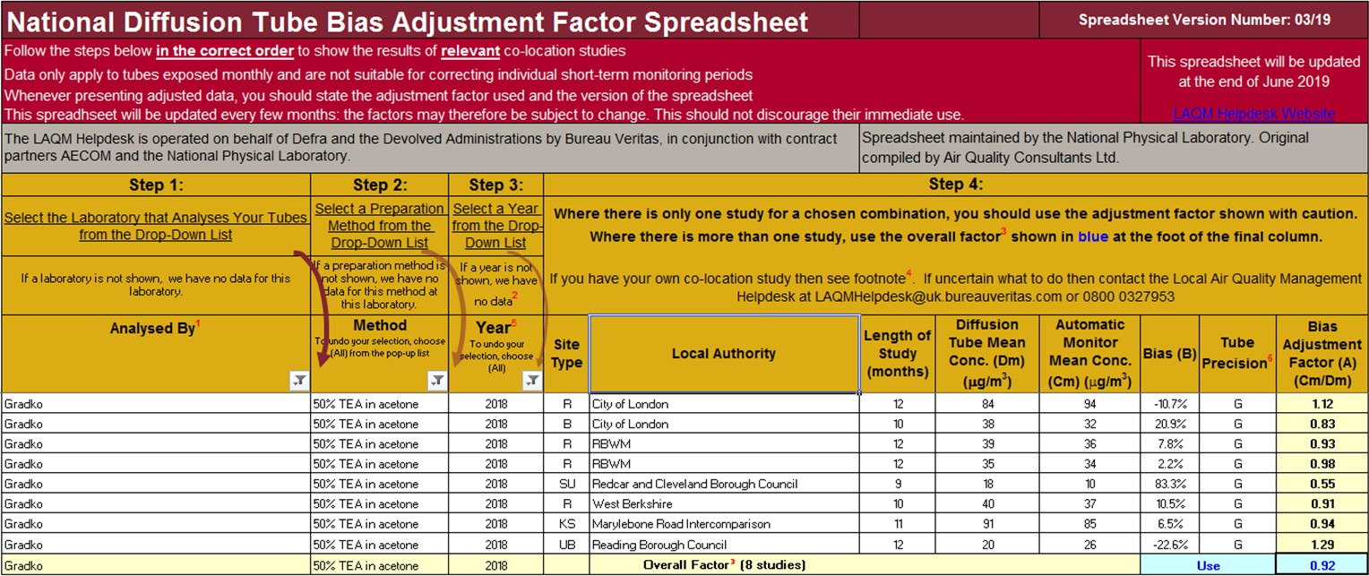

PM₁₀ Monitoring Adjustment
All PM₁₀ R&P TEOM data from 2008 onwards has been adjusted using the King’s College London Volatile Correction Method (VCM). This was carried out by Ricardo for the sites affiliated to the Scottish Air Quality Network in 2015 as part of the Scottish Government’s contract.
The PM₁₀ monitor at the A8 Grangemouth AURN site has been a FDMS since April 2009 and so no correction factor has been applied to the data after this date. The VCM has been applied to the 2008 and 2009 AURN TEOM data by King’s College under contract to DEFRA. A PM₁₀ Met One 1020 BAM analyser has replaced the R&P TEOM FDMS at the A8 Grangemouth AURN site on 06/06/2018 and no correction factor has been applied to this PM₁₀ data since the installation of this analyser.
The PM₁₀ monitor at the A13 Banknock 2 site has been a Palas FIDAS 200 analyser since February 2015 so no correction factor has been applied to the data after this date.

Estimating PM_{2.5} from PM₁₀ Measurements
LAQM TG (16) describes two methodologies for estimating PM_{2.5} from PM₁₀ measurements. Method one is to apply a locally derived correction ratio calculated from local sites measuring both PM₁₀ and PM_{2.5}. The second is to apply a nationally derived correction ratio of 0.7. The national correction ratio should only be used where no appropriate local sites measuring both PM₁₀ and PM_{2.5} are available. The locally derived correction ratio should only be used at sites of the same classification.
In 2018, Falkirk Council had three local sites monitoring both PM₁₀ and PM_{2.5} these were the A7 Falkirk West Bridge St, A8 Grangemouth AURN and A13 Banknock 2 sites. The A7 Falkirk West Bridge St automatic station was upgraded to include PM_{2.5} monitoring capability through the commissioning of a Palas FIDAS 200 analyser in November 2016. A sufficient volume of monitoring data has been collected since this installation date.
Using the guidance stated in LAQM TG (16) the PM_{2.5} / PM₁₀ ratios were calculated for the A7 Falkirk West Bridge St, A8 Grangemouth AURN and A13 Banknock 2 sites. The ratio derived from the A13 Banknock 2 data was applied to sites classified as ‘roadside (non-urban)’, the ratio derived from the A8 Grangemouth AURN data

was applied to sites classified as ‘urban background / industrial’ and the ratio derived from the A7 Falkirk West Bridge St data was applied to sites classified as ‘roadside (urban)’.
The local correction ratios were used to estimate PM_{2.5} from PM₁₀ measurements at the following sites: A4 Falkirk Haggs, A5 Falkirk Hope St, A10 Grangemouth Municipal Chambers, A14 Banknock 3 and A15 Main St Bainsford. Results are shown in Table A12 in Appendix A. Table C. 2 displays how the local ratios have been derived.
Table C.1 – Locally Derived PM_{2.5} / PM₁₀ Correction Ratio

Site | Site Type | Annual Average PM₁₀ (µg/m³), 2018 | Annual Average PM_{2.5} (µg/m³),  2018 | Ratio
A7 Falkirk West Bridge St | Roadside (Urban) | 6 | 6 | 1
A8 Grangemouth AURN | Urban Background / Industrial | 12 | 7 | 0.58
A13 Banknock 2 | Roadside (Non-urban) | 11 | 6 | 0.55

QA / QC Automatic Monitoring

Table C. 2 – Details of the QA / QC at the Automatic Monitoring Stations in 2018

QA / QC in 2018
Site | Analyser | Network
A3. Bo’ness | SO₂ | SAQN
A4. Falkirk Haggs | NO_{x} | SAQN
A4. Falkirk Haggs | PM₁₀ (TEOM) | SAQN
A5. Falkirk Hope St | NO_{x} | SAQN
A5. Falkirk Hope St | SO₂ | SAQN
A5. Falkirk Hope St | PM₁₀ (TEOM) | SAQN
A7. Falkirk West Bridge St | NO_{x} | SAQN
A7. Falkirk West Bridge St | PM_{10,} PM_{2.5} (FIDAS) | SAQN
A8. Grangemouth AURN (Inchyra) | NO_{x} | AURN
A8. Grangemouth AURN (Inchyra) | PM₁₀ (BAM) | AURN
A8. Grangemouth AURN (Inchyra) | PM_{2.5} (BAM) | AURN
A8. Grangemouth AURN (Inchyra) | SO₂ | AURN

A9. Grangemouth Moray | NO_{x} | AURN
A9. Grangemouth Moray | SO₂ | SAQN
A10. Grangemouth Municipal Chambers | NO_{x} | SAQN
A10. Grangemouth Municipal Chambers | PM₁₀ (TEOM) | SAQN
A10. Grangemouth Municipal Chambers | SO₂ | SAQN
A11. Grangemouth Zetland Park | SO₂ | SAQN
A12. Falkirk Grahams Rd | PM₁₀ (TEOM) | SAQN
A13. Banknock 2 | PM_{10,} PM_{2.5} (FIDAS) | SAQN
A14. Banknock 3 | PM₁₀ (Osiris) | Local
A15 Main St Bainsford | NO_{x} | SAQN
A15 Main St Bainsford | PM₁₀ (TEOM) | SAQN
Local sites:
- Analyser data is downloaded and a flow check is completed on a fortnightly basis.
- A filter change is completed on an approximate four weekly basis, although this is dependent on the weather and filter loading. The filters are retained for analysis.
- As with the other sites all LSO site visits are completed by Falkirk Council staffs that are audited to AURN standards.
- The Turnkey Osiris at Banknock 3 site is serviced on an annual basis and covered by a service agreement for any breakdowns, both are completed off-site.

AURN and Scottish AQ network sites:
- All NO_{x} and SO₂ analysers receive fortnightly zero and span checks and filter changes.

- TEOM heads are cleaned and the filter changed on a four weekly basis or more frequently if the filter loading increases above 90%.
- BAM PM₁₀ and PM_{2.5} nozzles are cleaned and tapes are changed every eight weeks.
- All LSO site visits are carried out by Falkirk Council staffs that are audited to AURN standards.
- Analysers are covered by an emergency callout contract and receive a service every six months.
- QA / QC are conducted to AURN / ‘national’ standards.
- Falkirk Council also checks the data on its internal systems and is in regular communication with Ricardo to ensure the best data quality is collected / presented. Unscaled data is supplied by Falkirk Council to Ricardo for the Scottish AQ Network sites on a six monthly basis to improve data capture

Glossary of Terms

Abbreviation | Description
AADT | Annual Average Daily Traffic – total volume of vehicle traffic on a highway or road for a year divided by 365 days.
AQAP | Air Quality Action Plan – A detailed description of measures, outcomes, achievement dates and implementation methods, showing how the LA intends to achieve air quality limit values’
AQMA | Air Quality Management Area – An area where air pollutant concentrations exceed / are likely to exceed the relevant air quality objectives. AQMAs are declared for specific pollutants and objectives
APR | Annual Progress Report in relation to air quality
AURN | Automatic Urban and Rural Network (UK air quality monitoring network)
BAM | Beta Attenuation Monitor
CAFS | Cleaner Air for Scotland
Defra | Department for Environment, Food and Rural Affairs
DMRB | Design Manual for Roads and Bridges – Air quality screening tool produced by Highways England
ECSVEP | East Central Scotland Vehicle Emissions Partnership
EIA | Environmental Impact Assessment
EPUK | Environmental Protection UK
EU | European Union
FEL | Forth Environment Link
FDMS | Filter Dynamics Measurement System
FPS | Flood Prevention Scheme
GCMS | Gas Chromatography–Mass Spectrometry - analysis method
HDV | Heavy Duty Vehicle
IAQM | Institute of Air Quality Management

LAQM | Local Air Quality Management
LDV | Light Duty Vehicle
MCPD | Medium Combustion Plant Directive
NAQS | National Air Quality Strategy
NO₂ | Nitrogen Dioxide
NO_{x} | Oxides of Nitrogen
PDU | Public Display Unit
PM₁₀ | Airborne particulate matter with an aerodynamic diameter of 10µm (micrometres or microns) or less
PM2.5 | Airborne particulate matter with an aerodynamic diameter of  2.5µm or less
PV | Photovoltaic (in relation to solar energy)
QA/QC | Quality Assurance and Quality Control
SEA | Supporting Environmental Appraisal
SEPA | Scottish Environment Protection Agency
SO₂ | Sulphur Dioxide
TD | Thermal Desorption – Analysis Method
TEOM | Tapered Element Oscillating Microbalance
TGT | Tail Gas Treatment

References
  - Technical Guidance LAQM.TG (16), DEFRA and Devolved Administrations, February 2018.
  - Civil Aviation Authority, UK Airport Statistics: http://www.caa.co.uk/data-and- analysis/#Data
  - Policy Guidance LAQM.PG (S) 16, Defra and Devolved Administrations, March 2016.

